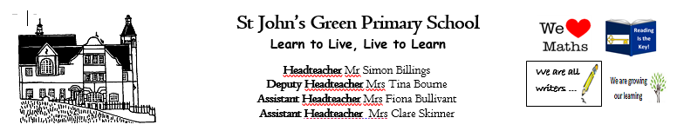
Subject: MATHS WHITE ROSE UNIT: decimals
Year Group: 4 (Miss Salmon/Miss Mitchell/Mrs Hancock)

RECOVERY CURRICULUM
Week Beginning: 01.03.2021
Small Steps:
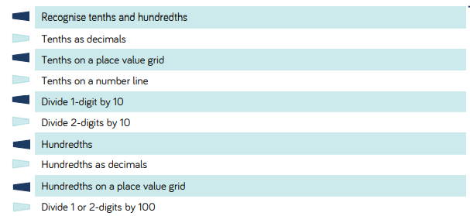

Day | MENTAL/ORAL STARTER  (10 mins)  Timetable tables, number bonds, use counting sticks, chanting, memorising games, dice games, interactive and pacey…… | Vocabulary  (5 mins)  Look at, read and talk about the maths vocabulary we will be using this week. Have this displayed and referred to constantly… | Introduction to the day’s learning. (10-15 mins)  Share the WALT and Success criteria in this section of time…  WALT: recognise tenths and hundredths. | Main Teaching Activity  (30-40 mins) | Plenary (5 mins)  What have we learnt? Compare to WALT and Success Criteria…How will we use these skills tomorrow?
Mon | Numbergym- guess my number with decimals. | divide  out of  tenths  hundredths  decimal  fraction  numberline  place value  square  row  partition  part  whole  equal | Children will need to recognise what tenths and hundredths are. Show children a hundred square to show that 1 square is equal to 1/100 and a row id equal to a tenth.  Then show children some diennes/base 10. Show children that a 1 cube out of a hundred can represent 1/100. Then the same with a tens.  Share these questions with the children  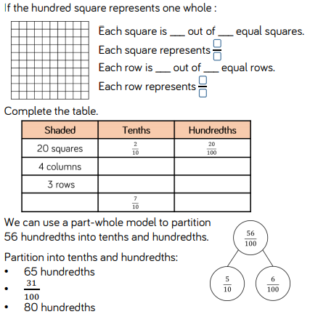 | Share ppt with chn  Chn complete sheet of questions. | 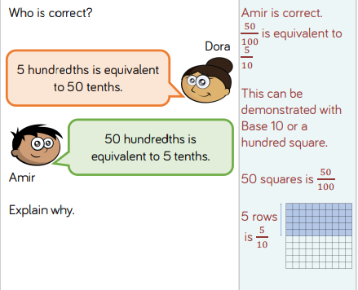
Day | MENTAL/ORAL STARTER  (10 mins)  Timetable tables, number bonds, use counting sticks, chanting, memorising games, dice games, interactive and pacey…… | Vocabulary  (5 mins)  Look at, read and talk about the maths vocabulary we will be using this week. Have this displayed and referred to constantly… | Introduction to the day’s learning. (10-15 mins)  Share the WALT and Success criteria in this section of time…  WALT: recognise tenths as a decimal | Main Teaching Activity  (30-40 mins) | Plenary (5 mins)  What have we learnt? Compare to WALT and Success Criteria…How will we use these skills tomorrow?  …
Tues | 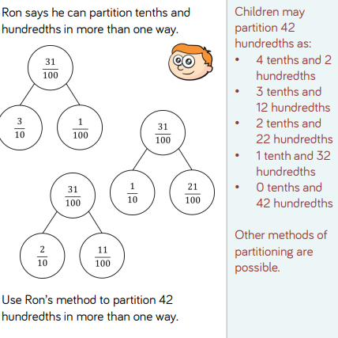 | divide  out of  tenths  hundredths  decimal  fraction  numberline  place value  square  row  partition  part  whole  equal | Start off by asking children these questions…  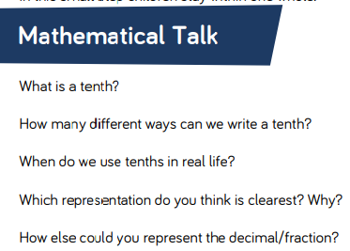  Children need to ensure they know the relationship between 1.10 and 0.1. practise saying a fraction like 2/10…on their whiteboards, can children write the decimal. Then show these questions on the board.  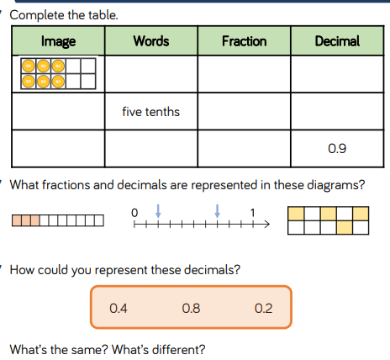 | Share ppt with chn  Chn complete sheet of questions. | 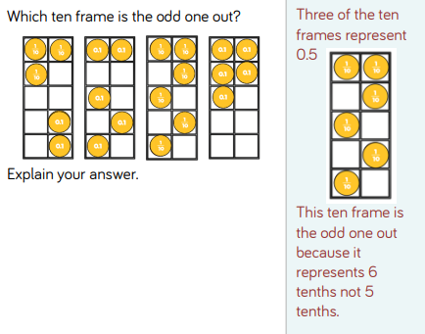
Day | MENTAL/ORAL STARTER  (10 mins)  Timetable tables, number bonds, use counting sticks, chanting, memorising games, dice games, interactive and pacey…… | Vocabulary  (5 mins)  Look at, read and talk about the maths vocabulary we will be using this week. Have this displayed and referred to constantly.. | Introduction to the day’s learning. (10-15 mins)  Share the WALT and Success criteria in this section of time…  WALT: Find tenths on a place value grid | Main Teaching Activity  (30-40 mins) | Plenary (5 mins)  What have we learnt? Compare to WALT and Success Criteria…How will we use these skills again?
Wed | Counting tenths and hundredths on a counting stick. | divide  out of  tenths  hundredths  decimal  fraction  numberline  place value  square  row  partition  part  whole  equal | children need to read and recognise tenths on a place value grid. They need to see that the tenth column is right of the decimal point.  In school, children can use a place value and practise, with the teacher, represent different tenths on there. Children will need to go beyond one at this point.  Go through these questions with the children.  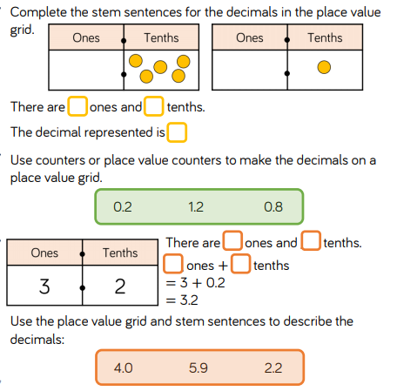 | Share ppt with chn  The PPt is quite tricky so more pratise may need to be required before slide 7  Chn complete sheet of questions. | Children to place decimal bingo  Children write 6 different decimals on their whitevoards  CT to say different ones and tenths they have  I have 4 ones and 3 tenths…children would need to find 4.3
 | MENTAL/ORAL STARTER  (10 mins)  Timetable tables, number bonds, use counting sticks, chanting, memorising games, dice games, interactive and pacey…… | Vocabulary  (5 mins)  Look at, read and talk about the maths vocabulary we will be using this week. Have this displayed and referred to constantly.. | Introduction to the day’s learning. (10-15 mins)  Share the WALT and Success criteria in this section of time…  WALT: Find fractions of a quantity | Main Teaching Activity  (30-40 mins) | Plenary (5 mins)  What have we learnt? Compare to WALT and Success Criteria…How will we use these skills again?
Thur  This is world book day. So lesson can be used on Friday. | Counting stick with fractions and decimals. | divide  out of  tenths  hundredths  decimal  fraction  numberline  place value  square  row  partition  part  whole  equal | Children will need to read and represent tenths on a number line. These can go beyond 1 also. In school, a counting stick can be used to represent this using post it notes.  Have a go at these questions with the children and think abou the maths talk questions as you work through them.  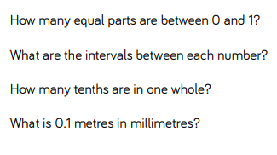  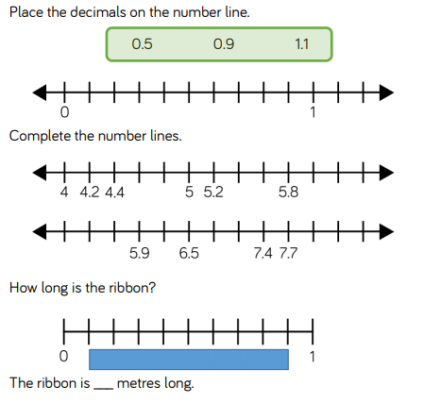 | Share ppt with chn  Chn complete sheet of questions.
Day | MENTAL/ORAL STARTER  (10 mins)  Timetable tables, number bonds, use counting sticks, chanting, memorising games, dice games, interactive and pacey…… | Vocabulary  (5 mins)  Look at, read and talk about the maths vocabulary we will be using this week. Have this displayed and referred to constantly… | Introduction to the day’s learning. (10-15 mins)  Share the WALT and Success criteria in this section of time…  WALT: Calculate Quantities | Main Teaching Activity  (30-40 mins) | Plenary (5 mins)  What have we learnt? Compare to WALT and Success Criteria…How will we use these skills tomorrow?
Fri

