EYFS AND YEAR 1

WEEK 5
MONDAY

Tricky words
There, where, house, friend

Phonics
Recap phase 3 sounds
Words to practise
Practise words to specific sound.
Challenge
Can you write some sentences with these words in?

MATHS

Position and Direction
https://www.youtube.com/watch?v=ryb26FjpgUE- children can watch this clip.
Discuss the vocabulary left, right, forwards and backwards. Take it in turns to be a ‘robot’ and give each other instructions on how to move around the house or garden.
Challenge
If your child can do this easily, then you could challenge them to this question.
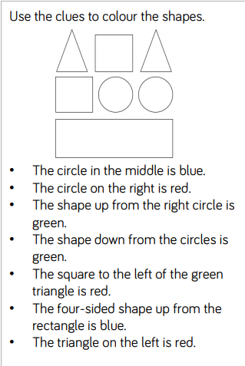
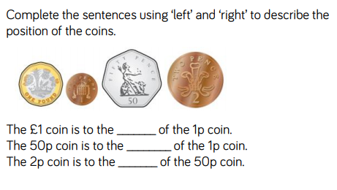

Theme Work
Build a den (inside or outside)
- Day 1- Plan your den with labelled drawings.
- Day 2- Draw a map on how to get there. Use your maths vocabulary.
- Day 3- Are there any rules in your den? Write these down for your den.
- Day 4- Which characters live in your den? Write a wanted poster for your character.
- Day 5- write a comic strip or story with your character and den in it.

TUESDAY
Tricky words
There, where, house, friend

Phonics
Recap phase 3 sounds
Words to practise
Practise words to specific sound.
Challenge
Can you write some sentences with these words in?

MATHS

Maths
Position and Direction
Children to discuss ‘top’, ‘in between’, ‘bottom’, ‘above’ and ‘below’ children can use any objects for this. Put these objects in different orders and get children to describe it to you.
Complete table of items around your house/garden.
In front of me | Behind me | To the left of me | To the right of me

Challenge.
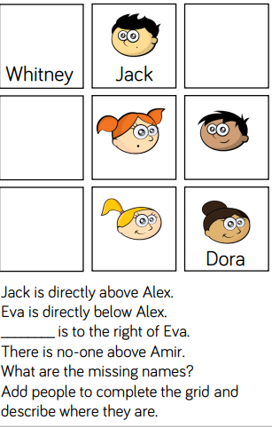

WEDNESDAY

Tricky words
There, where, house, friend

Phonics
Recap phase 3 sounds
Words to practise
Practise words to specific sound.
Challenge
Can you write some sentences with these words in?

MATHS

MATHS
Children to get different objects and explore putting these on the turning circle. Practise giving each other different instructions on how to turn the object.

Three quarter turn
Quarter turn
Half turn
Start

Challenge- can you discuss and practise clockwise and anti-clockwise.
THEME

THURSDAY

Tricky words
There, where, house, friend

Phonics
Recap phase 3 sounds
Words to practise
Practise words to specific sound.
Challenge
Can you write some sentences with these words in?

MATHS

Numbergym Practise- online access- username- sjg, password- welovemaths
Early Maths- shape and measure- route pathways
Adult Guidance- Children can explore other maths games linked to number and place value.

THEME

FRIDAY
PHONICS-
Phonics
Recap any sounds that your child has found tricky.
Challenge
Can you write some sentences with these words in?
Tricky words
Words from the week.
Words to practise
Words from the week

MATHS
EYFS-
https://whiterosemaths.com/homelearning/early-years/
YEAR 1- pick a lesson
https://whiterosemaths.com/homelearning/year-1/
THEME

