Remote Learning - EYFS
Tuesday 2nd March 2021
Below is a timetable guide of what we will be teaching today and the follow up activities for you to complete. The chat function will be available for any questions related to the learning
9.30AM LIVE Registration and Letters and Sounds
Children will need something to write with if possible.
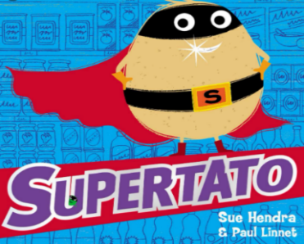
Following onto LIVE Literacy
Follow up activity:
ABC

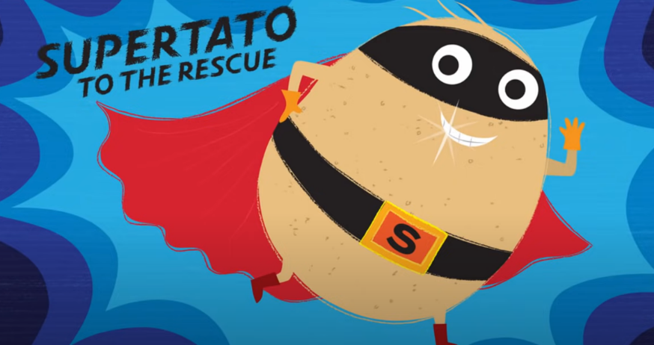
Encourage children to write a simple sentence using their phonic knowledge about the picture below,

- Think of your sentence.
- Say the sentence aloud.
- Use your sounds to write the sentence.
- Put a capital letter at the start of your sentence.
- Use Finger spaces in-between every word.
- Put a full stop at the end of your sentence.
- Check your sentence using the Writers Toolkit.

Short brain break videos
Head, Shoulders, Knees and Toes: https://www.youtube.com/watch?v=TSdeIhmv6v0
A Root Chy Cha: https://www.youtube.com/watch?v=SALCPlmRUeo
11.30 AM LIVE Mathematical Development
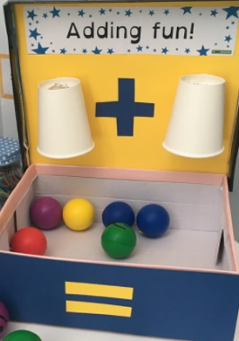
Number bonds to 10
Watch https://www.youtube.com/watch?v=jZi-6_-Uhwc

Number Bonds to 10 rainbow PP

Continue the use of the adding machine created last week. Two cups and a box

Model using the machine to find the number bond.

Follow up activity:
- Children to use their adding machine.
- Using 10 resources around the house can you put two amounts into the machine.
- *CHALLENGE – Can you record the number sentences *
- Complete the rainbow number bonds sheet (using your adding machine to help).
Short brain break videos
Cosmic Yoga: https://cosmickids.com/watch/ (choose a clip that you would like to participate in).
No LIVE sessions

Afternoon activity Music – Please follow the instructions below.
Follow up activity:
- The National Oaks Academy
- Lessons / Subjects
- Early Years Foundation Stage / Reception
- Music/ Out and about
- Watch: Lesson 2 – People in my neighbourhood
- Children to join in with the songs and activities.

  - Recorded Story

- Bring a teddy, a blanket, and a drink to listen to the story, to end the day calmly.

* Throughout the week individual Team calls for a short 1:1 reading session will happen *

