Home Learning in EYFS
Dear EYFS Parents,
In these unprecedented times, our contact with your children and you is to all extent and purposes non-existent. However, we are keen to monitor the children and keep up to date with the different things they are learning through doing at home. Many of you are already using Earwig to follow your children’s journey, some of you, not quite yet. We have now activated the ‘Parent Observation Feature’ on the Earwig account.
We’re asking you to upload and record onto the Earwig platform all of the different things that your child is learning at home. Our EYFS teachers and staff will then be able to login and comment on the things you’ve uploaded.
To help with this the EYFS team have broken down the different areas of the curriculum and put some ideas of things that you can share.
If you haven’t got an Earwig account or can’t login, please e-mail the school admin account.
Regards,
Simon Billings
Below are all of the 17 Early Learning Goals that we have been supporting the children to meet by the end of the Foundation unit. Underneath each heading are bullet points of ways to support your child to continue their learning at home.
Please use this opportunity to write observations, take photographs and videos of your child’s learning and upload them onto their Earwig Learning Journal. All Foundation teachers will then be able to view the observations.
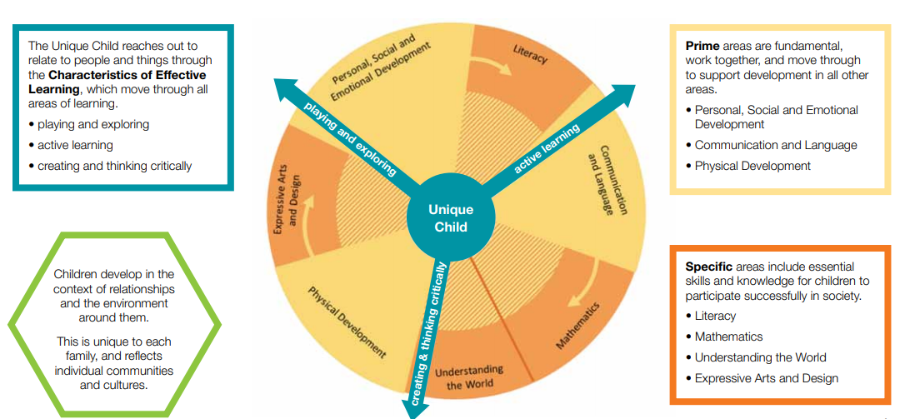

Communication and Language
Listening and Attention
Children listen attentively in a range of situations. They listen to stories, accurately anticipating key events and respond to what they hear with relevant comments, questions or actions. They give their attention to what others say and respond appropriately, while engaged in another activity.
Understanding
Children follow instructions involving several ideas or actions. They answer ‘how’ and ‘why’ questions about their experiences and in response to stories or events
Speaking
Children express themselves effectively, showing awareness of listeners’ needs. They use past, present and future forms accurately when talking about events that have happened or are to happen in the future. They develop their own narratives and explanations by connecting ideas or events.
- Record videos of your child talking about each book they read. This will help to show that they have understood it clearly and can express their thoughts about it.
- Record your child talking about something they have made, encourage them to talk through the process in order. Why did they choose particular materials?
- Make up a story with a clear beginning, middle and end.
Physical Development
Moving and handling
Children show good control and co-ordination in large and small movements. They move confidently in a range of ways, safely negotiating space. They handle equipment and tools effectively, including pencils for writing.
- Daily exercise – record your child participating in exercise (this could include Joe Wicks)
- Build and complete an obstacle course
- Challenge your child to create something using scissors. Ensure they are using them correctly and support them to hold it in the right position, where appropriate
- Daily writing challenges – forming letters correctly
Health and self-care
Children know the importance for good health of physical exercise, and a healthy diet, and talk about ways to keep healthy and safe. They manage their own basic hygiene and personal needs successfully, including dressing and going to the toilet independently.
- Encourage your child to plan/create a healthy meal each day. Talk about what makes it healthy and help to prepare it, where safe to do so.
- Encourage your child to get dressed and undressed every day, independently
- Can your child think of a list of rules on how to keep safe in the house?

Personal, Social and Emotional Development
Making relationships
Children play co-operatively, taking turns with others. They take account of one another’s ideas about how to organise their activity. They show sensitivity to others’ needs and feelings, and form positive relationships with adults and other children.
- Encourage your child to play turn-taking games with a member of the family
- Challenge your child to make up their own game and explain the rules clearly. Can they write/draw the rules?
Self-confidence and self-awareness
Children are confident to try new activities, and say why they like some activities more than others. They are confident to speak in a familiar group, will talk about their ideas, and will choose the resources they need for their chosen activities. They say when they do or don’t need help.
- Support your child to try a new activity at home and explain why they like or dislike it
- Encourage your child to tell a story to a family member with confidence
Managing feelings and relationships
Children talk about how they and others show feelings, talk about their own and others’ behaviour, and its consequences, and know that some behaviour is unacceptable. They work as part of a group or class, and understand and follow the rules. They adjust their behaviour to different situations, and take changes of routine in their stride.
- Can your child talk about what colour monster they feel each day and why?
- Challenge your child to show an act of kindness and make somebody smile every day

Literacy
Reading
Children read and understand simple sentences. They use phonic knowledge to decode regular words and read them aloud accurately. They also read some common irregular words. They demonstrate understanding when talking with others about what they have read.
- Share a story – record your child reading a book, using their phonic knowledge rather than memory
- Ask your child questions about the story they have read – type up the questions and your child’s response word for word

Writing
Children use their phonic knowledge to write words in ways which match their spoken sounds. They also write some irregular common words. They write simple sentences which can be read by themselves and others. Some words are spelt correctly and others are phonetically plausible.
- Encourage your child to write a sentence a day using their phonic knowledge. This could be in a daily journal or you could use pictures as inspiration for writing (e.g. Simon’s Cat) – take photographs of your child’s writing and upload it onto Earwig
- Challenge your child to write the Phase 2 and 3 tricky words; I no go to the into he she we be me all are they her (Epic Phonics songs)

Mathematical Development
Number
Children count reliably with numbers from one to 20, place them in order and say which number is one more or one less than a given number. Using quantities and objects, they add and subtract two single-digit numbers and count on or back to find the answer. They solve problems, including doubling, halving and sharing.
- Challenge your child to order numbers 1-20. Can they count objects out to match each number?
- Make a sandwich – can your child cut it in half equally?
- Using a small pile of sweets, ask your child to share these out equally amongst the family
- Using natural objects, toys, food etc. Challenge your child to add two groups together and count the total
- Using natural objects, toys, food etc. Challenge your child to take away an amount and count the total

Space, shape and measure
Children use everyday language to talk about size, weight, capacity, position, distance, time and money to compare quantities and objects and to solve problems. They recognise, create and describe patterns. They explore characteristics of everyday objects and shapes and use mathematical language to describe them.
- Use crayons to create rubbings of coins – discuss the value of each coin and compare them
- Create a ‘shop’ in the house and encourage your child to ‘buy’ a snack each day
- Encourage your child to help you cook – can they weigh out the ingredients? What weighs more? Why do they think that or how do they know?
- Using crayons, pencils, paint etc can they create a repeated pattern
- Go on a shape hunt around the house – what 2D and 3D shapes can your child find? How do they know which each shape is? Can they describe the properties?

Understanding the World
People and communities
Children talk about past and present events in their own lives and in the lives of family members. They know that other children don’t always enjoy the same things, and are sensitive to this. They know about similarities and differences between themselves and others, and among families, communities and traditions.
- Ask your child to create a poster about themselves and their family. Question them as to what is similar and what is different about each family member.
The world
Children know about similarities and differences in relation to places, objects, materials and living things. They talk about the features of their own immediate environment and how environments might vary from one another. They make observations of animals and plants and explain why some things occur, and talk about changes.
- Encourage your child to talk about Spring. What do they notice in the environment? What has changed? What insects do you see outside?
- Create a picture/ collage using nature
Technology
Children recognise that a range of technology is used in places such as homes and schools. They select and use technology for particular purposes.
- Log onto Purple Mash and explore (log in details are in the back of reading records)
- Log onto Number Gym and explore (log in details are in the back of reading records)
- View a range of learning videos (with an adult)
Expressive Arts and Design
Exploring and using media and materials
Children sing songs, make music and dance, and experiment with ways of changing them. They safely use and explore a variety of materials, tools and techniques, experimenting with colour, design, texture, form and function.
- Record your child making up a song – can they use objects around the house to create music?
- Play your child’s favourite song – can they make up a dance to that music?
- Can your child create props to support their play? (e.g. a sword, crown etc.) – using recyclable materials
- Build a den (inside or out) – why did your child choose those particular materials to build with?

Being imaginative
Children use what they have learnt about media and materials in original ways, thinking about uses and purposes. They represent their own ideas, thoughts and feelings through design and technology, art, music, dance, role play and stories.
- Challenge your child to create a story using their imagination – retell this story to an adult to record. Can they make the story into a book with pictures and writing? Do they need to make props to support their story telling?

Websites to support learning
https://www.phonicsplay.co.uk/ - (Phase 2 and 3)
https://www.purplemash.com/sch/stjohnsco2
http://www.doorwayonline.org.uk/
http://www.ictgames.com/resources.html
https://epicphonics.com/ - Teaching videos (Phase 2 and 3)
https://simonscat.com/
https://www.youtube.com/channel/UCAxW1XT0iEJo0TYlRfn6rYQ (Joe Wicks PE)

