Our rubric for a kenning
Audience: Your teacher and class Purpose: To compose a kenning of our own
 | Objective | Towards | At | Above
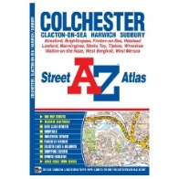 | Spellings | I can use at least one key word in my writing and spell it correctly. | I can use 3 key words in my writing and spell them correctly.  I can spell a range of high frequency words correctly. | I can use a range of key words from our class list.  I can spell high frequency words consistently and accurately.
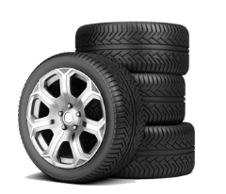 | Grammar | I sometime use more exciting verbs in my writing.  I sometimes use noun phrases in my work | I am beginning to use more exciting verbs in my writing.  I am beginning to use noun phrases in my work | I am using more exciting verbs in my writing.  I can create noun phrases in my work
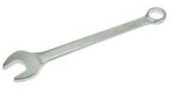 | Punctuation | I am beginning to use a new line for each line in my poems. |  | I can use a new line for each line in my poems.  I can use a hyphen in my phrases.
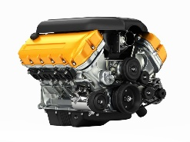 | Genre | I am beginning to use imaginative language in my poems. | I am using imaginative language in my poems.  I am making my poem a riddle by not mentioning its subject.
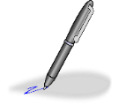 | Handwriting | I can write legibly and join some of the time. | I can write neatly and join up my writing. | I can write neatly, joined and with increasing speed throughout my text.

