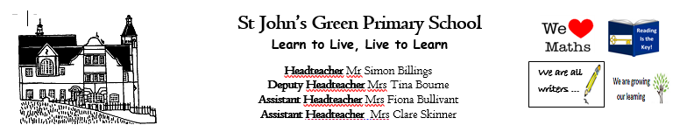

**Week 16 (W.B. 13/07/2020)**

**Theme: Music**

**Year 2/3**

* **Write your own mnemonic to remember the notes on the lines of the stave (EGBDF) and the notes in the space (FACE). Use the Musical Notes on a Stave powerpoint to help you.**
* **Listen to Indiana Jones theme song. This is the music to your movie. Write the scene that would be happening while this music is playing. Describe the characters, the movement, the tension. What does the music make you feel/imagine?**
* **Compose your own lyrics/rap to your favourite song**
* **Create a comic strip for Tchaikovsky’s ‘Nutcracker’.**
* **Make a musical instrument**
* **Clap the rhythms of the notes with the ‘Rhythm of Musical Notes’ Powerpoint. Write and perform your own rhythm using the musical notation.**
* **Listen to Indiana Jones again. As you’re listening draw a picture that represents the music. You could also use different mediums eg. Paint, sketching, colouring pens, collage.**
* **Match the musical instruments game https://www.twinkl.co.uk/resource/musical-instruments-interactive-matching-activity-tg-408**
* **Sort the musical instruments into the correct instrument families**
* **Play hot or cold with humming. Pick an object in the room and when your partner gets close to it, increase the volume of your hum.**
* **Use the body percussion sheets to create your own body percussion rhythms.**
* **STOMP dancing**
* **Read about Tchaikovsky and the story of the Nutcracker**
* **Learn the names and values of musical notation**
* **Musical note fractions**
* **Jazz Reading Comprehension**
* **Musical note number sentences**
* **Adding fractions**