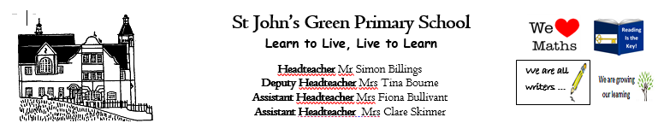

**Week 11 (W.B. 8.6.20)**

**Theme; Creativity**

**YEAR 2/3**

* **Discuss vocabulary relating to creativity**
* **Read and answer questions about ‘’The Dot’ by Peter H.Reynolds**
* **Insect symmetry**
* **Choreograph a movement piece to music**
* **Create balances and shapes with your body in Gymnastics**
* **Write a letter to Vashti about your creativity and how she has inspired you**
* **Research a famous abstract artist**
* **Create a factfile for a famous abstract artist**
* **Reading comprehension on The Wright Brothers**
* **Invent a new flying machine**
* **Write an explanation text for your flying machine**
* **Write a biography for yourself to be shown with your art**
* **Create an acrostic poem for yourself**
* **Draw a self portrait**
* **Create a junk model to represent yourself**
* **Origami**
* **Use mathematical vocab to describe an image you have drawn eg. Direction, shape, space, angle, size**
* **Properties of 2D shapes**