Animal shapes
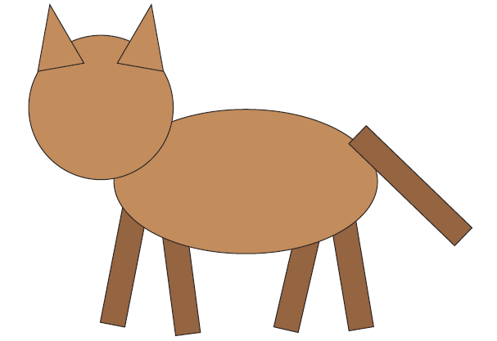
1) How many shapes can you see?
___________________
2) What shapes can you see?
* *
* *
 | Shape name | Number of sides | Number of vertices
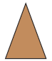

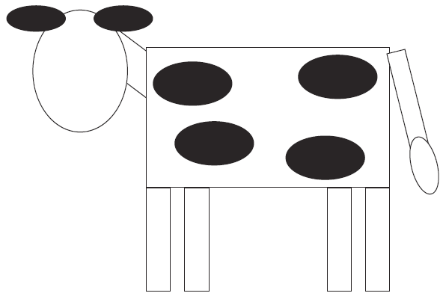
1) How many shapes can you see? ________
2) What shapes can you see?
*
*

 | Shape name | Number of sides | Number of vertices

