Paragraph: |  | Discuss the benefits of the internet
Introduction | Summarise the topic you are writing about – give a brief overview about why some people think it is good and others think it is bad.
Positives | What are the benefits and why?  Point  Evidence  Explain
Negatives | Why do some people think the internet is not a good thing?  Point  Evidence  Explain
Conclusion | Summarise the main points from each side of the argument. What is your final opinion?

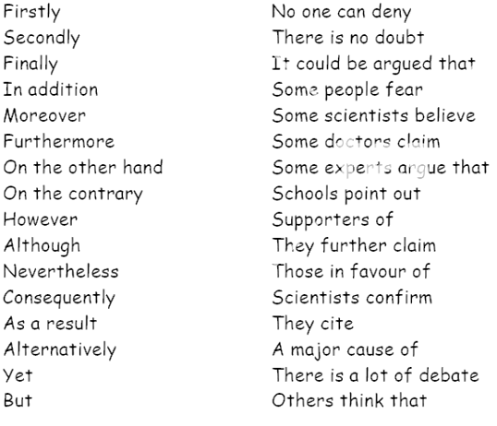
Useful vocabulary

