 | Monday | Tuesday | Wednesday | Thursday | Friday
9-9.30 | Movement  The Body Coach – Youtube on the day | Movement  https://www.youtube.com/user/CosmicKidsYoga | Movement  BBC Move it Dance Programme  https://www.bbc.co.uk/programmes/b03g64pk/episodes/player | Movement  Go outside for a walk. | Movement  The Body Coach – Youtube on the day
9.30-10 | Phonics | Phonics | Phonics | Phonics | Phonics
10-10.30 | Reading  Younger readers can read or share a text with someone. Can they write or draw what they read about? Can they answer questions about the text?  https://www.oxfordowl.co.uk/for-home/find-a-book/library-page/  username- SJGreading  password- SJGreading | Reading  Younger readers can read or share a text with someone. Can they write or draw what they read about? Can they answer questions about the text?  https://www.oxfordowl.co.uk/for-home/find-a-book/library-page/  username- SJGreading  password- SJGreading | Reading  Younger readers can read or share a text with someone. Can they write or draw what they read about? Can they answer questions about the text?  https://www.oxfordowl.co.uk/for-home/find-a-book/library-page/  username- SJGreading  password- SJGreading | Reading  Younger readers can read or share a text with someone. Can they write or draw what they read about? Can they answer questions about the text?  https://www.oxfordowl.co.uk/for-home/find-a-book/library-page/  username- SJGreading  password- SJGreading | Reading  Younger readers can read or share a text with someone. Can they write or draw what they read about? Can they answer questions about the text?  https://www.oxfordowl.co.uk/for-home/find-a-book/library-page/  username- SJGreading  password- SJGreading
 | Word of the day  Shade (of colour) | Word of the day  texture | Word of the day  shadow | Word of the day  Recycle | Word of the day  colour
11-11.15 | Break | Break | Break | Break | Break
11.15-12.15 | Maths  Number gym  http://www.numbergym.co.uk/  Appropriate calculation activity linked to year group e.g. add and subtract  See EYFS and Year 1 daily sheet. | Maths  Purple Mash  https://www.purplemash.com/login/  Shape focus – recap names of shapes. Creating your own Colour Monster shape picture.  See EYFS and Year 1 daily sheet. | Maths  Number gym  http://www.numbergym.co.uk/  Appropriate calculation activity linked to year group. EYFS/Yr1 looking at number bonds/numbers to 10  See EYFS and Year 1 daily sheet. | Maths  Purple Mash  https://www.purplemash.com/login/  See EYFS and Year 1 daily sheet. | Maths  Number gym  http://www.numbergym.co.uk/  Calculation focus – addition and subtraction  See EYFS and Year 1 daily sheet.
12.15-1.15 | Lunch | Lunch | Lunch | Lunch | Lunch
1.15-2.50 | Theme Work  See daily plan | Theme Work  See daily plan | Theme Work  See daily plan | Theme Work  See daily plan | Theme Work  See daily plan
2.50-3.15 | Reflecting Roxy 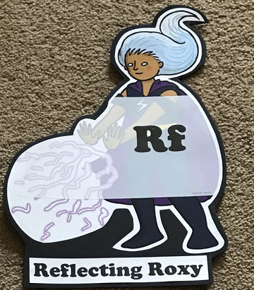  What have you learnt today and how could you have improved any of your work?  STORY TIME | Making Links Molly 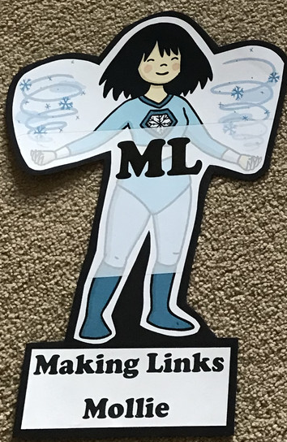  Can you use any learning that you have done today, in other parts of your life?  STORY TIME | Resilience Rex 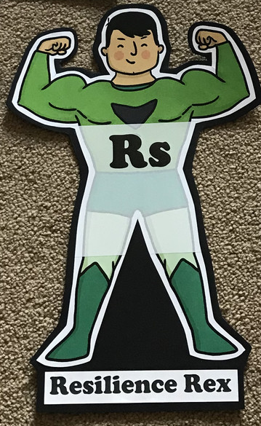  Have you found anything challenging today? How did you overcome the challenges?  STORY TIME | Collaborating Carlos 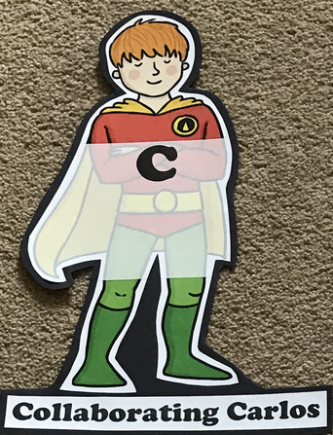  Did you work alone today or with someone else? How did that go?  STORY TIME | Motivating Melinda 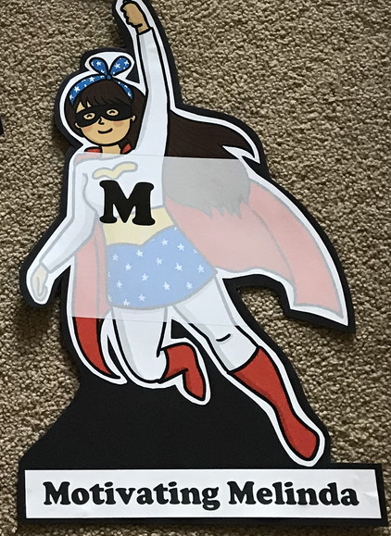  Have you encouraged someone else today? How did you motivate yourself today?  STORY TIME

Monday
Phonics
EYFS
Tricky words
They
My
You
Words to practise
Hear
Clear
Dear
Challenge
Can you write some sentences with these words in?
Phonics
Sound of day-
ear
Hear with your ear

Year 1
Tricky words
Oh
Mrs
People
Words to practise
Bake
Flake
Cake
Mistake
Challenge
Can you write some sentences with these words in?
Phonics
Sound of day-
a-e

Maths
Create an adding machine with toilet role tubes (like the image below) and use small items to represent the numbers (stones could work)
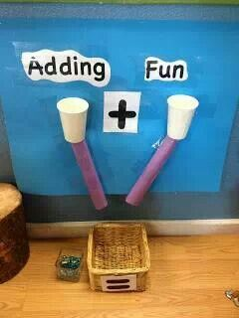
Foundation questions
3+2=
2+2=
4+4=
5+3=
7+1=
Challenge: Write out the number sentences and answers
Year 1 questions
8+4=
11+5=
14+3=
8+9=
2+13=

Tuesday
Phonics
EYFS
Tricky words
He
She
We
Words to practise

Chair
Hair
Fair

Phonics
Sound of day-
Air
That’s not fair
Challenge
Can you write some sentences with these words in?

Year 1
Phonics
Sound of day-
e-e

Words to practise
Theme
Extreme
Delete

Tricky words
Their
Called
Mr

Challenge
Can you write some sentences with these words in?

Maths
Using your adding machine an adding machine roll a dice to generate numbers to add together
Foundation: 1digit + 1digit=
Year 1: 1 _ + _ =

Wednesday
Phonics
EYFS
Words to practise
Pure
Sure
Cure

Tricky words
My
They
All
Phonics
Sound of day-
ure

Sure it’s pure
Challenge
Can you write some sentences with these words in?

Year 1
Phonics
Sound of day-
i-e

Words to practise
Site
Dive
Mine
Tricky words
Looked
Asked
Could
Challenge
Can you write some sentences with these words in?

Maths
Using your adding machine an adding machine roll a dice to generate numbers to add together
Foundation: 1digit + 1digit=
Year 1: 1 _ + _ =

Thursday
Phonics
EYFS
Tricky words
Was
Her
Are
Words to practise
Quack
Queen
Quit
Challenge
Can you write some sentences with these words in?

Phonics
Qu
Qu-qu- quick

Year 1
Words to practise
Explode
Phone
Alone

Tricky words
Called
People
Could
Challenge
Can you write some sentences with these words in?
Phonics
Sound of day-
o-e

Maths
Using your adding machine an adding machine roll a dice to generate numbers to add together
Foundation: 1digit + 1digit=
Year 1: 1 _ + _ =
Year 1 Challenge: Ronald the Rhino Colouring

Friday
Phonics: Phonics play
https://new.phonicsplay.co.uk/resources

Maths: Top marks- ordering and sequencing shapes games
https://www.topmarks.co.uk/ordering-and-sequencing/shape-patterns

