 | Wellbeing Theme – Week 7 04.05.20
 | Monday | Tuesday | Wednesday | Thursday | Friday
9-9.30 | Movement  The Body Coach – Youtube on the day | Movement  https://www.youtube.com/user/CosmicKidsYoga  Cosmic Yoga  (YouTube) | Movement  BBC Move it Dance Programme  https://www.bbc.co.uk/programmes/b03g64pk/episodes/player | Movement  Go outside for a walk. | Movement  The Body Coach – Youtube on the day
9.30-10 | Phonics | Phonics | Phonics | Phonics | Phonics
10-10.30 | Reading  Younger readers can read or share a text with someone. Can they write or draw what they read about? Can they answer questions about the text?  https://www.oxfordowl.co.uk/for-home/find-a-book/library-page/  username- SJGreading  password- SJGreading | Reading  Younger readers can read or share a text with someone. Can they write or draw what they read about? Can they answer questions about the text?  https://www.oxfordowl.co.uk/for-home/find-a-book/library-page/  username- SJGreading  password- SJGreading | Reading  Younger readers can read or share a text with someone. Can they write or draw what they read about? Can they answer questions about the text?  https://www.oxfordowl.co.uk/for-home/find-a-book/library-page/  username- SJGreading  password- SJGreading | Reading  Younger readers can read or share a text with someone. Can they write or draw what they read about? Can they answer questions about the text?  https://www.oxfordowl.co.uk/for-home/find-a-book/library-page/  username- SJGreading  password- SJGreading | Reading  Younger readers can read or share a text with someone. Can they write or draw what they read about? Can they answer questions about the text?  https://www.oxfordowl.co.uk/for-home/find-a-book/library-page/  username- SJGreading  password- SJGreading
11-11.15 | Break | Break | Break | Break | Break
11.15-12.15 | Maths  Number gym  http://www.numbergym.co.uk/  Appropriate calculation activity linked to year group e.g. add and subtract  See EYFS and Year 1 daily sheet. | Maths  Purple Mash  https://www.purplemash.com/login/  Shape focus – recap names of shapes. Creating your own Colour Monster shape picture.  See EYFS and Year 1 daily sheet. | Maths  Number gym  http://www.numbergym.co.uk/  Appropriate calculation activity linked to year group. EYFS/Yr1 looking at number bonds/numbers to 10  See EYFS and Year 1 daily sheet. | Maths  Purple Mash  https://www.purplemash.com/login/  See EYFS and Year 1 daily sheet. | Maths  Number gym  http://www.numbergym.co.uk/  Calculation focus – addition and subtraction  See EYFS and Year 1 daily sheet.
12.15-1.15 | Lunch | Lunch | Lunch | Lunch | Lunch
1.15-2.50 | Theme Work  See daily plan | Theme Work  See daily plan | Theme Work  See daily plan | Theme Work  See daily plan | Theme Work  See daily plan
2.50-3.15 | Reflecting Roxy 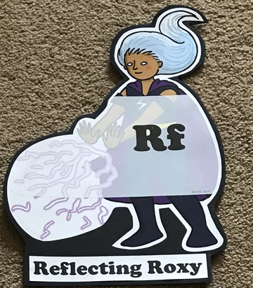  What have you learnt today and how could you have improved any of your work?  STORY TIME | Making Links Molly 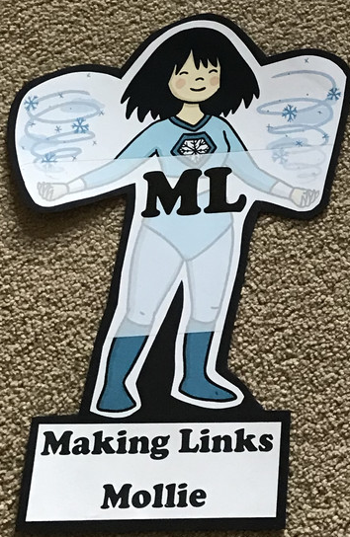  Can you use any learning that you have done today, in other parts of your life?  STORY TIME | Resilience Rex 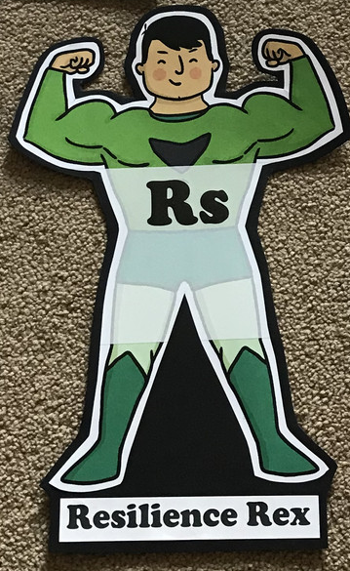  Have you found anything challenging today? How did you overcome the challenges?  STORY TIME | Collaborating Carlos 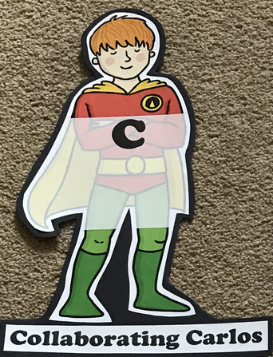  Did you work alone today or with someone else? How did that go?  STORY TIME | Motivating Melinda 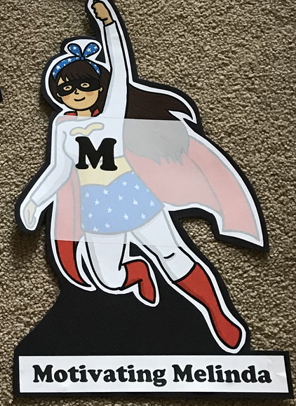  Have you encouraged someone else today? How did you motivate yourself today?  STORY TIME

Theme-
As this theme is quite broad, we would like the children to take ownership and go with whatever they would like to learb about. Here are some suggested activities for them.
- https://www.youtube.com/watch?v=lO_B7CT_-Cs- Man on The Moon- Bob looks after the Moon.
- Write a diary entry about Bob, Character description or instructions on how to look after the moon, fact file about the moon.
- Fact file about the planets. (see attached sheet)
- How to Catch a Star- children to write about how they would catch a Star.
- Make a rocket out of junk modelling.
- Write about what you would take to the moon.
- Create an alien and write a description or story. (Don’t forget to give them a name!)
- Create a dance to ‘Reach for the stars’ by S Club.
- Famous astronauts- create a diary about Tim Peake.
- Hot and cold experiment (see attached sheet)

EYFS/YEAR 1- WEEK 7- Space
Monday
Phonics
EYFS
Tricky words
Your, said, you
Words to practise
Rain, Spain, plain, stain, brain, train
Challenge
Can you write some sentences with these words in?
Phonics
Sound of day-
Ai
Ai ai snail in the rain

YEAR 1
Words to practise
Blue, venue, glue, Tuesday, value
Alien words-
Balue, nescue, flue

Phonics
Sound of day-
Ue (oo/you)
Ue ue to the rescue
Tricky words
Your, said, you
Challenge
Can you write some sentences with these words in?

Maths
Children to go and collect and certain amount of objects. Children to count the objects first. Then subtract a certain amount and say how many is left.
Year 1 to record them in a number sentence.

Tuesday
Phonics
EYFS
Phonics
Sound of day-
Ee
Ee what you can you see?
Words to practise

See three leek keeping peeling feeling
Tricky words
He are me
Challenge
Can you write some sentences with these words in?

YEAR 1
Words to practise
Enjoy toy boy joy, ploy oyster
Alien words- droy, empoy ployster goyal

Tricky words
He are me
Challenge
Can you write some sentences with these words in?
Phonics
Sound of day-
oy
Royal boy

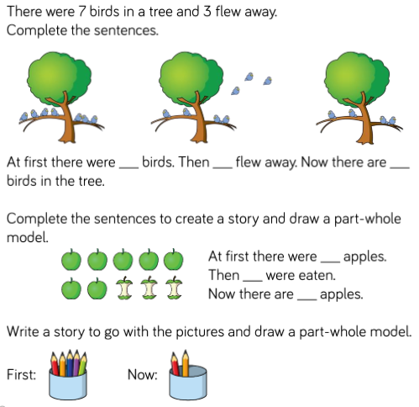
Maths
Create some subtraction stories with your child. Here are some examples.

Year 1s could write these themselves.

Wednesday
Phonics
EYFS
Tricky words
He are me
Words to practise
High thigh light night bright
Challenge
Can you write some sentences with these words in?
Phonics
Sound of day-
Igh

Igh igh fly high

YEAR 1
Words to practise
Skirt birth first thirsty thirty
Alien words
Firl firt birt girt

Tricky words
He are me
Challenge
Can you write some sentences with these words in?
Phonics
Sound of day-
Ir
Ir ir whirl and twirl

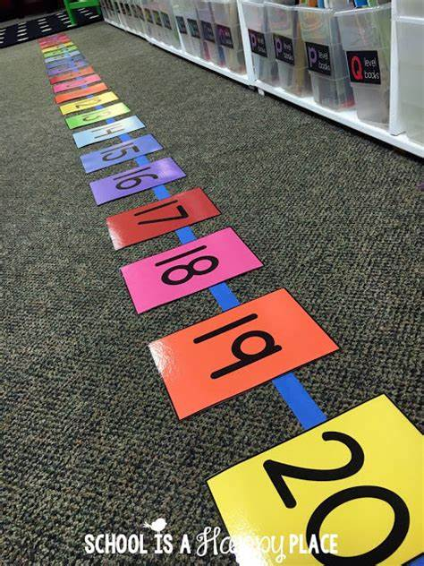
Maths
Create a giant number track. Get children to count up to a number then walk back like they are taking away. Year 1 children could record with chalk on a piece of paper. You could pretend you are a rocket to link it to Space.

Thursday
Phonics
EYFS
Tricky words
Go the all
Words to practise
Float, moat, goat, bloat, throat
Challenge
Can you write some sentences with these words in?
Phonics
Oa
Oa goat in a boat

YEAR 1
Words to practise
Dawn, shawl, lawn,
Alien words
Flawn, sawk, hawm

Tricky words
Go the all
Challenge
Can you write some sentences with these words in?
Phonics
Sound of day-
Aw
Aw yawn at dawn

Maths
Play the rocket maths subtraction game. Year 1 have some challenge cards too.

Friday
Phonics
Phonics play
https://new.phonicsplay.co.uk/resources

Maths
Suggested games
https://www.ictgames.com/mobilePage/numberL/- drag it to any number and jump back.
https://www.ictgames.com/mobilePage/bottleTakeAway/index.html

