Remote Learning - EYFS
Friday 5th March 2021
Below is a timetable guide of what we will be teaching today and the follow up activities for you to complete. The chat function will be available for any questions related to the learning
Letters and Sounds
Children will need something to write with if possible.
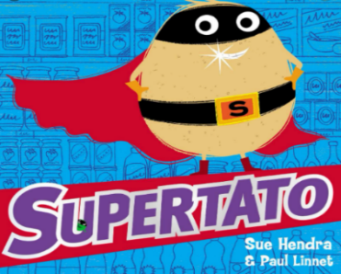
Literacy
Follow up activity:
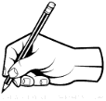
ABC

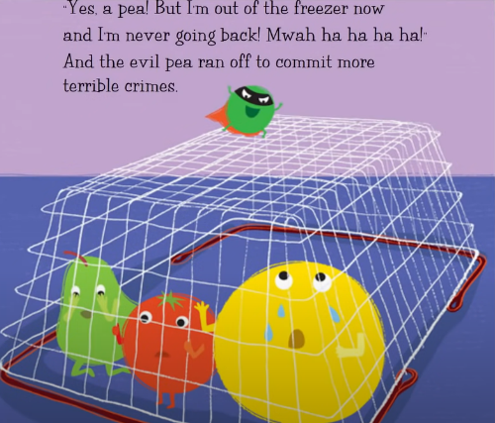
Encourage children to write a simple sentence using their phonic knowledge about the picture below,

- Think of your sentence.
- Say the sentence aloud.
- Use your sounds to write the sentence.
- Put a capital letter at the start of your sentence.
- Use Finger spaces in-between every word.
- Put a full stop at the end of your sentence.
- Check your sentence using the Writers Toolkit.

Short brain break videos
A Ram Sam Sam Dance: https://www.youtube.com/watch?v=zBttxAMxaXE
Princess Pat: https://www.youtube.com/watch?v=1Eii8Dws_eY
Mathematical Development
Number bonds to 10
Watch number bond song clip x2 Watch first (pause and model movement) and then see if the children can join in with the actions. https://www.youtube.com/watch?v=B_CI6__DvII
Complete the ten in bed number bond PP
Follow up activity:
- Complete the ten in a bed sheet.
- ** CHALLENGE – Complete number bonds to 10 number search **
Short brain break videos
Cosmic Yoga: https://cosmickids.com/watch/ (choose a clip that you would like to participate in).
Expressive Art and Design
Watch the clip – https://www.youtube.com/watch?v=kVa3Mx0_ZWs
Follow up activity:
- Children to be encouraged to create a superhero potato making props on a small scale.
- Can you make your potato a cape, a little mask, some cuffs or a power pack?
- Use your skills learnt recently. Wrapping, sellotaping, gluing, cutting and joining etc.
Extra activity
PD – Can your child move like a superhero.
Koo, Koo. Kangaroo – Superhero https://www.youtube.com/watch?v=ok7V1pWtRzs
Train like a superhero - https://www.youtube.com/watch?v=90-Mkbp2XuA
Joe Wicks Sessio

