 | Animal Planet Theme – Week 9 18.05.20
 | Monday | Tuesday | Wednesday | Thursday | Friday
9-9.30 | Movement  The Body Coach – Youtube on the day | Movement  https://www.youtube.com/user/CosmicKidsYoga | Movement  BBC Move it Dance Programme  https://www.bbc.co.uk/programmes/b03g64pk/episodes/player | Movement  Go outside for a walk. | Movement  The Body Coach – Youtube on the day
9.30-10 | Phonics | Phonics | Phonics | Phonics | Phonics
10-10.30 | Reading  Younger readers can read or share a text with someone. Can they write or draw what they read about? Can they answer questions about the text?  https://www.oxfordowl.co.uk/for-home/find-a-book/library-page/  username- SJGreading  password- SJGreading | Reading  Younger readers can read or share a text with someone. Can they write or draw what they read about? Can they answer questions about the text?  https://www.oxfordowl.co.uk/for-home/find-a-book/library-page/  username- SJGreading  password- SJGreading | Reading  Younger readers can read or share a text with someone. Can they write or draw what they read about? Can they answer questions about the text?  https://www.oxfordowl.co.uk/for-home/find-a-book/library-page/  username- SJGreading  password- SJGreading | Reading  Younger readers can read or share a text with someone. Can they write or draw what they read about? Can they answer questions about the text?  https://www.oxfordowl.co.uk/for-home/find-a-book/library-page/  username- SJGreading  password- SJGreading | Reading  Younger readers can read or share a text with someone. Can they write or draw what they read about? Can they answer questions about the text?  https://www.oxfordowl.co.uk/for-home/find-a-book/library-page/  username- SJGreading  password- SJGreading
11-11.15 | Break | Break | Break | Break | Break
11.15-12.15 | Maths  Number gym  http://www.numbergym.co.uk/  Appropriate calculation activity linked to year group e.g. add and subtract  See EYFS and Year 1 daily sheet. | Maths  Purple Mash  https://www.purplemash.com/login/  Shape focus – recap names of shapes. Creating your own Colour Monster shape picture.  See EYFS and Year 1 daily sheet. | Maths  Number gym  http://www.numbergym.co.uk/  Appropriate calculation activity linked to year group. EYFS/Yr1 looking at number bonds/numbers to 10  See EYFS and Year 1 daily sheet. | Maths  Purple Mash  https://www.purplemash.com/login/  See EYFS and Year 1 daily sheet. | Maths  Number gym  http://www.numbergym.co.uk/  Calculation focus – addition and subtraction  See EYFS and Year 1 daily sheet.
12.15-1.15 | Lunch | Lunch | Lunch | Lunch | Lunch
1.15-2.50 | Theme Work  See daily plan | Theme Work  See daily plan | Theme Work  See daily plan | Theme Work  See daily plan | Theme Work  See daily plan
2.50-3.15 | Reflecting Roxy 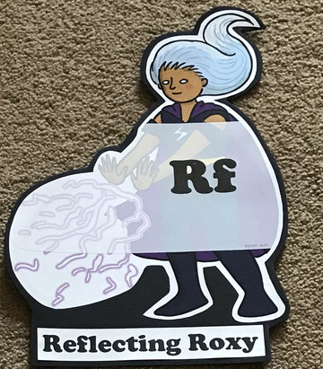  What have you learnt today and how could you have improved any of your work?  STORY TIME | Making Links Molly 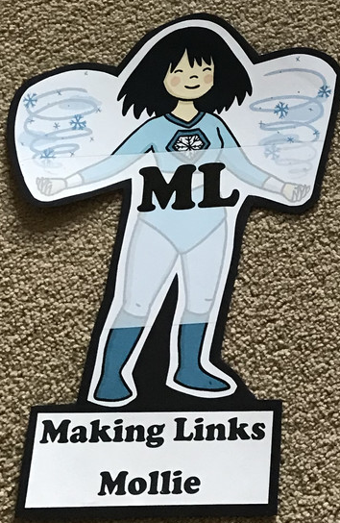  Can you use any learning that you have done today, in other parts of your life?  STORY TIME | Resilience Rex 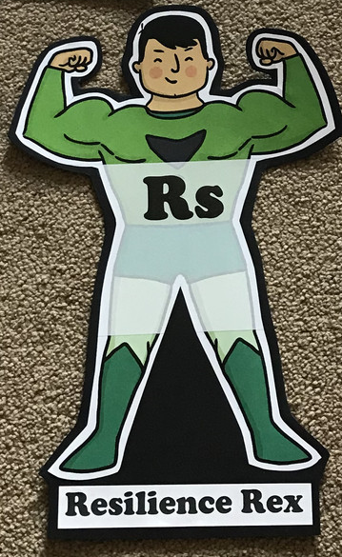  Have you found anything challenging today? How did you overcome the challenges?  STORY TIME | Collaborating Carlos 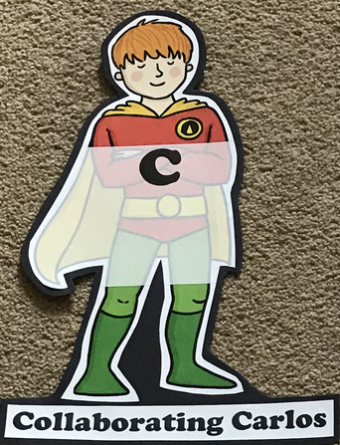  Did you work alone today or with someone else? How did that go?  STORY TIME | Motivating Melinda 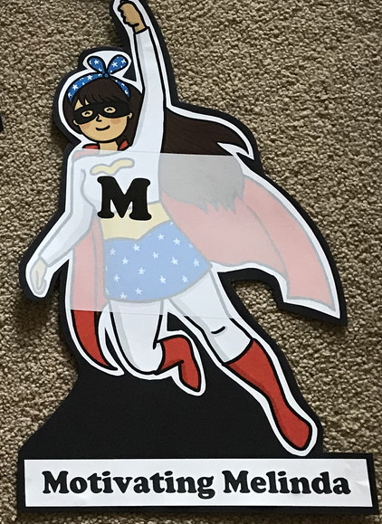  Have you encouraged someone else today? How did you motivate yourself today?  STORY TIME

Theme Ideas
Key question- What is the best animal on the planet? Children to create a project researching different interesting animals. They present it to their families or FaceTime grandparents showing them their project.
Other creative ideas
- Life cycles of animals
- Sorting animals into different groups- reptiles, mammals, birds, fish etc
- Carnivores, herbivores and omnivores
- Endangered animals
- How to look after an animal
- Project about their pets

EYFS/YEAR 1- WEEK 9- Animal Planet
Monday
Phonics
EYFS
Words to practise
Church slurp
Turn pur
Fur curb
surf

Tricky words
People, because
Challenge
Can you write some sentences with these words in?
Phonics
Sound of day-
Ur
Nurse with a purse

YEAR 1
Words to practise
August
automatic
author
haunt
Alien words
baunch, yaul, maut

Phonics
Sound of day-
Au
Paul the astronaut

Tricky words
People, because

Challenge
Can you write some sentences with these words in?

Maths
Go for a walk around your house or on your daily walk. How many different 2D shapes can you find?

Tuesday
Phonics
EYFS
Phonics
Sound of day-
Ow
Down into town
Words to practise

Cow howl
Now crown
Clown
Frown

Tricky words
People, because

Challenge
Can you write some sentences with these words in?

YEAR 1
Words to practise
Sea, beach, flea, beat, teacher, dream
Alien words-
Gweab, fleab, heach

Phonics
Sound of day-
Ea
Cup of tea
Tricky words
People, because

Challenge
Can you write some sentences with these words in?

Maths
Go for a walk around your house or on your daily walk. How many different 3D shapes can you find?

Wednesday
Phonics
EYFS
Words to practise
Oil, foil, boil, coin, soil, avoid
Tricky words
People, because

Challenge
Can you write some sentences with these words in?
Phonics
Sound of day-
oi

dig the soil

YEAR 1
Words to practise
Lake, fake, steak, same, shame, chase
Alien words
Habe, yame, slake, chake

Tricky words
People, because

Challenge
Can you write some sentences with these words in?
Phonics
Sound of day-
a-e
make a cake

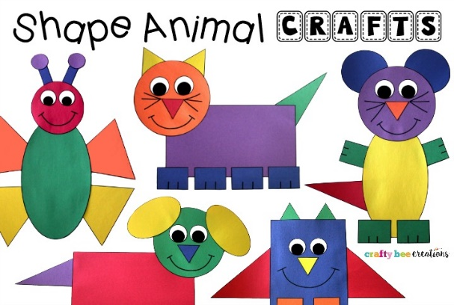
Maths
Create a range of animals using different 2D shapes.

Theme

Thursday
Phonics
EYFS
Tricky words
People, because

Words to practise
Dear, hear, fear, near, beard
Challenge
Can you write some sentences with these words in?
Phonics
ear
hear with your ear

YEAR 1
Words to practise
Steve, Pete, concrete, theme
Alien words
Treme, kete, lepe

Tricky words
People, because

Challenge
Can you write some sentences with these words in?
Phonics
Sound of day-
e-e
go Pete and Steve

Maths
Discuss the properties of 2D shapes using the key words:
- Sides
- Vertices (corners)
Complete the properties of 2D shapes worksheet

Friday
Phonics
Phonics play
https://new.phonicsplay.co.uk/resources

Maths
Top marks- ordering and sequencing shapes games
https://www.topmarks.co.uk/ordering-and-sequencing/shape-patterns

