

**Help Sheet**

***If my child has recently moved from a school that uses Agora, how do I change the account to the new school?***

**You will need to go to ‘My Account’ – ‘My Links’ then click on located near the previous school account and click ‘hide school’. This will remove the link. You will then need a new link and reference number for St John’s Green.**

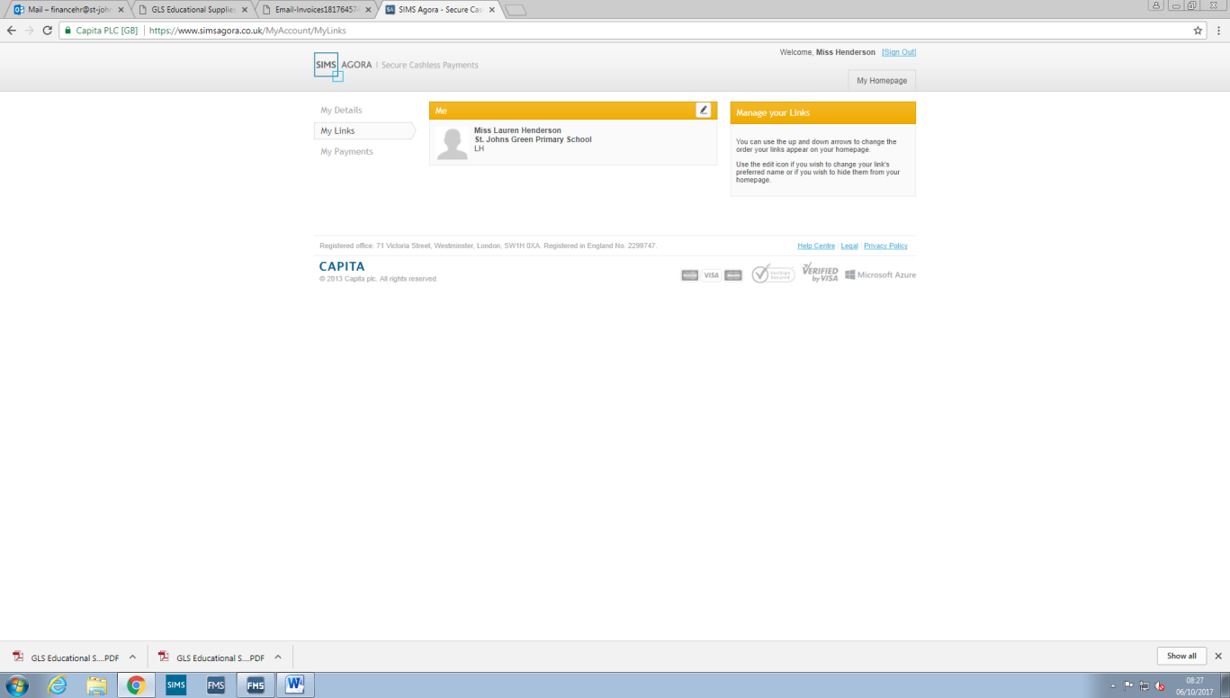

***My link on the acceptance email from Agora does not work.***

**This link only works once therefore, a new link will have to be generated. This can be done from either school office.**

***What do I do if I have brought the wrong thing?***

**For example… “I have paid for £2.00 to go in Breakfast Club but I was meant to pay £2.00 for School Meals”**

**This can be resolved but the school cannot move money from one product to another. A refund will have to be issued to the card used and then you will have to re-purchase the correct product.**

***I have lost my reference number!***

**If you have misplaced your reference number, a new one can be generated. This can be done from either school office.**

***My child reference has expired, what should I do?***

**You have 28 days to activate your account once your reference has been generated by the school. If the reference you have received from school does not work, please contact either school office. The reference number expiry date can also be extended to give you more time to register.**

***Why can I not log in?***

1. **From** [**https://www.simsagora.co.uk**](https://www.simsagora.co.uk)**, click the SIGN IN WITH YOUR MICROSOFT ACCOUNT button.**
2. **At the bottom of the SIGN IN page, click the CAN’T ACCESS YOUR ACCOUNT? Link to display the WHY CAN’T YOU SIGN IN? page.**
3. **Select the relevant radio button and follow the on-screen instructions.**

***Sims Agora for Parents user guide***

[***http://simspublications.com/546577/welcome.html***](http://simspublications.com/546577/welcome.html)