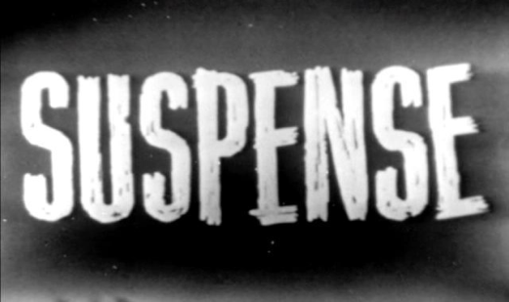

Purpose:
To make a piece of text scary or threatening

Structure:
- Characters start in a safe environment with other characters around.
- Setting becomes dark and threatening – character often alone in dark place.
- The threat often ends up being something that is not scary.

Language Features:
- Short sentences e.g. the sound stopped. John turned slowly.
- Use questions e.g. who was there? What did they want?
- Noise words – quiet environment except for scary noises
- Show the characters feelings, e.g., shaking with fear
- Movement in shadows
- Do not see what is ‘out there’ until the end.
- Scary words and images e.g. flickering lights, creeping, creaking, footsteps etc

Purpose:
To make a piece of text scary or threatening

Structure:
- Characters start in a safe environment with other characters around.
- Setting becomes dark and threatening – character often alone in dark place.
- The threat often ends up being something that is not scary.

Language Features:
- Short sentences e.g. the sound stopped. John turned slowly.
- Use questions e.g. who was there? What did they want?
- Noise words – quiet environment except for scary noises
- Show the characters feelings, e.g., shaking with fear
- Movement in shadows
- Do not see what is ‘out there’ until the end.
- Scary words and images e.g. flickering lights, creeping, creaking, footsteps etc

