WB 1st March 2021 Name _____________________
WALT measure using non-standard units

Collect a range of objects and measure their length using non-standard units.

Name of object | Non-standard unit of measure I am using e.g. cubes/paperclips.  ___________________________

My longest object is _________________________________

My shortest object is ________________________________

PS & R challenge

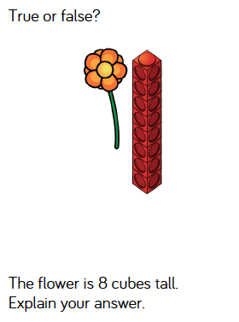

WB 1st March 2021 Name _____________________
WALT measure using non-standard units

Collect a range of objects and measure their length using non-standard units.

Name of object | Estimate | Non-standard unit of measure I am using e.g. cubes/paperclips/coins.  ___________________________

My longest object is _________________________________

My shortest object is ________________________________

PS & R challenge

