 | MUSIC Theme – Week 16 Years 4/5/6
 | Monday | Tuesday | Wednesday | Thursday | Friday
9-11 | WORD OF THE DAY  Introduce a new word, find out the meaning, use it in conversation, can you draw something to help you remember the word and / or how to spell it? Find out the origin, are there words which mean the same? Use it in written sentences.  Rhythm -combination of long and short sounds that convey meaning.  Look at the History of Music PowerPoint…introduce ‘Music’ as the week’s theme.  Writing  Choose an activity from the list. | WORD OF THE DAY  Introduce a new word, find out the meaning, can you draw something to help me remember the word and / or how to spell it? Can you use it in conversation, find out the origin, are there words which mean the same? Use it in written sentences.  Duration – length of sound  Reading  Complete 30 minutes of reading.  Writing  Choose an activity from the list. | WORD OF THE DAY  Introduce a new word, find out the meaning, can you draw something to help me remember the word and / or how to spell it? Can you use it in conversation, find out the origin, are there words which mean the same?  Pitch – how high or low a sound is.  Writing  Choose an activity from the list. | WORD OF THE DAY  Introduce a new word, find out the meaning, can you draw something to help me remember the word and / or how to spell it? Can you use it in conversation, find out the origin, are there words which mean the same? Use it in written sentences.  Tempo –the speed of the music  Reading  Complete 30 minutes of reading.  Writing  Choose an activity from the list. | WORD OF THE DAY  Introduce a new word, find out the meaning, can you draw something to help me remember the word and / or how to spell it? Can you use it in conversation, find out the origin, are there words which mean the same? Use it in written sentences.  Pulse- the underlying steady beat of music. This is what we may tap our foot or clap along with.  Writing  Choose an activity from the list.
 | Movement  The Body Coach – YouTube – find the current day | Movement  https://www.youtube.com/user/CosmicKidsYoga  Cosmic Yoga  (YouTube) | Movement  The Body Coach – YouTube - find the current day | Movement  Go outside for a walk. | Movement  The Body Coach – YouTube on the day
11-11.15 | Break | Break | Break | Break | Break
11.15-12.15 | Maths  White Rose (Home Learning Tab)  https://whiterosemaths.com/homelearning/ | Maths  Number gym  http://www.numbergym.co.uk/  Calculation activity linked to year group e.g. multiplication and division, addition and subtraction | Maths  White Rose (Home Learning Tab) https://whiterosemaths.com/homelearning/  Watch video and answer questions. | Maths  Number gym  http://www.numbergym.co.uk/  Table Trainer, Bond Builder | Maths  White Rose (Home Learning Tab) https://whiterosemaths.com/homelearning/  Watch video and answer questions.
12.15-1.15 | Lunch | Lunch | Lunch | Lunch | Lunch
1.15-2.50 | Theme Work  Choose an activity from the list. | Theme Work  Choose an activity from the list. | Theme Work  Choose an activity from the list. | Theme Work  Choose an activity from the list. | Theme Work  Choose an activity from the list.
2.50-3.15 | Reflecting Roxy 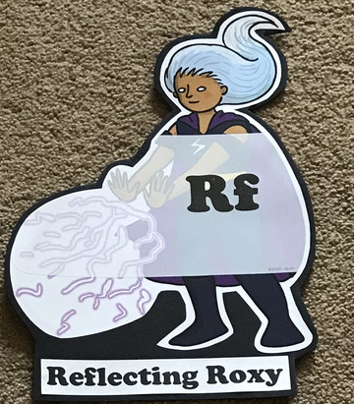  What have you learnt today and how could you have improved any of your work?  STORY TIME | Making Links Molly 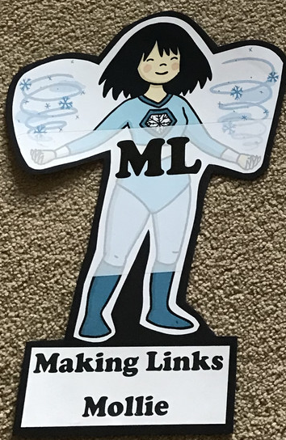  Can you use any learning that you have done today, in other parts of your life?  STORY TIME/ | Resilience Rex 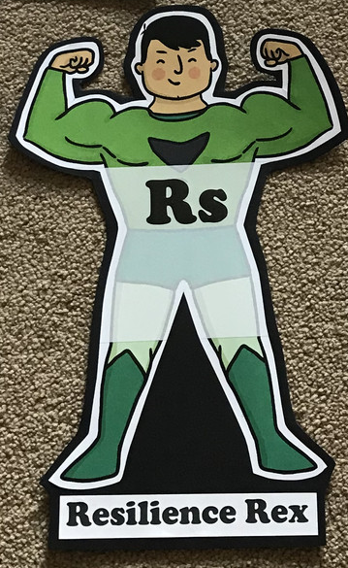  Have you found anything challenging today? How did you overcome the challenges?  STORY TIME/ | Collaborating Carlos 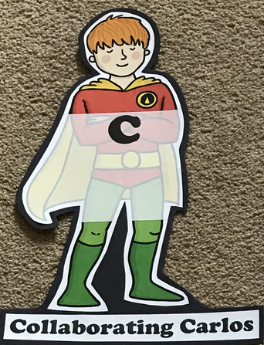  Did you work alone today or with someone else? How did that go?  STORY TIME/ | Motivating Melinda 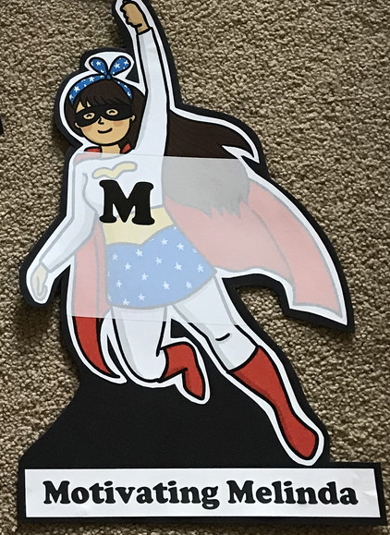  Have you encouraged someone else today? How did you motivate yourself today?  STORY TIME/

Writing *** These ideas will last for a few sessions.
Peter and the Wolf
https://www.literacyshed.com/the-music-shed.html

Prokofiev - Peter And The Wolf This is a very popular piece of classical music which I think has huge potential in Literacy. Developing character is not always easy for children but I think this video will really help children develop characters in their stories. Each character in the story of 'Peter and the Wolf' is described through music, not words. The carefully chosen instruments help us visualise movement and actions in the story.
- Find a large space, play the piece of music and ask children to move around in role. This should lead to writing a character description.
- Can you explain why certain instruments have been chosen to represent characters?
- Retell the story of 'Peter and the Wolf' in your own words.
- Find another piece of music with solo instruments that you think might help describe characters.
The Sorcerers Apprentice:
https://www.literacyshed.com/the-music-shed.html
Video Link: https://www.youtube.com/watch?v=T8gOh0wEgLg
Teaching ideas:
- Write a description of the character Mickey Mouse represents (The Apprentice)
- Write a poem based on the story using exciting vocabulary to show how the characters move and interact with each other.
- Retell the story.
- Create a comic strip based on 'The Sorcerers Apprentice'.
- Let children listen to a completely different piece of classical music, what story ideas can they come up with to accompany the music? Get the children to act out and explore their story before writing it.

Theme
- Complete the Listening to Music record sheet, listen to different pieces of music. Can you ask a family member which is their favourite era for music, and / or their favourite piece of music. Then listen to it and try to complete the sheets.
- Read a child’s story- a simple one. Can you add music to it? Think of using everyday objects (remember ‘STOMP’) and body percussion, voices etc.
- Can you draw out the music for the story? Use symbols and pictures to record the music. Can someone else follow it?
- Make a music instrument out of recycling materials… https://redtri.com/homemade-instruments/slide/4
- Listen to a piece of music and create a piece of art work (what does the music make you think of?).

