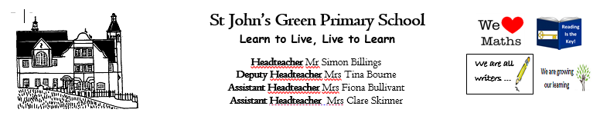

**Week 14 (W.B. 15/06/2020)**

**Theme: Blue Planet**

**Year 4/5/6**

**Theme**

* <https://www.bbc.co.uk/teach/class-clips-video/science-ks2-blue-planet-live/zd9y7nb> (This link takes you to lots of video clips and factual information)
* 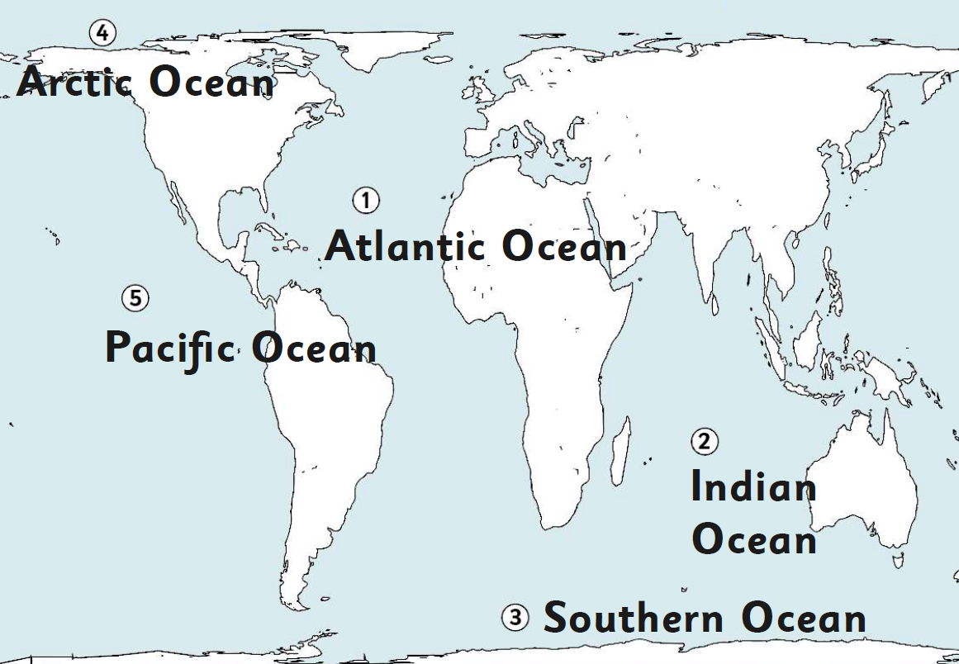Locate the oceans of the world. What other large areas of water are there? What facts can you find out about all of them?
* <https://www.natgeokids.com/uk/discover/geography/general-geography/ocean-facts/> Look at this website for facts about our oceans. Can you create a poster all about our oceans? Include as many facts as possible. Add diagrams, drawings and captions to add extra details. Think about WHO the poster is for (audience and purpose).
* Create a painting or piece of art of an underwater scene. Use water colours for the background and add the creatures and plant life with pastels or crayons for depth.

<https://www.youtube.com/watch?v=599Ctm4vxB0> HOW TO DRAW SEA CREATURES; have a go and try some of these!