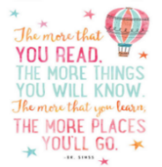
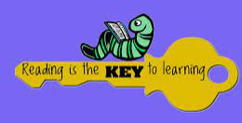
- CREATE A COMIC STRIP ABOUT YOUR FAVOURITE FICTION BOOK.  Completed: | 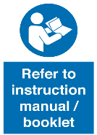  - READ INSTRUCTIONS OR A MANUAL AND WRITE DOWN THE PROCESS OR INFORMATION YOU HAVE LEARNED.  Completed: | 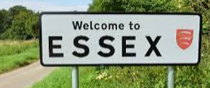  - READ SOMETHING CONNECTED TO COLCHESTER OR ESSEX AND WRITE A SUMMARY ABOUT IT.  Completed: | - READ ABOUT SOMEONE WHO HAS INSPIRED YOU, WRITE DOWN WHY THEY HAVE INSPIRED YOU.  Completed:
- READ A RECIPE, MAKE IT AND WRITE ABOUT THE TASTES AND TEXTURES OF THE FOOD.  Completed: | - READ A BOOK THAT ONE OF YOUR GRANDPARENTS/PARENTS/SIBLINGS LOVED AS A CHILD AND WRITE DOWN WHAT YOU THINK ABOUT THE BOOK.  Completed: | - READ A REVIEW OF YOUR FAVOURITE FILM OR SPORTING EVENT AND WRITE DOWN IF YOU AGREE WITH IT OR NOT.  Completed: | - BORROW ANY BOOK, OF ANY KIND FROM YOUR LOCAL LIBRARY AND READ IT. WRITE DOWN THE NAME OF YOUR BOOK AND ABOUT YOUR EXPERIENCE IN THE LIBRARY.  Completed:
- READ A BOOK ABOUT DIGNITY AND ANSWER QUESTIONS ABOUT IT.  Completed: | - READ A BOOK ABOUT EQUALITY AND ANSWER QUESTIONS ABOUT IT.  Completed: | - READ A BOOK ABOUT SAFETY AND ANSWER QUESTIONS ABOUT IT.  Completed: | - READ A BOOK ABOUT ENTERPRISE AND ANSWER QUESTIONS ABOUT IT.  Completed:
- READ A BOOK LINKED TO YOUR LEARNING THIS ASSESSMENT PERIOD AND ANSWER QUESTIONS ABOUT IT.  Completed: | - FIND SOME INTERESTING WORDS IN A BOOK YOU ARE READING AND FIND ITS SYNONYMS. SHOW YOUR FINDINGS TO AN ADULT.  Completed: | - READ A BOOK ABOUT A PLACE OR COUNTRY YOU WOULD LIKE OT VISIT, AND TELL AN ADULT ABOUT IT, AND WHY YOU WANT TO VISIT.  Completed: | - READ YOUR FAVOURITE POEM OR A FEW PAGES OF YOUR FAVOURITE BOOK TO YOUR CLASS AND TAKE QUESTIONS ON IT.  Completed:
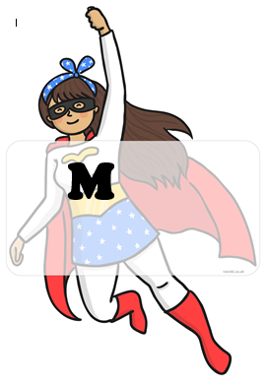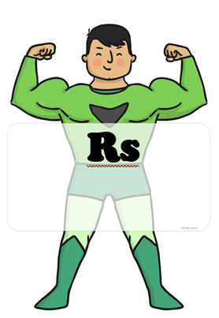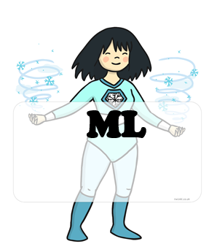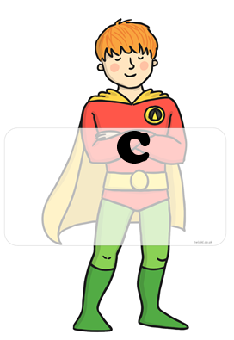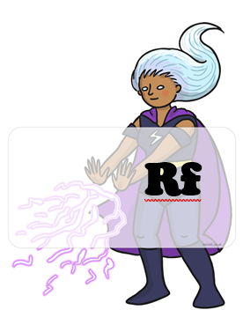 BLUE : home challenges YELLOW : school challenges

HOME CHALLENGES EVIDENCE
CHALLENGE 6:
CHALLENGE 5:
CHALLENGE 4:
CHALLENGE 3:
CHALLENGE 2:
CHALLENGE 1:
CHALLENGE 8:
CHALLENGE 7:

