 | Monday | Tuesday | Wednesday | Thursday | Friday
9-11 | WORD OF THE DAY;  Teamwork - the combined action of a group, especially when effective and efficient.  Daily timed lap of the field/given area  Reading  Unusual Olympic sports 60 second reading comprehension  PE  Choose a team game. Football, Rugby, Netball, basketball, cricket etc.  Maths  Parallel and perpendicular lines.  Parallel – two lines side by side, with the same distance between them consistently. Parallel lines will never meet  Perpendicular – two lines which meet at a 90 degree angle eg. The corner of a square.  How many parallel and perpendicular lines can you find in the flags of different countries? | WORD OF THE DAY;  Rules- in sports, rules define what is allowed or not allowed to occur during situations on and off the court.  Daily timed lap of the field/given area  Reading  Pick a book and answer some of the reading comprehension challenge cards about the text you have read  PE  Try one of the sports you have created. Do your rules work? Is it simple for others to play?  Maths  Design you own country flag with a criteria eg. 4 parallel lines and 2 perpendicular lines. Can you set a challenge for someone else? | WORD OF THE DAY;  Skill - the ability to do something well; expertise  Daily timed lap of the field/given area  Reading  Reading comprehension on Usain Bolt.  PE  Skills activities –  Dribble a basketball, shoot hoops, sprint relay, throwing and catching, passing  Maths  Maths Mystery – Missing Sports Day Trophy | WORD OF THE DAY;  Mindset – a set of attitudes someone holds  Daily timed lap of the field/given area  Reading  Growth Mindset reading activities  PE  Choose a different team game to play. Focus on your positive mind set. Does it change your gameplay? Do you feel more successful?  Maths  Year 2 – Roll a dice to create 2 digit numbers. Add two of them together using ‘Sticks and Stones’ (draw the tens and ones)  Year 3 – Roll a dice to create 3 digit numbers. Add two of them together using column addition. Remember to exchange if needed. | WORD OF THE DAY;  Achievement - a thing done successfully with effort, skill, or courage.  Daily timed lap of the field/given area  Reading  Read a book of your choice and discuss with someone else  PE  Mini Sports Day. Compete in different activities with a leaderboard. Use all your skills and positive mind set from the week.  Maths  Numbergym
11-11:15 | Break | Break | Break | Break | Break
11:15-12:15 | Writing  Choose a writing activity from the list | Writing  Choose a writing activity from the list | Writing  Choose a writing activity from the list | Writing  Choose a writing activity from the list | Writing  Choose a writing activity from the list
12:15-1:15 | Lunch | Lunch | Lunch | Lunch | Lunch
1:15-2:50 | Theme Work  Choose an activity from the list | Theme Work  Choose an activity from the list | Theme Work  Choose an activity from the list | Theme Work  Choose an activity from the list | Theme Work  Choose an activity from the list
2:50-3:15 | Reflecting Roxy 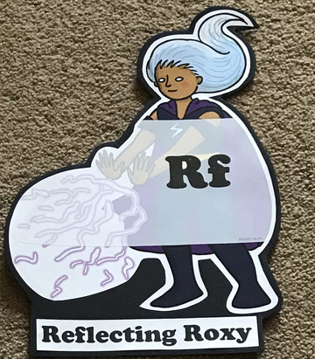  What have you learnt today and how could you have improved any of your work? | Making Links Molly 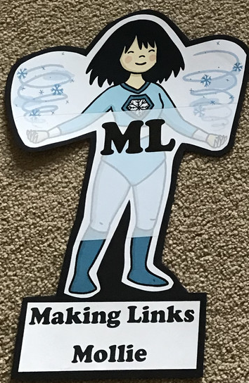  Can you use any learning that you have done today, in other parts of your life? | Resilience Rex 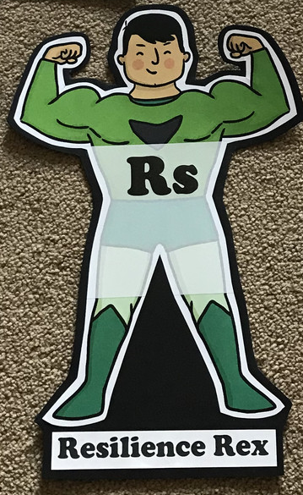  Have you found anything challenging today? How did you over come the challenges? | Collaborating Carlos 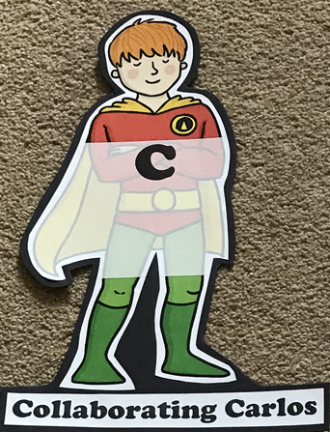  Did you work alone today or with someone else? How did that go? | Motivating Melinda 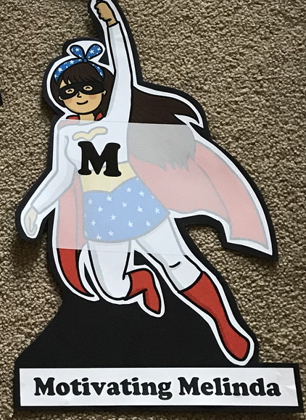  Have you encouraged someone else today? How did you motivate yourself today?

Writing

- ‘A day in the life of’ – Pick a sportsman/athlete you really admire. Write a diary entry as if you were them for a day. What would you do?
- Design your own sport and write the instructions/rules of play for it
- Write interview questions for your favourite sportsman. What would you ask them? You could even write a letter/email asking them the questions and send it to them.
- Write a biography for your favourite sportsman
- https://www.literacyshed.com/the-sports-shed.html# Watch the clip from the Mens 200m final with Usain Bolt up until 4 minutes. Write a short newspaper report on the event.
Theme
- Create an exercise plan and meal plan for a sportsman to keep them energised and healthy
- Read about the Ancient Greek Olympics and compare the sports involved then and now
- Design a sports kit for your new sport
- Run round a given area each day timing yourself. Can you improve your time?
- Keep a daily exercise log
- Redesign the Olympic logo for 2021
- Plan your own Olympic opening ceremony. Watch the highlights of the London 2012 olympics for inspiration. Can be a series of drawings, description or a comic strip

