Monday | Tuesday | Wednesday | Thursday | Friday
WORD OF THE DAY; Introduce a new word, find out the meaning, use it in conversation, can you draw something to help you remember the word and / or how to spell it? Find out the origin, are there words which mean the same? Use it in written sentences.  Reading  Read and then write a summary of what you read; showing comprehension skills. Younger readers can read or share a text with someone. Can they write or draw what they read about? | WORD OF THE DAY; Introduce a new word, find out the meaning, can you draw something to help me remember the word and / or how to spell it? Can you use it in conversation, find out the origin, are there words which mean the same? Use it in written sentences.  Pobble 365  http://www.pobble365.com/  Choose one of the images and write a descriptive paragraph about it. | WORD OF THE DAY  Introduce a new word, find out the meaning, can you draw something to help me remember the word and / or how to spell it? Can you use it in conversation, find out the origin, are there words which mean the same? Use  Reading  Read and then write a summary of what you read; showing comprehension skills. Younger readers can read or share a text with someone. Can they write or draw what they read about? | WORD OF THE DAY; Introduce a new word, find out the meaning, can you draw something to help me remember the word and / or how to spell it? Can you use it in conversation, find out the origin, are there words which mean the same? Use it in written sentences.  POBBLE 365  http://www.pobble365.com/  Use of one of the images and write a story about it. | WORD OF THE DAY; Introduce a new word, find out the meaning, can you draw something to help me remember the word and / or how to spell it? Can you use it in conversation, find out the origin, are there words which mean the same? Use it in written sentences.  Reading  Read and then write a summary of what you read; showing comprehension skills. Younger readers can read or share a text with someone. Can they write or draw what they read about?
Movement  The Body Coach  https://www.youtube.com/watch?v=d3LPrhI0v-w  https://www.thebodycoach.com/blog/pe-with-joe-1254.html | Movement  https://www.youtube.com/user/CosmicKidsYoga  Cosmic Yoga  (YouTube) | Movement  Go for a walk/play outside. | Movement  The Body Coach  https://www.youtube.com/watch?v=d3LPrhI0v-w  https://www.thebodycoach.com/blog/pe-with-joe-1254.html | Movement  Cosmic Yoga  (YouTube)  https://www.youtube.com/user/CosmicKidsYoga
Maths  Number gym  http://www.numbergym.co.uk/ | Maths  Purple Mash  https://www.purplemash.com/login/ | Maths  Number gym  http://www.numbergym.co.uk/ | Maths  Purple Mash  https://www.purplemash.com/login/ | Maths  Number gym  http://www.numbergym.co.uk/
Theme Work  See website for the week’s theme and ideas | Theme Work  See website for the week’s theme and ideas | Theme Work  See website for the week’s theme and ideas | Theme Work  See website for the week’s theme and ideas | Theme Work  See website for the week’s theme and ideas
Reflecting Roxy 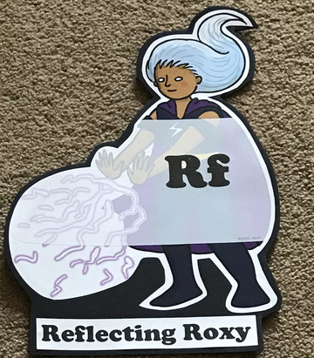  What have you learnt today and how could you havwe improved any of your work? | Making Links Molly 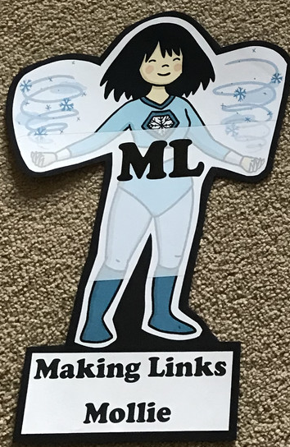  Can you use any learning that you have done today, in other parts of your life? | Resilience Rex 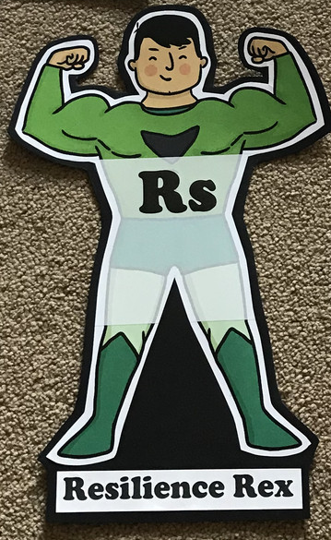  Have you found anything challenging today? How did you over come the challenges? | Collaborating Carlos 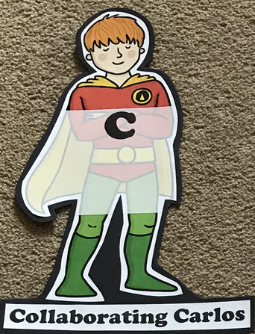  Did you work alone today or with someone else? How did that go? | Motivating Melinda 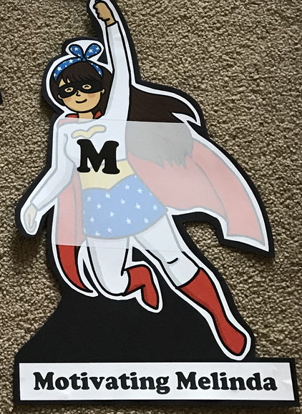  Have you encouraged someone else today? How did you motivate yourself today?

