 | Monday | Tuesday | Wednesday | Thursday | Friday
9-11 | WORD OF THE DAY;  PRODUCER/PREDATOR/ PREY  Reading  Birds in the garden comprehension (yr 2)  Jane Goodall comprehension (yr 3/4)  PE  Joe Wicks  Maths  Animal shapes – what shapes can you see? How many sides/ vertices does the shape have? NEED to MAKE  Number gym  Purple Mash activity | WORD OF THE DAY;  HERBIVORE/CARNIVORE/ OMNIVORE  Reading  Deadly animals comprehension  PE  Cosmic Yoga – Lulu the baby lioness  https://www.youtube.com/watch?v=ZvJH8Kbzj54  Maths  Arithmetic questions  Number gym  Purple Mash activity | WORD OF THE DAY;  MAMMAL – an animal that breathes air, has a backbone and grows hair at some point of its life. A mammal gives birth to live young.  Reading  Read the tale of two feathers book and discuss  PE  Create a dance – based on animals  https://www.youtube.com/watch?v=k2RPKMJmSp0&t=50s  See ppt for ideas  Maths  Animal word problem sheet  NEED to MAKE  Number gym  Purple Mash activity | WORD OF THE DAY;  PRIMATE – They are a group of mammals and tend to be the more intelligent animal in the animal kingdom. They are human beings, apes and monkeys.  Reading  Tigers Comprehension (yr 2)  David Attenborough (yr3/4)  PE  Game of basketball/ football/ kick cricket/ rounders etc  Maths  Mystery feather (year 2)  Mystery zoo (Year 3 & 4)  Number gym  Purple Mash activity | WORD OF THE DAY;  HABITAT – the natural home or environment of a plant, animal or other organism.  Reading  Read a book that involves an animal  PE  Joe Wicks  Maths  Animal block diagram Make questions  Number gym  Purple Mash activity
11-11:15 | Break | Break | Break | Break | Break
11:15-12:15 | Writing  Choose a writing activity from the list | Writing  Choose a writing activity from the list | Writing  Choose a writing activity from the list | Writing  Choose a writing activity from the list | Writing  Choose a writing activity from the list
12:15-1:15 | Lunch | Lunch | Lunch | Lunch | Lunch
1:15-2:50 | Theme Work  Choose an activity from the list | Theme Work  Choose an activity from the list | Theme Work  Choose an activity from the list | Theme Work  Choose an activity from the list | Theme Work  Choose an activity from the list
2:50-3:15 | Reflecting Roxy 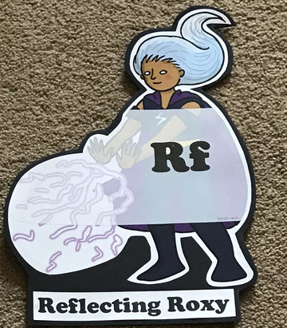  What have you learnt today and how could you havwe improved any of your work? | Making Links Molly 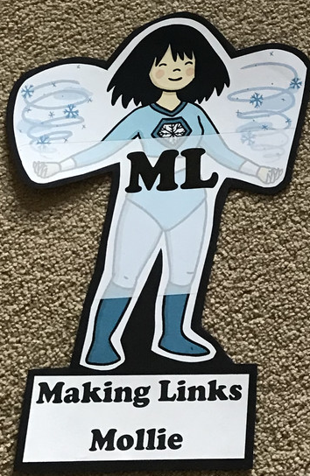  Can you use any learning that you have done today, in other parts of your life? | Resilience Rex 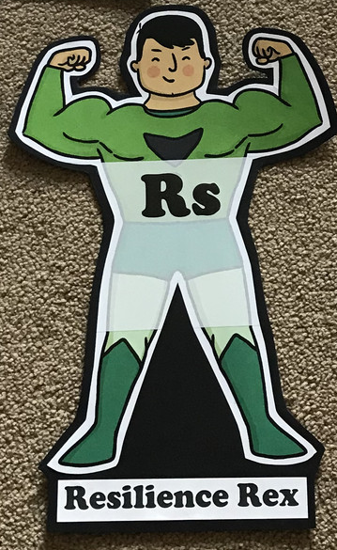  Have you found anything challenging today? How did you over come the challenges? | Collaborating Carlos 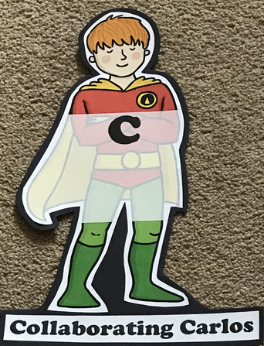  Did you work alone today or with someone else? How did that go? | Motivating Melinda 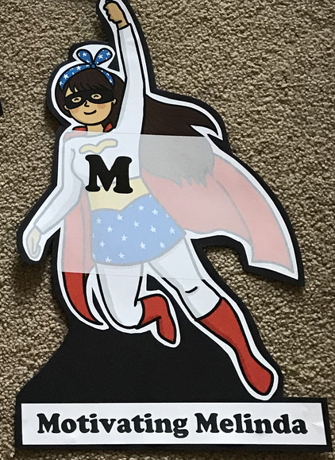  Have you encouraged someone else today? How did you motivate yourself today?

Writing

- Create instruction on how to take care of an animal/ pet.
- Create a fact file on an animal.
- Choose a habitat and describe it. Think about what it is made of and who might live there.
- Create your own animal.
- Create your own zoo and then send an invitation to someone to visit.
- Write a diary entry as if you were a zookeeper or animal.
- Create a persuasive poster persuading someone to visit your zoo.
- Create a brochure for your zoo
- Choose an animal you would like to be and explain why you would choose to be that animal.

Theme

- Complete the omnivore, herbivore and carnivore sorting activity.
- Create a collage of your chosen animal – use a variety of resources you can find including recycled items or things you find outside.
- Design a zoo – which animals would you have? Why? Think about space/enclosures for the animals, paths, places to eat/drink.
- Look at various food chains and play the games! https://www.bbc.co.uk/bitesize/topics/zbnnb9q
- Look at how animals are adapted to their environment http://www.primaryhomeworkhelp.co.uk/adaptation.htm
- Watch Madagascar, Rio, Zootropolis, We Bought A Zoo, The Jungle Book
- Complete the food chains sheet
- Research Steve Backshall – who was he?
- Categorise animals into sets sheet
- Research what adaptation means and how animals have adapted http://www.primaryhomeworkhelp.co.uk/adaptation.htm
- Top trumps cards
- Make animals out of shapes

