Create a family theme tune!
https://www.youtube.com/watch?v=_yjkkNtshNo
Add instruments using items of recycling (tins, plastic tubs, elastic bands)
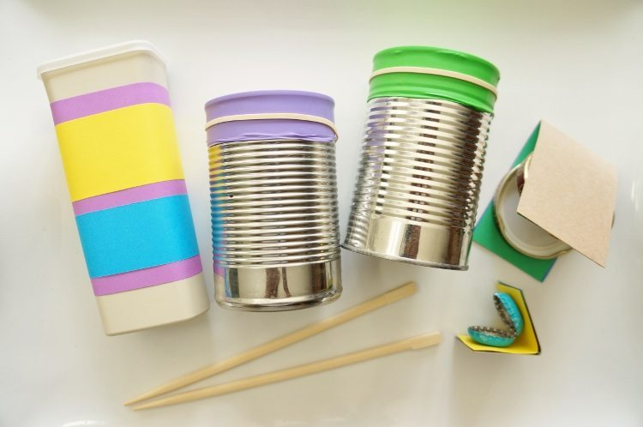
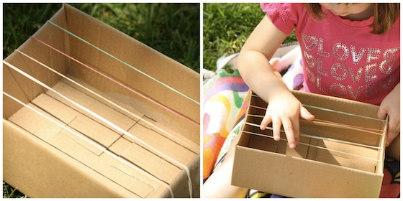

Create a family print using a body part
