Name: Date:
Renewable Energy – resource management
Read the text below carefully then use what you’ve learned to answer to the questions.

Our planet Earth only has a finite amount of certain resources such as coal, otherwise known as a fossil fuel. As the population gets larger year by year, it means we have to be more careful about how we make use of these resources.  The switch needs to be made to more renewable sources of energy like wind or solar power. In order to make sure | 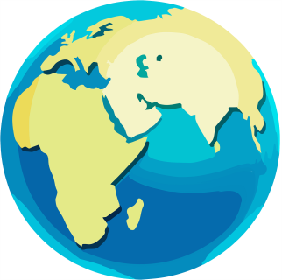
we have enough energy sources to match the growing population’s needs. Switching to renewable sources of energy is important, because it would help protect the environment from the damage these finite sources of energy cause.
What is the best description of a finite resource?
- A resource that doesn’t renew itself over time and will run out.
- A resource that we’ll never run out of.
- A resource that we’ve never had enough of.
What is an example of a finite resource?
- Food
- Water
- Coal
What is an example of a renewable energy source?
- Oil
- Solar power
- Fossil fuels
Why is it important to switch to more renewable sources of energy?
- Because it would save money.
- Because it would help to save the environment.
- Because we have no more coal.

Wind, solar and water power
Read the text below carefully. You may be asked to quote from it to answer some of the questions.
Wind turbines
For windmills to be effective it needs to be windy. This is why they’re placed in places that have a history of windy weather. When the blades are turned by the wind this generates power. The electricity is then distributed to homes and businesses. Wind turbines can be noisy! So you probably wouldn’t want to have one near your house. This is the main argument against the installation of wind turbines. Another reason some people dislike them is because they can look out of place in a natural landscape. Some are not designed to look appealing.
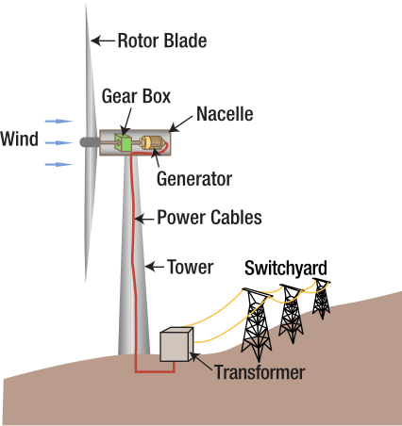
Solar panels
Solar panels are a way that homes can generate their own electricity. As light from the suns hits the panels it is converted into useable electricity. Any electricity not used in that house is distributed to others.
Solar panels can be costly to install so some people argue that they are not a viable energy source because of this. After the cost of installation however, the electricity is free and it makes solar power one of the most cost effective ways of producing electricity, long term.
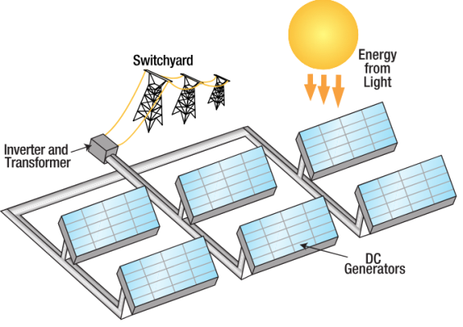
Hydroelectricity
Water can also generate electricity. The force of moving water (kinetic energy) is converted into electricity. It works in much the same way as a wind turbine, however it uses water to spin the turbine instead of wind.
Until it is needed, the water is held back behind a dam. This method of electricity production may cause damage to water based ecosystems. For example, the migration patterns of certain species of fish could be disturbed. Droughts can also pose a problem. If there is no water, then no power can be generated.
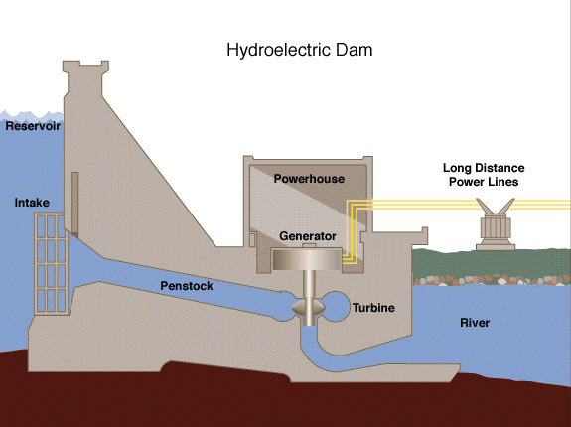
Why might you not want a wind turbine near your home? Use evidence from the text to support your answer.

Why do some people dislike solar panels?
- They don’t generate enough electricity
- They can be costly to install
- They’re not sustainable
What is a downside of hydroelectric electricity production?
- It could disrupt a water based ecosystem
- It’s too noisy
- There’s not enough water for it to work
Which is overall the cheapest source of electricity?
- Wind turbines
- Hydroelectricity
- Solar Power
Teaching notes

These comprehension activities can be used as an introduction to work on renewable energy.
Learning objective
Human and physical geography
- Describe and understand key aspects of:
  - human geography, including: the distribution of natural resources including energy, food, minerals and water.
Answers
Renewable Energy – resource management
  - A resource that doesn’t renew itself over time and will run out.
  - Coal
  - Solar power
  - Because it would help to save the environment
Wind, solar and water power
- (Sample answer) Wind turbines might not look very nice, ‘some are not designed to look appealing’. It might spoil the view.
- It could disrupt a water based ecosystem
- They can be costly
- Solar power

