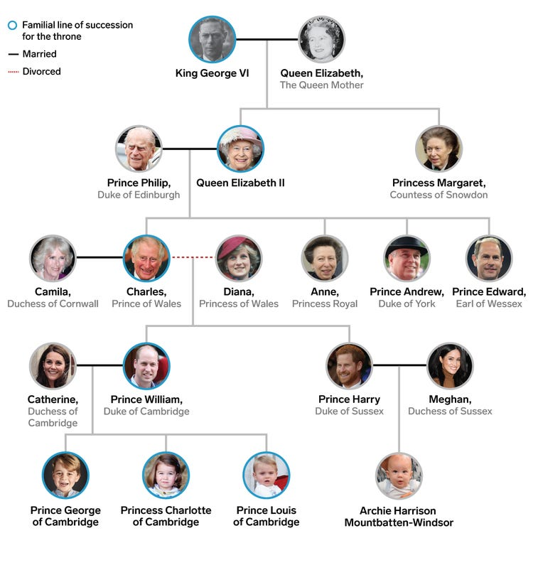**The Royal Family: A Family Tree**