 | Monday | Tuesday | Wednesday | Thursday | Friday
9-9.30 | Movement  The Body Coach – Youtube on the day | Movement  https://www.youtube.com/user/CosmicKidsYoga | Movement  BBC Move it Dance Programme  https://www.bbc.co.uk/programmes/b03g64pk/episodes/player | Movement  Go outside for a walk. | Movement  The Body Coach – Youtube on the day
9.30-10 | Phonics | Phonics | Phonics | Phonics | Phonics
10-10.30 | Reading  Read through a twinkl story  Can they write or draw what they read about? Can they answer questions about the text?  https://www.twinkl.co.uk/resource/hide-a-saurus-ebook-t-or-1336 | Reading  Younger readers can read or share a text with someone. Can they write or draw what they read about? Can they answer questions about the text?  https://www.oxfordowl.co.uk/for-home/find-a-book/library-page/  username- SJGreading  password- SJGreading | Reading  Read through a twinkl story  Can they write or draw what they read about? Can they answer questions about the text?  https://www.twinkl.co.uk/resource/t-or-738-a-magical-muddle-ebook | Reading  Younger readers can read or share a text with someone. Can they write or draw what they read about? Can they answer questions about the text?  https://www.oxfordowl.co.uk/for-home/find-a-book/library-page/  username- SJGreading  password- SJGreading | Reading  Read through a twinkl story  Can they write or draw what they read about? Can they answer questions about the text?  https://www.twinkl.co.uk/resource/stop-telling-fibs-ebook-t-or-1373
 | Word of the day  Character | Word of the day  Genre | Word of the day  Fiction | Word of the day  Non-fiction | Word of the day  Author
11-11.15 | Break | Break | Break | Break | Break
11.15-12.15 | Maths  Number gym  http://www.numbergym.co.uk/  Appropriate calculation activity linked to year group e.g. add and subtract  See EYFS and Year 1 daily sheet. | Maths  Purple Mash  https://www.purplemash.com/login/  Shape focus – recap names of shapes. Creating your own Colour Monster shape picture.  See EYFS and Year 1 daily sheet. | Maths  Number gym  http://www.numbergym.co.uk/  Appropriate calculation activity linked to year group. EYFS/Yr1 looking at number bonds/numbers to 10  See EYFS and Year 1 daily sheet. | Maths  Purple Mash  https://www.purplemash.com/login/  See EYFS and Year 1 daily sheet. | Maths  Number gym  http://www.numbergym.co.uk/  Calculation focus – addition and subtraction  See EYFS and Year 1 daily sheet.
12.15-1.15 | Lunch | Lunch | Lunch | Lunch | Lunch
1.15-2.50 | Theme Work  See daily plan | Theme Work  See daily plan | Theme Work  See daily plan | Theme Work  See daily plan | Theme Work  See daily plan
2.50-3.15 | Reflecting Roxy 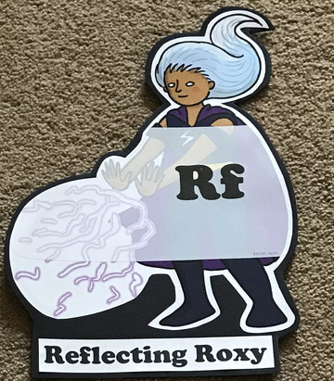  What have you learnt today and how could you have improved any of your work?  STORY TIME | Making Links Molly 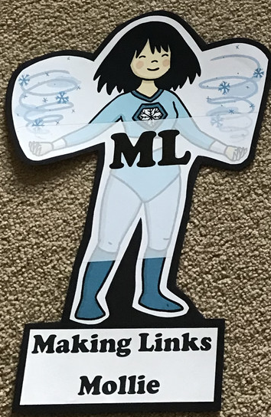  Can you use any learning that you have done today, in other parts of your life?  STORY TIME | Resilience Rex 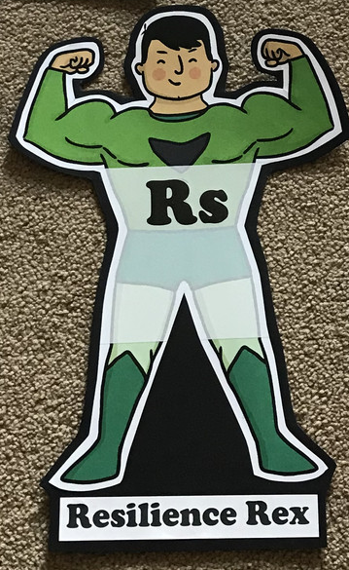  Have you found anything challenging today? How did you overcome the challenges?  STORY TIME | Collaborating Carlos 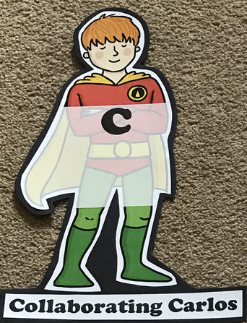  Did you work alone today or with someone else? How did that go?  STORY TIME | Motivating Melinda 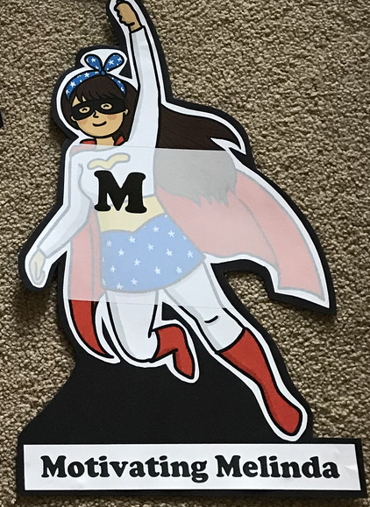  Have you encouraged someone else today? How did you motivate yourself today?  STORY TIME

Monday
Phonics
EYFS
Words to practise
Phil
Alien words
Phom
Raph

Tricky words
Be
You
All
Are

Phonics
Sound of day-
Ph
Photograph a dolphin

Challenge
Can you write some sentences with these words in?

Year 1
Tricky words
People
Oh
Their

Words to practise
Boil
Avoid
Toilet

Challenge
Can you write some sentences with these words in?
Phonics
Sound of day-
oi
dig the soil

Maths: measurement
Comparing lengths and heights (EYFS)
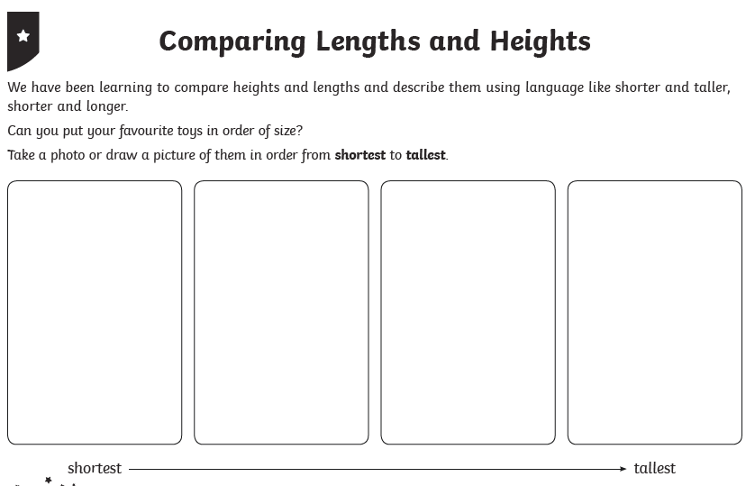
Year 1
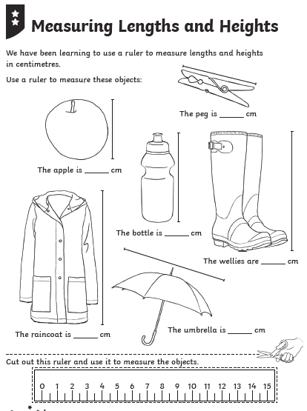

Tuesday
Phonics
EYFS
Tricky words
He
She
We
Words to practise

Down
Frown
Clown

Phonics
Sound of day-
Ow
Down into town
Challenge
Can you write some sentences with these words in?

Year 1
Phonics
Sound of day-
Wh
Wagon wheel
Tricky words
Mr
Mrs
Looked

Words to practise
Wheel
White
Whisk

Challenge
Can you write some sentences with these words in?

Maths: Measurement
Using scales, weigh the difference between two object.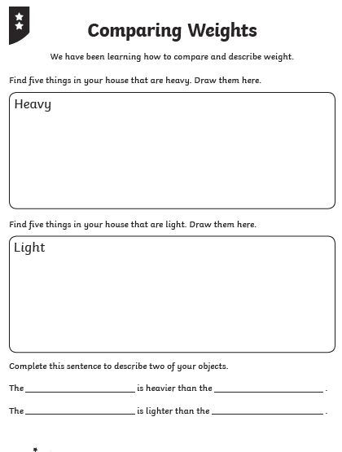
Wednesday
Phonics
EYFS
Tricky words
Her
Was
They
My

Words to practise
Surf
Burp
Hurt
Phonics
Sound of day-
Ur
Nurse with a purse
Challenge
Can you write some sentences with these words in?

Year 1
Phonics
Sound of day-
Ue
To the rescue
Tricky words
Could
Asked
Their
Words to practise
Argue
Blue
Statue

Challenge
Can you write some sentences with these words in?

Maths: Measurement
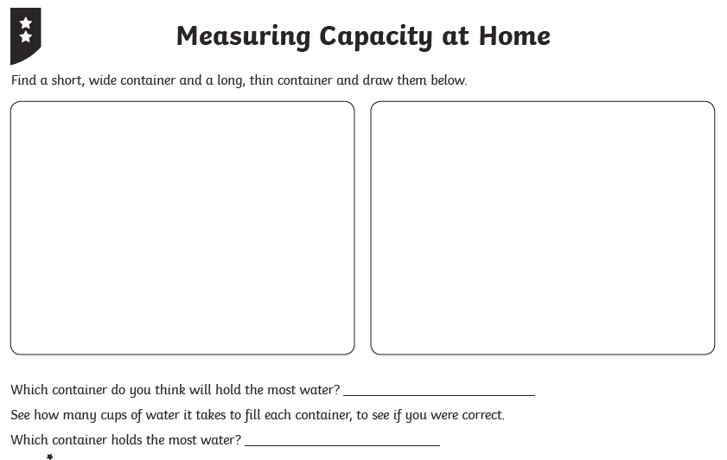
Thursday
Phonics
EYFS
Tricky words
All
Are
Me
My
Words to practise
Horn
Pork
Corn
Challenge
Can you write some sentences with these words in?

Phonics
Or
Shut the door

Year 1
Tricky words
Called
Looked
Mrs
Words to practise
Straw
Launch
Audit
Challenge
Can you write some sentences with these words in?
Phonics
Aw
Yawn at dawn

Maths: Make a Teddy Bear Passport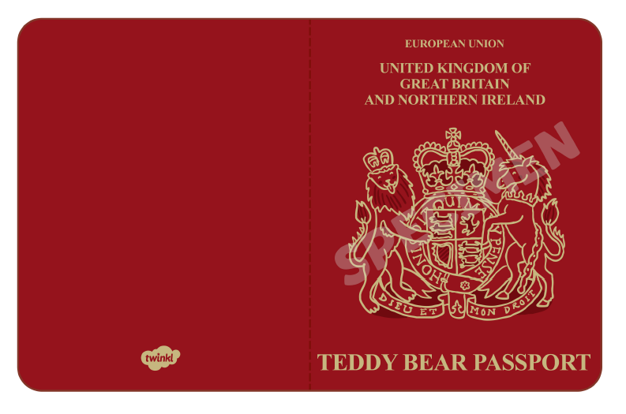
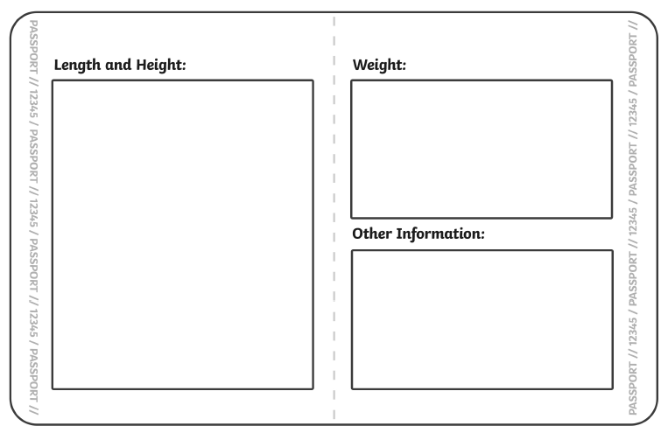
Friday
Phonics: Phonics play
https://new.phonicsplay.co.uk/resources

Maths: Top marks- Measurement
https://www.topmarks.co.uk/early-years/lets-compare
https://www.topmarks.co.uk/maths-games/measuring-in-cm

