 | Wellbeing Theme – Week 6 27.04.20
 | Monday | Tuesday | Wednesday | Thursday | Friday
9-11 | WORD OF THE DAY  Introduce a new word, find out the meaning, use it in conversation, can you draw something to help you remember the word and / or how to spell it? Find out the origin, are there words which mean the same? Use it in written sentences.  FIXED MINDSET  Reading  Complete Reading Comprehension  Writing  Choose an activity from the list. | WORD OF THE DAY  Introduce a new word, find out the meaning, can you draw something to help me remember the word and / or how to spell it? Can you use it in conversation, find out the origin, are there words which mean the same? Use it in written sentences.  GROWTH MINDSET  Reading  Complete 30 minutes of reading.  Writing  Choose an activity from the list. | WORD OF THE DAY  Introduce a new word, find out the meaning, can you draw something to help me remember the word and / or how to spell it? Can you use it in conversation, find out the origin, are there words which mean the same?  CONTENTMENT  Reading  Choose a reading activity from the list based on what you read yesterday.  Writing  Choose an activity from the list. | WORD OF THE DAY  Introduce a new word, find out the meaning, can you draw something to help me remember the word and / or how to spell it? Can you use it in conversation, find out the origin, are there words which mean the same? Use it in written sentences.  HEALTHY  Reading  Complete 30 minutes of reading.  Writing  Choose an activity from the list. | WORD OF THE DAY  Introduce a new word, find out the meaning, can you draw something to help me remember the word and / or how to spell it? Can you use it in conversation, find out the origin, are there words which mean the same? Use it in written sentences.  WELFARE  Reading  Choose a reading activity from the list based on what you read yesterday.  Writing  Choose an activity from the list.
 | Movement  The Body Coach – Youtube – find the current day | Movement  https://www.youtube.com/user/CosmicKidsYoga  Cosmic Yoga  (YouTube) | Movement  The Body Coach – Youtube - find the current day | Movement  Go outside for a walk. | Movement  The Body Coach – Youtube on the day
11-11.15 | Break | Break | Break | Break | Break
11.15-12.15 | Maths  White Rose (Home Learning Tab)  https://whiterosemaths.com/homelearning/  Watch video and answer questions. | Maths  Number gym  http://www.numbergym.co.uk/  Calculation activity linked to year group e.g. multiplication and division, addition and subtraction | Maths  White Rose (Home Learning Tab) https://whiterosemaths.com/homelearning/  Watch video and answer questions. | Maths  Number gym  http://www.numbergym.co.uk/  Table Trainer, Bond Builder | Maths  White Rose (Home Learning Tab) https://whiterosemaths.com/homelearning/  Watch video and answer questions.
12.15-1.15 | Lunch | Lunch | Lunch | Lunch | Lunch
1.15-2.50 | Theme Work  Choose an activity from the list. | Theme Work  Choose an activity from the list. | Theme Work  Choose an activity from the list. | Theme Work  Choose an activity from the list. | Theme Work  Choose an activity from the list.
2.50-3.15 | Reflecting Roxy 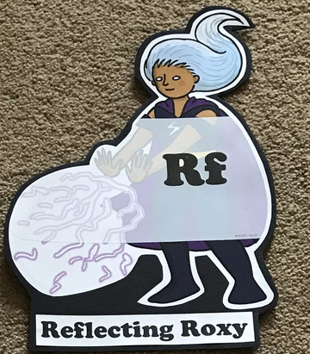  What have you learnt today and how could you have improved any of your work?  STORY TIME/  Well being calendar | Making Links Molly 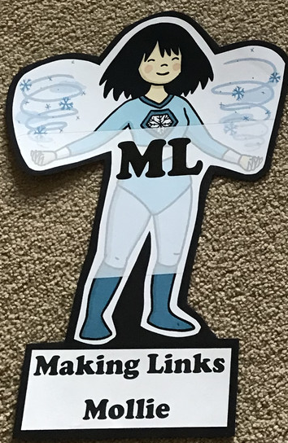  Can you use any learning that you have done today, in other parts of your life?  STORY TIME/  Well being calendar | Resilience Rex 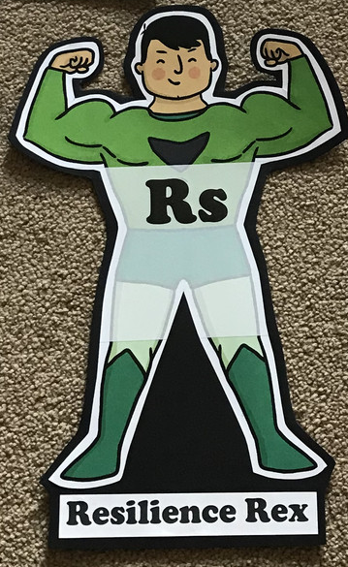  Have you found anything challenging today? How did you overcome the challenges?  STORY TIME/  Well being calendar | Collaborating Carlos 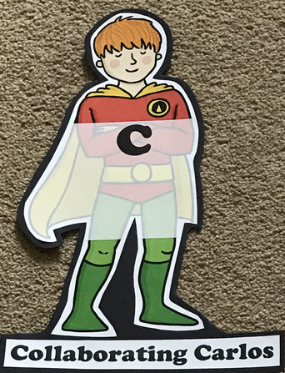  Did you work alone today or with someone else? How did that go?  STORY TIME/  Well being calendar | Motivating Melinda 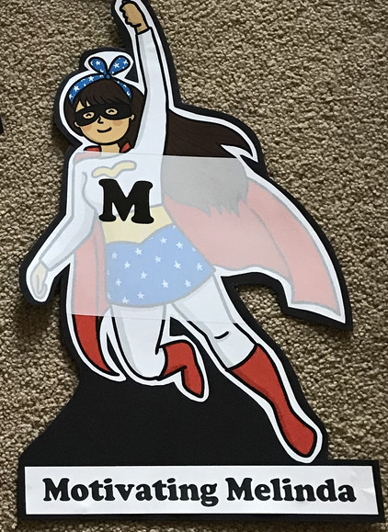  Have you encouraged someone else today? How did you motivate yourself today?  STORY TIME/  Well being calendar

Writing
- POBBLE 365 http://www.pobble365.com/ Choose one of the images and write a descriptive paragraph about it.
- Use a thesaurus to find synonyms for emotions discussed in the Colour Monster. Can you use these new words in sentences?
- Write a story or diary entry based on the Colour Monster
- Write gratitude cards to celebrate the people and things you are thankful for
- Write a letter to a family member or friend you are missing or thanking Key workers for their efforts
- Write a letter of thanks/draw a picture for a Key worker or inspirational person (e.g. Joe Wicks)
- Design a peaceful reflection area for home or school

Theme
- Listen to the story of The Colour Monster https://www.youtube.com/watch?v=Ih0iu80u04Y. Write down the emotions mentioned. When do you feel these emotions? How does your body feel? What do you do when you feel these? How can you combat the more negative emotions? Sort into positive and negative emotions. Can you add any more of your own?
- Create your own colour monster! Choose colours that might represent them (e.g. frustration, disgust, envy). You could use the template provided, draw your own or even make it out of playdough
- Go for a walk and collect some rocks/ large pebbles. Decorate it with a positive message. When you go for a walk again, leave the rock in a special place for someone to find. Whilst on the walk, have a look around for things that make you happy and fill a discovery jar with interesting and beautiful things.
- Make a list of colours and find translations for them in other languages e.g. French, Spanish, German
- Create a hug to send to a family member or friend they are missing
- Complete wellbeing journal every day
- Create a Wordle (you will need Internet Explorer) for words relating to wellbeing. Hint: The more times you type a word, the larger it will appear in your finished Wordle! Click randomise to change the position and colour. You could print it too! (SEE EXAMPLE BELOW)

