Challenge – can you use a spelling word/WOTD and parenthesis?
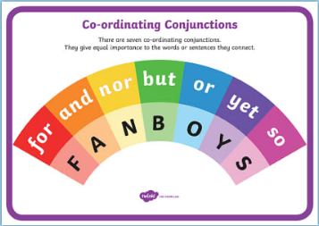
Write 2 sentences in role as Anne Frank with co-ordinating conjunctions

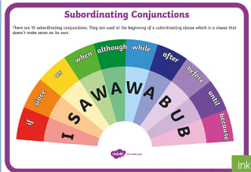
Write 2 sentences in role as Anne Frank with subordinating conjunctions

