Uploading Work to Teams
Using Assignments on a PC or laptop.
Your teacher can set assignments for you to complete. You will see the assignments tab at the top of the page, and also down the left hand side of the page. Click on either of these and you will see the work that has been set for you.
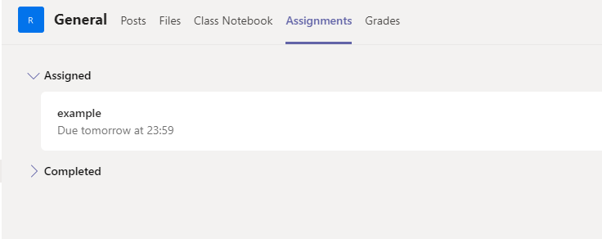
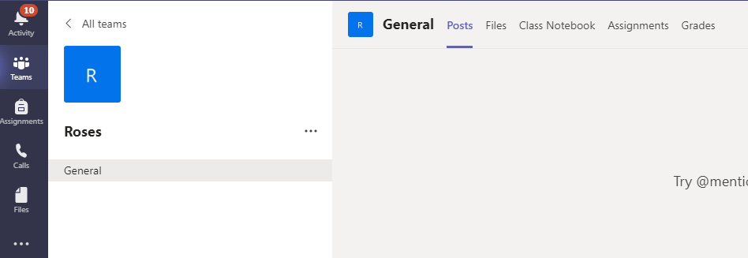

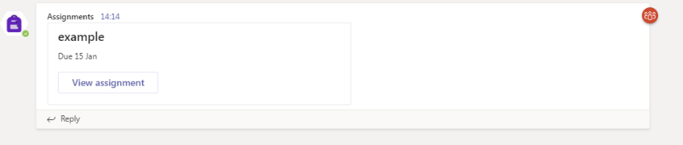
Work set will also show in the team feed
like this.

Click on the Assignment to find out what your teacher wants you to do. Once you are ready to start the work, you first need to create a new document. To do this click Add Work, then the New File button. Then choose whether you want to use Word, PowerPoint or Excel.

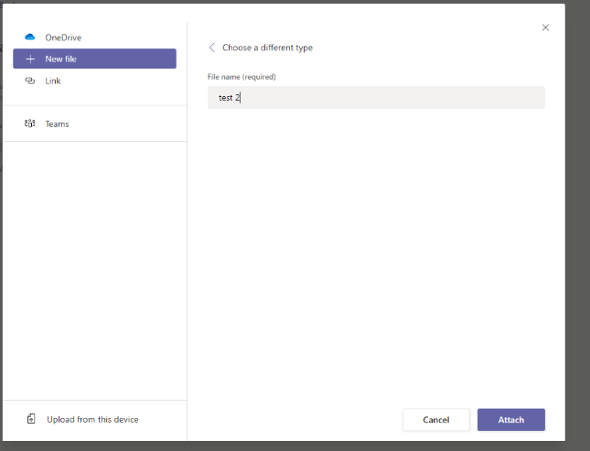
Give your work a name then click the Attach button.
This will attach your blank document to the page.
Once you have done this, click on your document. It will
open and you can start typing. There will be a Close
button at the top of the page and your work will save
automatically when you click on this so you don’t have to finish it
in one go.

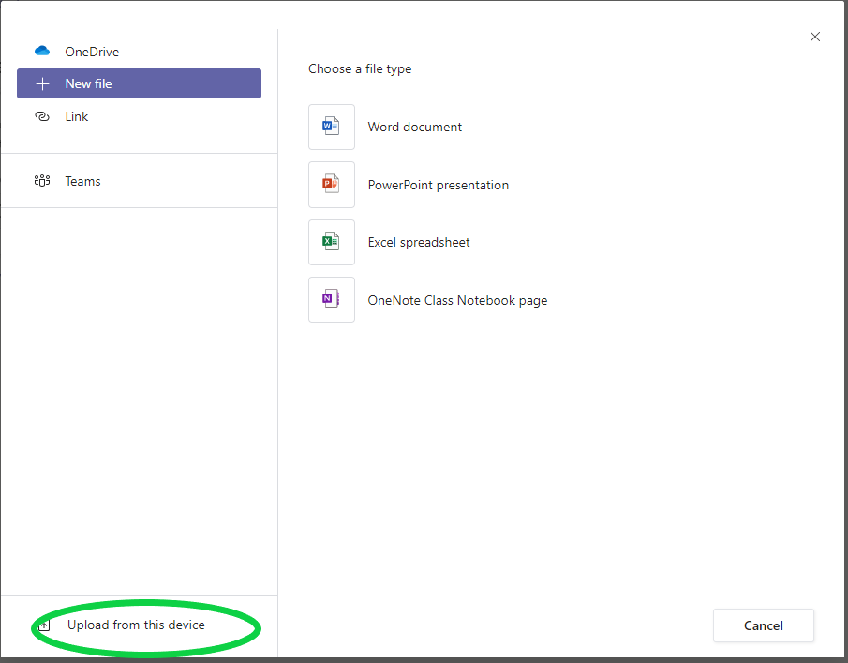
You can also upload work such as photos or files
you have saved on your device. To do this, instead of clicking
‘New File’, click on ‘Upload from this device’. You can then
choose a picture or other file you have saved.

When you are finished, you need to hand your work in. There is a purple ‘hand in’ button top right of the Assignments screen. Click this and your teacher will be able to look at your work and mark it. Only your teacher and you can see your work and any feedback.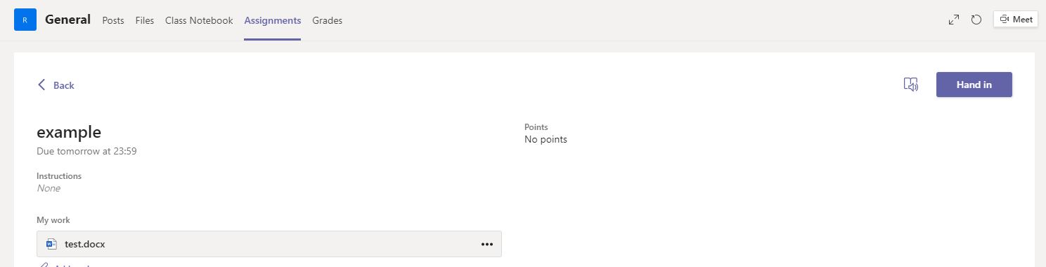
You will get a notification in your activity feed when the teacher has marked you work or set you another assignment. Or you can go into the Assignments tab again and check. Click on your file to open it and see the feedback from your teacher.

Uploading work from a phone or tablet.
If you are using Teams on a mobile phone or tablet, you can follow the instructions above and use Word, PowerPoint or Excel in the same way. However, if you have some work you have written on paper that you need to upload, you can take a photo of it with your phone or tablet and upload it.
