 | Discovery Theme – Week 8 11.05.2020
 | Monday | Tuesday | Wednesday | Thursday | Friday
9-11 | WORD OF THE DAY; Introduce a new word, find out the meaning, use it in conversation, can you draw something to help you remember the word and / or how to spell it? Find out the origin, are there words which mean the same? Use it in written sentences.  Discovery - The act of detecting something new, or something previously unrecognized as meaningful.  Reading  Complete reading comprehension.  Writing  Choose from the list. | WORD OF THE DAY; Introduce a new word, find out the meaning, can you draw something to help me remember the word and / or how to spell it? Can you use it in conversation, find out the origin, are there words which mean the same? Use it in written sentences.  Locate – Discover the exact place or position of.  Reading  Complete 30 minutes of reading.  Writing  Choose from the list. | WORD OF THE DAY  Introduce a new word, find out the meaning, can you draw something to help me remember the word and / or how to spell it? Can you use it in conversation, find out the origin, are there words which mean the same? Use it in written sentences.  Identify - Establish or indicate who or what (someone or something) is.  Reading  Choose a reading activity from the list based on what you read yesterday.  Writing  Choose from the list. | WORD OF THE DAY;  Introduce a new word, find out the meaning, can you draw something to help me remember the word and / or how to spell it? Can you use it in conversation, find out the origin, are there words which mean the same? Use it in written sentences.  Describe - Give a detailed account in words of something or someone.  Reading  Complete 30 minutes of reading.  Writing  Choose from the list. | WORD OF THE DAY;  Introduce a new word, find out the meaning, can you draw something to help me remember the word and / or how to spell it? Can you use it in conversation, find out the origin, are there words which mean the same? Use it in written sentences.  Compare - To examine (two or more objects, ideas, people, etc.) in order to note similarities and differences.  Reading  Choose a reading activity from the list based on what you read yesterday.  Writing  Choose from the list.
 | Movement  The Body Coach – YouTube – find the current day | Movement  https://www.youtube.com/user/CosmicKidsYoga  Cosmic Yoga  (YouTube) | Movement  The Body Coach – YouTube - find the current day | Movement  Go outside for a walk. | Movement  The Body Coach – YouTube on the day
11-11.15 | Break | Break | Break | Break | Break
11.15-12.15 | Maths  White Rose Maths (Home Learning Tab) Watch video and download related questions.  https://whiterosemaths.com/homelearning/ | Maths  Number gym  http://www.numbergym.co.uk/  Appropriate calculation activity linked to year group e.g. multiplication and division 2/3/4/5/6. | Maths  White Rose Maths (Home Learning Tab) Watch video and download related questions.  https://whiterosemaths.com/homelearning/ | Maths  Number gym  http://www.numbergym.co.uk/  Appropriate calculation activity linked to year group e.g. multiplication and division 2/3/4/5/6. | Maths  White Rose Maths (Home Learning Tab) Watch video and download related questions.  https://whiterosemaths.com/homelearning/
12.15-1.15 | Lunch | Lunch | Lunch | Lunch | Lunch
1.15-2.50 | Theme Work  Choose from the list. | Theme Work  Choose from the list. | Theme Work  Choose from the list. | Theme Work  Choose from the list. | Theme Work  Choose from the list.
2.50-3.15 | Reflecting Roxy 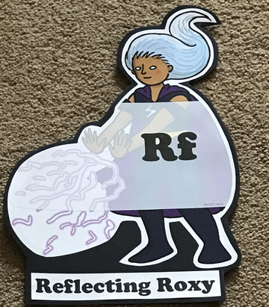  What have you learnt today and how could you have improved any of your work?  STORY TIME | Making Links Molly 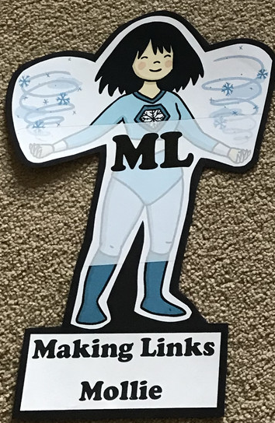  Can you use any learning that you have done today, in other parts of your life?  STORY TIME | Resilience Rex 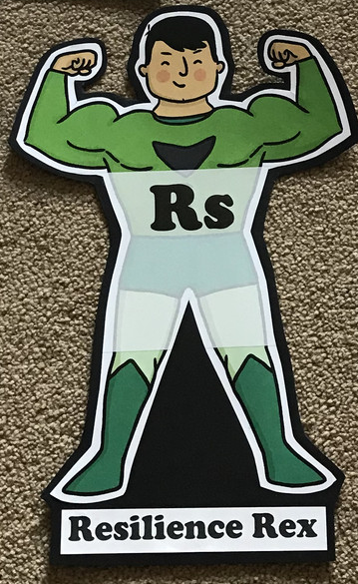  Have you found anything challenging today? How did you overcome the challenges?  STORY TIME | Collaborating Carlos 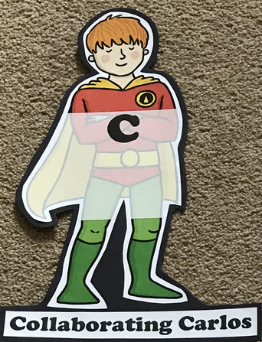  Did you work alone today or with someone else? How did that go?  STORY TIME | Motivating Melinda 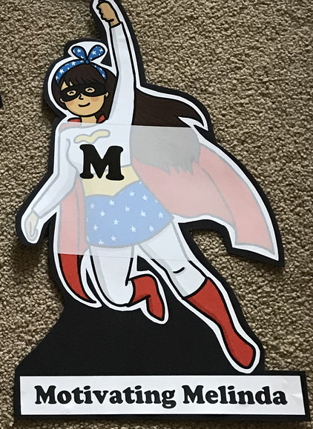  Have you encouraged someone else today? How did you motivate yourself today?  STORY TIME

Writing
- Research and make a fact file on the seven wonders of the world.
- Research one of the famous landmarks and write a postcard about visiting there.
- Research a famous inventor and write them a letter with any questions you would like to ask them. (Alexander Graham Bell has been given as an example)
- Watch https://www.bbc.co.uk/teach/class-clips-video/science-ks2-scientists-and-scientific-method/z43mbdm. Choose one discoverer to write a poem about.
- Read information about these discoverers https://www.dkfindout.com/uk/science/famous-scientists/ Create a quiz for your family (write by hand or use Purple Mash)
Theme Work
- Watch David Attenborough programmes (available on BBC iPlayer)
- Mapping the 7 Wonders of the World (Resource available)
- Use silhouettes to create a landscape of landmarks.
- Discover a job that someone needs help around the house with and create/design and invention that does this.
- Discovery Walks - https://home.oxfordowl.co.uk/blog/discovery-walks-fun-outdoor-learning-ideas/#
- Complete the quizzes https://www.britannica.com/quiz/exploration-and-discovery

