 | Monday | Tuesday | Wednesday | Thursday | Friday
9-9.30 | Movement  The Body Coach – Youtube on the day | Movement  https://www.youtube.com/user/CosmicKidsYoga | Movement  BBC Move it Dance Programme  https://www.bbc.co.uk/programmes/b03g64pk/episodes/player | Movement  Go outside for a walk. | Movement  The Body Coach – Youtube on the day
9.30-10 | Phonics | Phonics | Phonics | Phonics | Phonics
10-10.30 | Reading  Younger readers can read or share a text with someone. Can they write or draw what they read about? Can they answer questions about the text?  https://www.oxfordowl.co.uk/for-home/find-a-book/library-page/  username- SJGreading  password- SJGreading | Reading  Younger readers can read or share a text with someone. Can they write or draw what they read about? Can they answer questions about the text?  https://www.oxfordowl.co.uk/for-home/find-a-book/library-page/  username- SJGreading  password- SJGreading | Reading  Younger readers can read or share a text with someone. Can they write or draw what they read about? Can they answer questions about the text?  https://www.oxfordowl.co.uk/for-home/find-a-book/library-page/  username- SJGreading  password- SJGreading | Reading  Younger readers can read or share a text with someone. Can they write or draw what they read about? Can they answer questions about the text?  https://www.oxfordowl.co.uk/for-home/find-a-book/library-page/  username- SJGreading  password- SJGreading | Reading  Younger readers can read or share a text with someone. Can they write or draw what they read about? Can they answer questions about the text?  https://www.oxfordowl.co.uk/for-home/find-a-book/library-page/  username- SJGreading  password- SJGreading
 | Word of the day  Noise | Word of the day  Music | Word of the day  Lyrics | Word of the day  Beat | Word of the day  Volume
11-11.15 | Break | Break | Break | Break | Break
11.15-12.15 | Maths  Number gym  http://www.numbergym.co.uk/  Appropriate calculation activity linked to year group e.g. add and subtract  See EYFS and Year 1 daily sheet. | Maths  Purple Mash  https://www.purplemash.com/login/  Shape focus – recap names of shapes. Creating your own Colour Monster shape picture.  See EYFS and Year 1 daily sheet. | Maths  Number gym  http://www.numbergym.co.uk/  Appropriate calculation activity linked to year group. EYFS/Yr1 looking at number bonds/numbers to 10  See EYFS and Year 1 daily sheet. | Maths  Purple Mash  https://www.purplemash.com/login/  See EYFS and Year 1 daily sheet. | Maths  Number gym  http://www.numbergym.co.uk/  Calculation focus – addition and subtraction  See EYFS and Year 1 daily sheet.
12.15-1.15 | Lunch | Lunch | Lunch | Lunch | Lunch
1.15-2.50 | Theme Work  See daily plan | Theme Work  See daily plan | Theme Work  See daily plan | Theme Work  See daily plan | Theme Work  See daily plan
2.50-3.15 | Reflecting Roxy 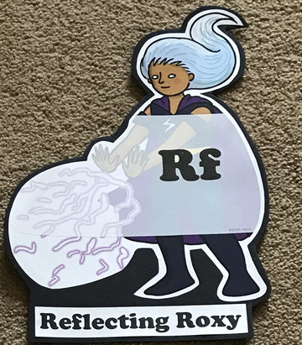  What have you learnt today and how could you have improved any of your work?  STORY TIME | Making Links Molly 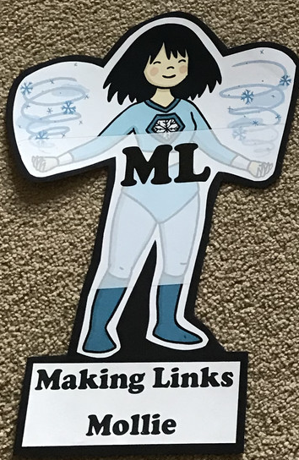  Can you use any learning that you have done today, in other parts of your life?  STORY TIME | Resilience Rex 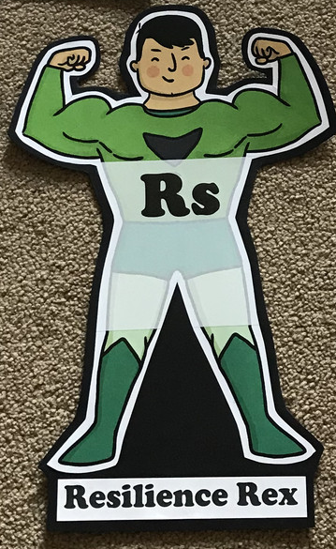  Have you found anything challenging today? How did you overcome the challenges?  STORY TIME | Collaborating Carlos 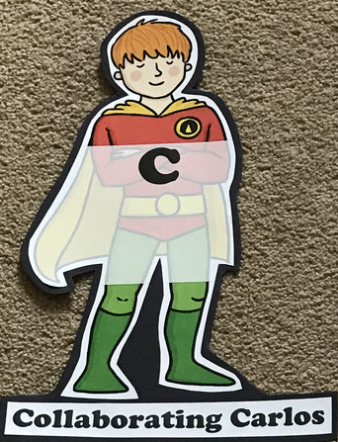  Did you work alone today or with someone else? How did that go?  STORY TIME | Motivating Melinda 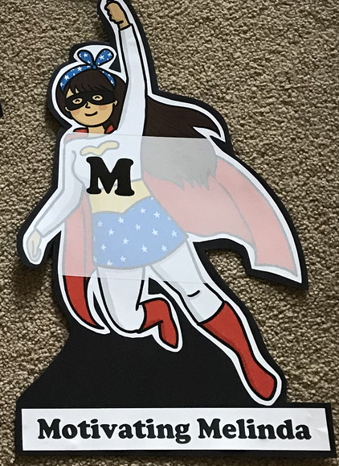  Have you encouraged someone else today? How did you motivate yourself today?  STORY TIME

Monday
Phonics
EYFS
Tricky words
They
My
You
Words to practise
Chick
Church
Chop
Challenge
Can you write some sentences with these words in?
Phonics
Sound of day-
Ch
Ch ch ch chicken

Year 1
Tricky words
Oh
Mrs
People
Words to practise
Play
Midday
Array
Challenge
Can you write some sentences with these words in?
Phonics
Sound of day-
Ay
May I play?

Maths
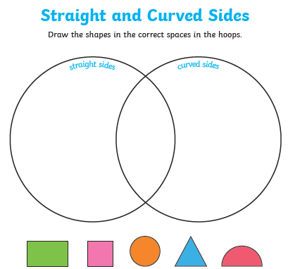

Tuesday
Phonics
EYFS
Tricky words
He
She
We
Words to practise

Zebra
Zip
Zigzag

Phonics
Sound of day-
z/zz
zzzz…zip
Challenge
Can you write some sentences with these words in?

Year 1
Phonics
Sound of day-
Ou
Shout it out
Words to practise
Shout
About
Round

Tricky words
Their
Called
Mr

Challenge
Can you write some sentences with these words in?

Maths
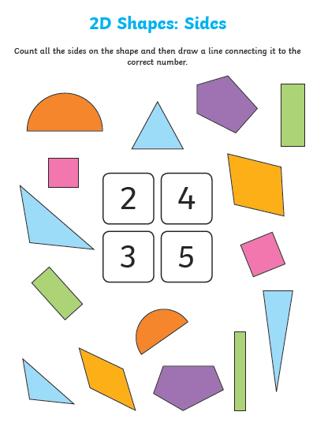

Wednesday
Phonics
EYFS
Words to practise
Yack
Yam
Yet
Tricky words
My
They
All
Phonics
Sound of day-
Y
Y_Y_Y yack
Challenge
Can you write some sentences with these words in?

Year 1
Phonics
Sound of day-
ie
terrible tie

Words to practise
Flies
Tries
Pie
Tricky words
Looked
Asked
Could
Challenge
Can you write some sentences with these words in?

Maths EYFS
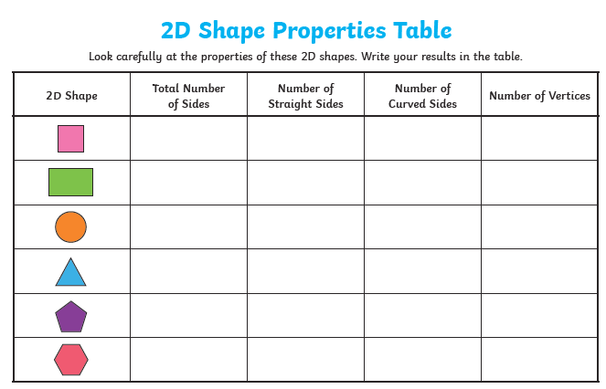

Year 1
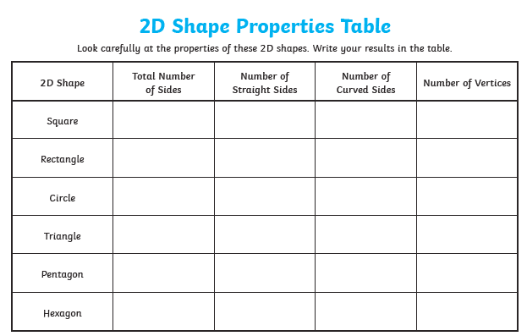

Thursday
Phonics
EYFS
Tricky words
Was
Her
Are
Words to practise
Box
Fox
Exercise

Challenge
Can you write some sentences with these words in?

Phonics
X
X_X_X exercise

Year 1
Words to practise
Tea
Beak
Dream

Tricky words
Called
People
Could
Challenge
Can you write some sentences with these words in?
Phonics
Sound of day-
ea
Cup of tea

Maths
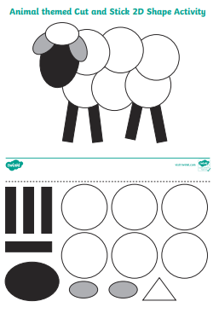
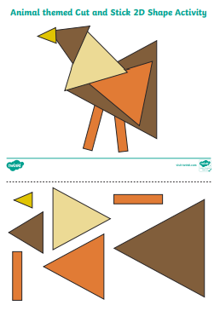
Friday
Phonics: Phonics play
https://new.phonicsplay.co.uk/resources

Maths: Top marks- ordering and sequencing shapes games
https://www.topmarks.co.uk/ordering-and-sequencing/shape-patterns

