 | What’s in a Book? Theme – Week 13 Years 4/5/6 22.6.20
 | Monday | Tuesday | Wednesday | Thursday | Friday
9-11 | WORD OF THE DAY  Introduce a new word, find out the meaning, use it in conversation, can you draw something to help you remember the word and / or how to spell it? Find out the origin, are there words which mean the same? Use it in written sentences.  Literature -most generically, is anybody or collection of written works  Reading  Complete a reading comprehension from the pack  Writing  Choose an activity from the list. | WORD OF THE DAY  Introduce a new word, find out the meaning, can you draw something to help me remember the word and / or how to spell it? Can you use it in conversation, find out the origin, are there words which mean the same? Use it in written sentences.  Interpret - to decide what the intended meaning of something is  Reading  Complete 30 minutes of reading.  Writing  Choose an activity from the list. | WORD OF THE DAY  Introduce a new word, find out the meaning, can you draw something to help me remember the word and / or how to spell it? Can you use it in conversation, find out the origin, are there words which mean the same?  Publish - to make information available to  people, especially in a book, magazine, or newspaper, or to produce and sell a book, magazine, or newspaper  Reading  Choose another reading comprehension from the pack.  Writing  Choose an activity from the list. | WORD OF THE DAY  Introduce a new word, find out the meaning, can you draw something to help me remember the word and / or how to spell it? Can you use it in conversation, find out the origin, are there words which mean the same? Use it in written sentences.  Edit - to make changes to a text or film, deciding what will be removed and what will be kept in, in order to prepare it for being printed or shown  Reading  Complete 30 minutes of reading.  Writing  Choose an activity from the list. | WORD OF THE DAY  Introduce a new word, find out the meaning, can you draw something to help me remember the word and / or how to spell it? Can you use it in conversation, find out the origin, are there words which mean the same? Use it in written sentences.  Language -to make changes to a text or film, deciding what will be removed and what will be kept in, in order to prepare it for being printed or shown  Reading  Choose another reading comprehension from the pack.  Writing  Choose an activity from the list.
 | Movement  The Body Coach – YouTube – find the current day | Movement  https://www.youtube.com/user/CosmicKidsYoga  Cosmic Yoga  (YouTube) | Movement  The Body Coach – YouTube - find the current day | Movement  Go outside for a walk. | Movement  The Body Coach – YouTube on the day
11-11.15 | Break | Break | Break | Break | Break
11.15-12.15 | Maths  White Rose (Home Learning Tab)  https://whiterosemaths.com/homelearning/  Watch video and answer questions. | Maths  Number gym  http://www.numbergym.co.uk/  Calculation activity linked to year group e.g. multiplication and division, addition and subtraction | Maths  White Rose (Home Learning Tab) https://whiterosemaths.com/homelearning/  Watch video and answer questions. | Maths  Number gym  http://www.numbergym.co.uk/  Table Trainer, Bond Builder | Maths  White Rose (Home Learning Tab) https://whiterosemaths.com/homelearning/  Watch video and answer questions.
12.15-1.15 | Lunch | Lunch | Lunch | Lunch | Lunch
1.15-2.50 | Theme Work  Choose an activity from the list. | Theme Work  Choose an activity from the list. | Theme Work  Choose an activity from the list. | Theme Work  Choose an activity from the list. | Theme Work  Choose an activity from the list.
2.50-3.15 | Reflecting Roxy 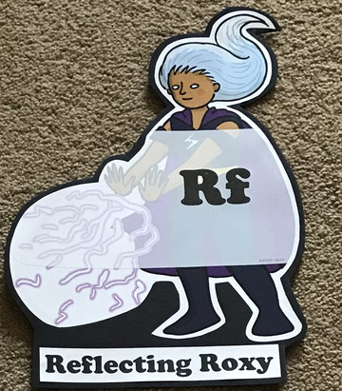  What have you learnt today and how could you have improved any of your work?  STORY TIME | Making Links Molly 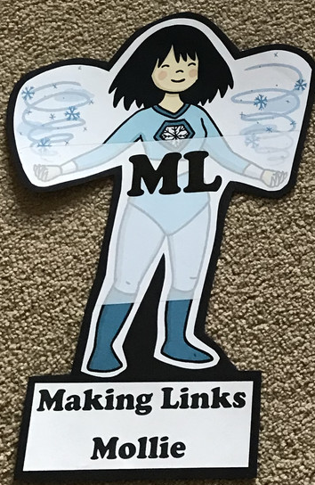  Can you use any learning that you have done today, in other parts of your life?  STORY TIME | Resilience Rex 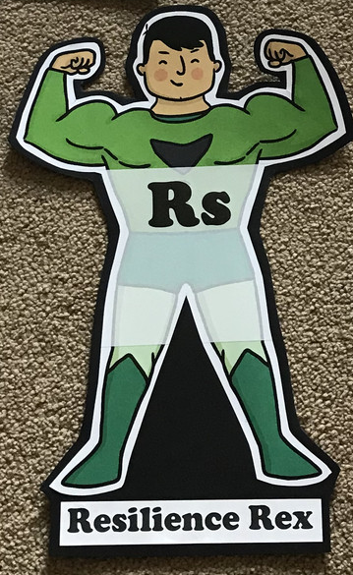  Have you found anything challenging today? How did you overcome the challenges?  STORY TIME | Collaborating Carlos 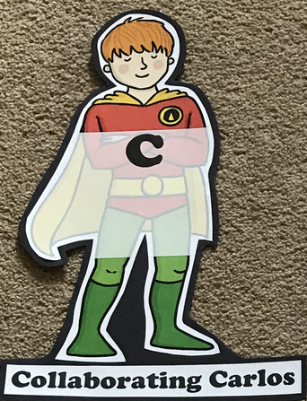  Did you work alone today or with someone else? How did that go?  STORY TIME | Motivating Melinda 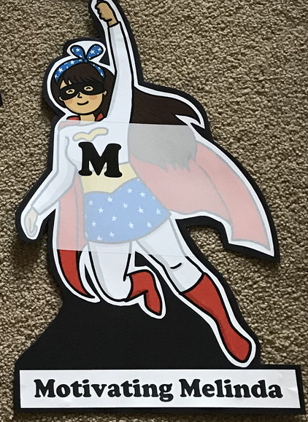  Have you encouraged someone else today? How did you motivate yourself today?  STORY TIME

Writing

- Choose a book to read; at or slightly above your reading ability…When you come across a new and unfamiliar word, roll a dice 3 times and complete the corresponding activities to help you understand and be able to use it for yourself:
1 – Write a synonym for your word
2 – Write an antonym for your word
3 – Illustrate your word
4 – Use the word in a sentence of your own
5 – Act out your word to a friend (or your Mu, Dad, pet…)
6 – Create an alliteration containing your word and 2 others

The Hobbit - an unexpected Journey https://www.literacyshed.com/the-myths-and-legends-shed.html
The opening scenes when Bilbo meets Gandalf for the first time.
Writing tasks
- Rewrite sections of the dialogue punctuating correctly.
- Use of adverbs to describe the characters actions.
- Write in the role of Bilbo either as a diary or a letter expressing his outrage as to what has been requested of him by Gandalf.

- Write about what a character might be thinking or feeling at different stages of a story. You could write it in the first person, or in a speech bubble.

- Choose a key moment in a book/your favourite book and change the event. Write that new event into a high quality paragprah. Can you add an illustration?

- Create a cartoon strip of main events from a story of your choice/a well known story.
- List the words and phrases used to create an atmosphere, such as ‘scary’, ‘deep in the misty, silent forest’ (of course you could change this to ‘List the words and phrase that were used to create humour, excitement, mystery etc.).’ Now try to use some of these words and phrase in a paragraph of your own.
- Write a fact file or biography about your favourite author.
- Write a news article about an important event from a favourite book.
- Explain why you think a particular book will or will not be read 100 years from now. Support your opinion by stating specific events in the story.

Theme
- Create your own Mr Man/Little Miss
- Alternate ending – create a story map of a favourite story then give it an alternate ending
- Put yourself into the story – what would you do to change/alter the course of events?
- Use music to tell a story and to create a scene/characters within the book
- Draw your favourite character from a story and describe them
- Draw/collage/build the scene from your favourite book and describe it
- Put on a play acting out your favourite book
- Make props for the play/for character role play
- Jumble up a story! Take a good character from one story (Ben [Gangsta Granny]), the bad character from another story (Mr Twit) and a setting from another (Hogwarts). What happens when they meet? What could they do?
- Character profile of your favourite character
- Teacher’s choice book focus
- Write a letter as one character in a story to another
- Create a beast (Beast Quest) for Tom to battle - act it out thinking about how the beast would move, describe the beast, create and describe a habitat for the beast and write a story detailing their meeting
- If you had to choose 3 best friends who are characters from a story, who would you choose and why?
- Write a list of interview questions for a character. Extend to write answers in the style of the character
- Design a library/cosy reading area where you could lose yourself in a book. What would you include and why?
- Use Purplemash 2animate to animate a scene from a story
- You can invite 2 authors and their characters to dinner – who would you invite and why? Write their invitation
- Pretend you are a talk show host and interview a character or author .
- Create a book jacket, including illustrations, an enticing synopsis, author bio, and favourable reviews.
- Give a dramatic reading of a scene in the book of your choice (rehearse, say it aloud etc. before performing to an audience).
- Design a poster or new book cover depicting the climax of a well-known or chosen story.

