 | Creativity Theme – Week 11 Years 4/5/6 8.6.20
 | Monday | Tuesday | Wednesday | Thursday | Friday
9-11 | WORD OF THE DAY  Introduce a new word, find out the meaning, use it in conversation, can you draw something to help you remember the word and / or how to spell it? Find out the origin, are there words which mean the same? Use it in written sentences.  Creativity - Creativity is a phenomenon whereby something new and somehow valuable is formed. The created item may be intangible (such as an idea, a scientific theory, a musical composition, or a joke) or a physical object (such as an invention, a printed literary work, or a painting).  - Find some synonyms for CREATIVITY  Reading  Complete Reading Comprehension  Writing  Choose an activity from the list. | WORD OF THE DAY  Introduce a new word, find out the meaning, can you draw something to help me remember the word and / or how to spell it? Can you use it in conversation, find out the origin, are there words which mean the same? Use it in written sentences.  - Abstract existing in thought or as an idea but not having a physical or concrete existence.  "abstract concepts such as love or beauty" synonyms :theoretical · conceptual · notional · intellectual · metaphysical · philosophical ·  [  - relating to or denoting art that does not attempt to represent external reality, but rather seeks to achieve its effect using shapes, colours, and textures.  Reading  Complete 30 minutes of reading.  Writing  Choose an activity from the list. | WORD OF THE DAY  Introduce a new word, find out the meaning, can you draw something to help me remember the word and / or how to spell it? Can you use it in conversation, find out the origin, are there words which mean the same?  Perception - becoming aware of something via the senses. the process of perceiving. knowledge gained by perceiving; "a man admired for the depth of his perception".  Reading  Choose a reading activity from the list based on what you read yesterday.  Writing  Choose an activity from the list. | WORD OF THE DAY  Introduce a new word, find out the meaning, can you draw something to help me remember the word and / or how to spell it? Can you use it in conversation, find out the origin, are there words which mean the same? Use it in written sentences.  Unique - Being the only one of its kind: the unique existing example of Donne's handwriting. 2. Characteristic only of a particular category or entity: a weather pattern that is unique to coastal areas. 3. Remarkable; extraordinary: a unique opportunity to buy a house.  Reading  Complete 30 minutes of reading.  Writing  Choose an activity from the list. | WORD OF THE DAY  Introduce a new word, find out the meaning, can you draw something to help me remember the word and / or how to spell it? Can you use it in conversation, find out the origin, are there words which mean the same? Use it in written sentences.  Expressive - showing what someone thinks or feels: an expressive face, hands, dance piece of art work…  Reading  Choose a reading activity from the list based on what you read yesterday.  Writing  Choose an activity from the list.
 | Movement  The Body Coach – YouTube – find the current day | Movement  https://www.youtube.com/user/CosmicKidsYoga  Cosmic Yoga  (YouTube) | Movement  The Body Coach – YouTube - find the current day | Movement  Go outside for a walk. | Movement  The Body Coach – YouTube on the day
11-11.15 | Break | Break | Break | Break | Break
11.15-12.15 | Maths  White Rose (Home Learning Tab)  https://whiterosemaths.com/homelearning/  Watch video and answer questions. | Maths  Number gym  http://www.numbergym.co.uk/  Calculation activity linked to year group e.g. multiplication and division, addition and subtraction | Maths  White Rose (Home Learning Tab) https://whiterosemaths.com/homelearning/  Watch video and answer questions. | Maths  Number gym  http://www.numbergym.co.uk/  Table Trainer, Bond Builder | Maths  White Rose (Home Learning Tab) https://whiterosemaths.com/homelearning/  Watch video and answer questions.
12.15-1.15 | Lunch | Lunch | Lunch | Lunch | Lunch
1.15-2.50 | Theme Work  Choose an activity from the list. | Theme Work  Choose an activity from the list. | Theme Work  Choose an activity from the list. | Theme Work  Choose an activity from the list. | Theme Work  Choose an activity from the list.
2.50-3.15 | Reflecting Roxy 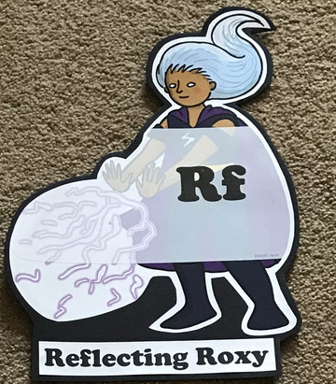  What have you learnt today and how could you have improved any of your work?  STORY TIME | Making Links Molly 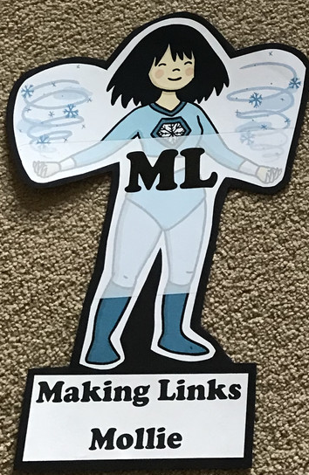  Can you use any learning that you have done today, in other parts of your life?  STORY TIME/ | Resilience Rex 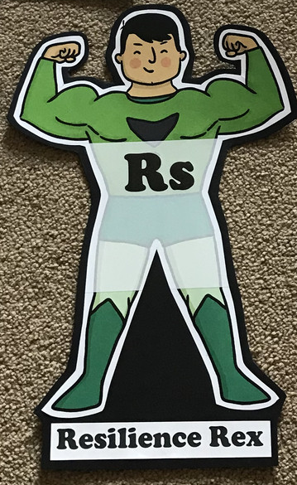  Have you found anything challenging today? How did you overcome the challenges?  STORY TIME/ | Collaborating Carlos 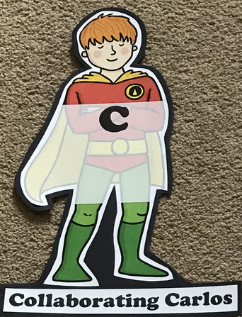  Did you work alone today or with someone else? How did that go?  STORY TIME/ | Motivating Melinda 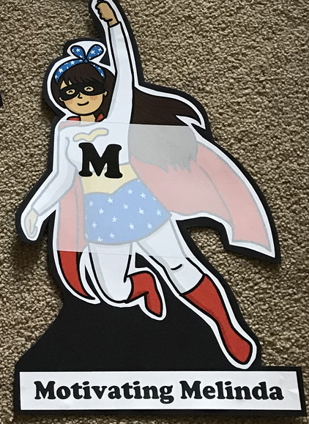  Have you encouraged someone else today? How did you motivate yourself today?  STORY TIME/

Writing

Back-and-Forth Stories (at least 2 people needed)
Writing back-and-forth stories takes a little creativity and a lot of flexibility. How long can you and a partner keep this story going?
An abandoned home sat at the top of the hill. Matt and Brianna knew the rumours about it, but they had to see it for themselves. They tiptoed their way up the steps, and when they reached the door, it swung open. Inside . . .
- Continue the story. Write for two minutes.
- Pass the story to a writing partner.
- The partner continues the story where you left off and writes for two minutes before passing the story back.
- Continue writing and passing the story every two minutes.
- How long can you keep the story going? What happens inside the house?

Diary of a Famous Figure
- List three famous people or characters you like or admire.
- Imagine you are one of the famous figures from your list.
- As that person, think of what you would do on a summer day.
- Write a diary entry (or blog post) about your special day as the famous person.
- Then write additional entries as you so choose.

Sound Off with Onomatopoeia
English has many words that sound like what they name. For example, sizzle sounds like frying food, and buzz sounds like the beating of a bee's wings or static on an amplifier. This similarity of sound is called onomatopoeia. Present students with a list of sound words, like those in the table below:
splat | whish | sploosh
gunk | whump | poing
gush | whoop | slurp
oomph | bang | thwack
Then have them choose their favourite sound word and list all the ways in which it could be produced in real life. Encourage students to think of as many ways as they can, no matter how wild the ideas may seem. Finally, have them organise their ideas into a list poem like the example that follows:
Splat is . . . a hippo doing a belly flop.
an egg hitting the floor
fat rain slapping a windshield.
water landing in an empty stomach.
a cream pie in the face.
atoms colliding.
Write a Script
Write a script for a made up story, the story of ‘your life’ or re-write part or all of your favourite story in a play script style.

Theme
- Research a famous ‘creative’ person; an artist, musician, writer, dancer…create a fact file, poster or Wikipedia page about them.
- Choosing a piece of work which inspires you (art, music, dance, poetry, literature) and recreate part of it in a visual way. (If a piece of art, can you replicate it? If a piece of text can you create a picture to depict scene, paragraph? Dance or music? Draw or paint how it makes you feel or imagine when you hear or watch it.)
- Can you create your own invention? Who is it for? What does it do? Why?
- Create a piece of music using everyday items. (Watch https://www.youtube.com/watch?v=UWJd_J2_aRY STOMP KITCHEN UTENSILS, for inspiration, ignore the Christmas hats!)
- Create your own world or planet; what does it look like? Who or what lives there? Give some facts. Population? Atmosphere? Physical features? Data? Size?
- Create a piece of art work – representing you. Self-portrait, abstract art (think ‘Picasso’), images which represent you. You can use any media you like, collage, paint, pencil, everyday recycling to create a statue or model.
- Create an outfit/costume for your favourite character.
- Create a piece of STOP MOTION digital art to tell story.

