Year 6
Home
Learning
Pack

Maths- addition and subtraction

Maths- multiplication and division

BODMAS (brackets, order, division, multiplication, addition, subtraction)
4³ + 15 ÷ 3=
7 + 48 ÷ (18-16)=
64 ÷ (2 x 8) + 5=
99 ÷ (11 x 3)=

Algebra
- 3n - 3 = 21
- 6n + 5 = 41
- 3n - 5 = 10
- 3n + 2 = 17
- 5n - 16 = n + 20
- 3n + 3 = 2n + 8

Fractions, decimals and percentages

Fill in the missing gaps in the table below- the first one has been done for you to refresh your memory (remember to convert your decimal to a fraction by converting it to a tenth or hundredth) Can you simplify the fraction?

Fraction | Decimal | Percentage
40  100 | 0.4 | 40%
5  10 | 0.5
 | 0.25 | 25%
63
100
2  10 |  | 20%
 | 0.1
3
4
 | 0.99

- Tom and Sam shared equally one quarter of a chocolate bar.
What percentage of the chocolate bar did each child get?

- Sharif says:

“All you do when converting percentages to decimals is put ‘0.’ in front of the number e.g. 78% is 0.78.”

Do you agree? Prove it!

- Three friends were competing in a race.

- Billy completed half of the race.
- Harrison completed 50% of what Billy completed
- Charlotte completed 0.25 of what Billy completed.
What fraction of the race did they each complete?

Fraction of amounts

Percentages
Reminders- to find 10% divide the whole number by 10, to find 1% divide the whole number by 100.

53% of 276

65% of 987

33% of 856

45% of 145

78% of 892

13% of 789

24% of 423

99% of 1932

Writing

Use lined paper to plan and write the following tasks…

Task 1- you need to write a balanced argument about whether or not children should have to wear school uniform. Make sure you use argument sentence openers (on the contrary, furthermore, on the other hand, consequently, research shows etc). Start with an introduction then argue for and against before giving your opinion in a conclusion.

Task 2- Can you write a setting description of the image below? Try to include powerful adjectives, expanded noun phrases, similes and a variety of sentence openers.

Task 3- Can you write a newspaper report informing the world of the current pandemic of the coronavirus? What has happened? When? Where? Who is involved? Why? and what measures are the Government and people taking to protect themselves and others.
Reading- use lined paper to answer where necessary
RUBBISH
They had seen the piece of chain lying in a heap of rubbish in the scrap yard a few days previously. It was just what they needed to complete the camp they had made – to secure the door and keep those not in the group out. All that was required was for one of them to climb the wire mesh fence, drop into the yard and retrieve it.
All eyes were on Josh, who was a tall, strong boy with an athletic body and straight, brown floppy hair.
“Go on, Josh, you could do it easily,” they urged him.
He didn’t want to; he knew it was wrong, but he also knew he would get no peace until he did.
Keeping his toes in the small mesh holes was tricky; however, he was soon at the top and dropping down to the ground into a crouch. It was as he landed that he heard it . . . a faint growl that swiftly grew to a furious barking. As he dived behind an old, wrecked van, he heard footsteps and then an angry voice shouted at his friends,
“Clear off out of here the lot of you! If I see you hanging round again, I’ll let the dog loose on you.”
There was laughter and running footsteps . . . . then silence.
Not knowing where the man was, Josh edged round the other side of the van where he had a good view of the site office. He could see a small room with two men. No, wait, was that a third on the floor? Something was wriggling and appeared tied up like a parcel with lots of tape. The voices were muffled but Josh could just make out what they were saying.
“If we’re going to do it, we better get on with it.”
“Where will we dispose of it?”
“Weighed down in the quarry, it’ll never be found.”
At that moment a man (it must have been the one who had chased away the other children) arrived blocking Josh’s view of the proceedings. He was happy not to see and soon wished he was deaf.
Not long later, a car started and Josh crept closer to the gateway. As it opened and the car left, he sprinted out, pursued by the sound of barking and shouting as they realised his presence. He ran for his life, dodging down streets, and as he ran, thought about what to do if he escaped without being caught.

- Where was the chain? (2)
- What surrounded the scrap yard? (1)
- Why did they want the chain? (1)
- Why did the gang think Josh could easily get over the fence? (3)
- How do you know the dog was chained? (2)
- What do you think was on the floor and why? (2)
- Why do you think it says ‘he soon wished he was deaf’? (2)
- What do you think Josh should do if he escapes and why? (3)
- Find and copy the word closest in meaning to sporty (1)
- Find and copy the word closest in meaning to ‘get rid of’ (1)
- Find and copy the phrase that shows Josh was trying to escape quickly. (1)

She waded out into the shallows. Waves of water lapped up against her bare legs, sending a chill up her already trembling body. She stole a glance back at what she had left behind on the shore. No regrets.
Fog wrapped its arms around the girl, adding to her feeling of growing trepidation. She held a lantern in her hand; it swayed gently by her side as she moved, leaking a milky light out into the night. That light was the only comfort she had.
As she stole away, the outline of the ship crept out of the mist like a silent predator. Would the ship bring the solace she had been longing for?

- What does the word ‘solace’ mean?
- Who is the girl in the picture?
- Can you give her a name?
- Why is she dressed in the way she is?
- What has she left behind on the shore?
- What does it mean by ‘that light was her only comfort’?
- What is the ship? Why has it been described as a ‘silent predator?
- Why does the girl want to reach the ship?
What will happen once she does?

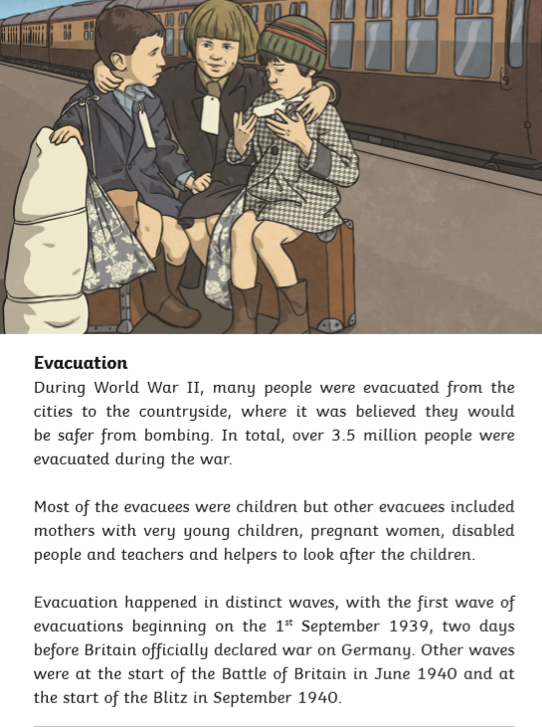
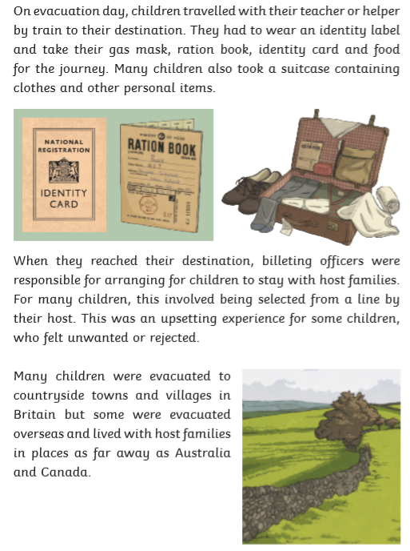

Read this extract carefully.
Describe two ways that the text gives the impression that evacuation was a large-scale operation. Use evidence from the text to support your answer.
[3 marks]

________________________________________________________________________________________________________________________________________________________________________________________________________________________________________________________________________________________________________________________________________________________________________________________________________________________________________________________________________________________________________________________________________________________________________________________________________________________________________________________________________________
GAPS- word classes

GAPS- passive (object verb subject) and active (subject verb object)

