 | Discovery Theme – Week 8 11.05.20
 | Monday | Tuesday | Wednesday | Thursday | Friday
9-9.30 | Movement  The Body Coach – Youtube on the day | Movement  https://www.youtube.com/user/CosmicKidsYoga  Cosmic Yoga  (YouTube) | Movement  BBC Move it Dance Programme  https://www.bbc.co.uk/programmes/b03g64pk/episodes/player | Movement  Go outside for a walk. | Movement  The Body Coach – Youtube on the day
9.30-10 | Phonics | Phonics | Phonics | Phonics | Phonics
10-10.30 | Reading  Younger readers can read or share a text with someone. Can they write or draw what they read about? Can they answer questions about the text?  https://www.oxfordowl.co.uk/for-home/find-a-book/library-page/  username- SJGreading  password- SJGreading | Reading  Younger readers can read or share a text with someone. Can they write or draw what they read about? Can they answer questions about the text?  https://www.oxfordowl.co.uk/for-home/find-a-book/library-page/  username- SJGreading  password- SJGreading | Reading  Younger readers can read or share a text with someone. Can they write or draw what they read about? Can they answer questions about the text?  https://www.oxfordowl.co.uk/for-home/find-a-book/library-page/  username- SJGreading  password- SJGreading | Reading  Younger readers can read or share a text with someone. Can they write or draw what they read about? Can they answer questions about the text?  https://www.oxfordowl.co.uk/for-home/find-a-book/library-page/  username- SJGreading  password- SJGreading | Reading  Younger readers can read or share a text with someone. Can they write or draw what they read about? Can they answer questions about the text?  https://www.oxfordowl.co.uk/for-home/find-a-book/library-page/  username- SJGreading  password- SJGreading
11-11.15 | Break | Break | Break | Break | Break
11.15-12.15 | Maths  Number gym  http://www.numbergym.co.uk/  Appropriate calculation activity linked to year group e.g. add and subtract  See EYFS and Year 1 daily sheet. | Maths  Purple Mash  https://www.purplemash.com/login/  Shape focus – recap names of shapes. Creating your own Colour Monster shape picture.  See EYFS and Year 1 daily sheet. | Maths  Number gym  http://www.numbergym.co.uk/  Appropriate calculation activity linked to year group. EYFS/Yr1 looking at number bonds/numbers to 10  See EYFS and Year 1 daily sheet. | Maths  Purple Mash  https://www.purplemash.com/login/  See EYFS and Year 1 daily sheet. | Maths  Number gym  http://www.numbergym.co.uk/  Calculation focus – addition and subtraction  See EYFS and Year 1 daily sheet.
12.15-1.15 | Lunch | Lunch | Lunch | Lunch | Lunch
1.15-2.50 | Theme Work  See daily plan | Theme Work  See daily plan | Theme Work  See daily plan | Theme Work  See daily plan | Theme Work  See daily plan
2.50-3.15 | Reflecting Roxy 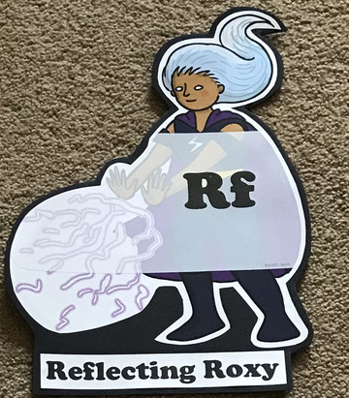  What have you learnt today and how could you have improved any of your work?  STORY TIME | Making Links Molly 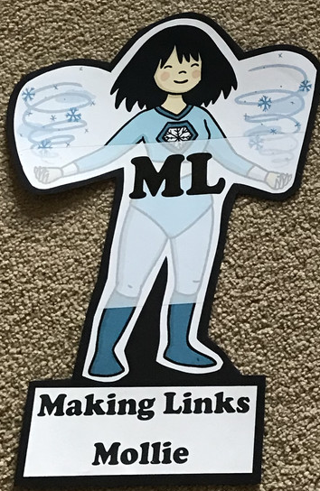  Can you use any learning that you have done today, in other parts of your life?  STORY TIME | Resilience Rex 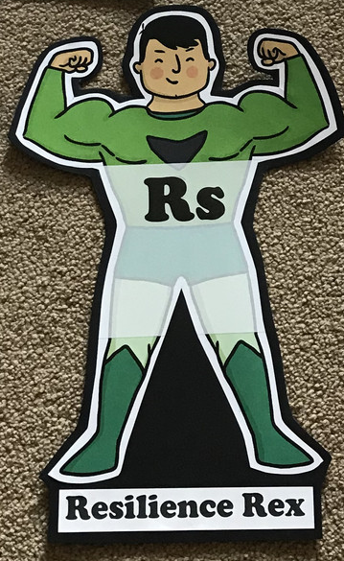  Have you found anything challenging today? How did you overcome the challenges?  STORY TIME | Collaborating Carlos 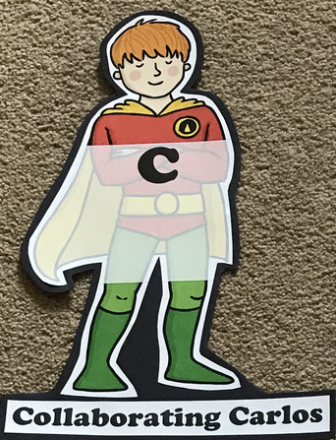  Did you work alone today or with someone else? How did that go?  STORY TIME | Motivating Melinda 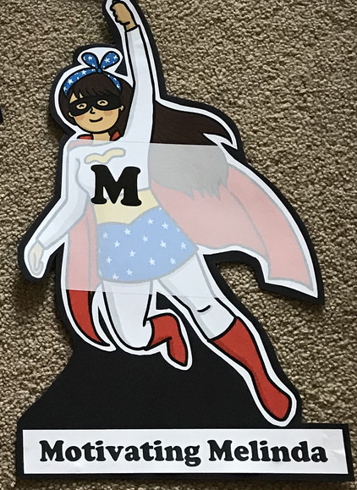  Have you encouraged someone else today? How did you motivate yourself today?  STORY TIME

EYFS/YEAR 1- WEEK 8- Discovery
Monday
Phonics
EYFS
Words to practise
Boot, shoot, moon, noon, room, broom, hoop, bloom
Tricky words
Who, what, was
Challenge
Can you write some sentences with these words in?
Phonics
Sound of day-
oo
Poo at the zoo

YEAR 1
Words to practise
Whisper, whip, whisk, white, when, what.
Alien words-
Whooted, whif, whelf, whem

Phonics
Sound of day-
Wh
Wagon wheel
Tricky words
Who, what, was
Challenge
Can you write some sentences with these words in?

Maths
This week we would like the children to make an addition and subtraction board game. This must include challenge cards.
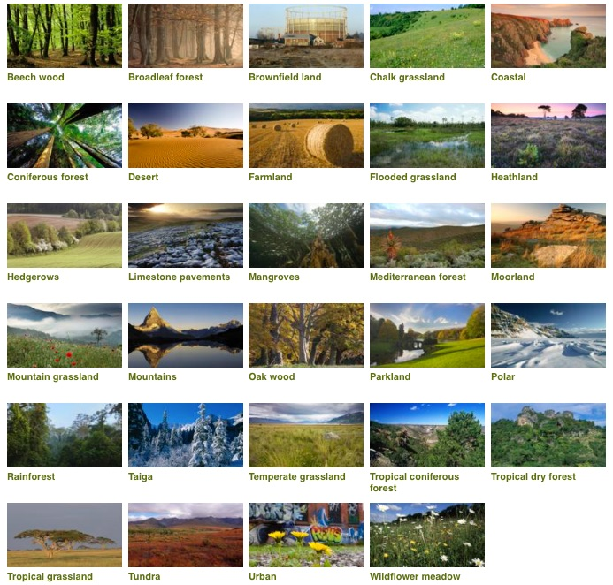

Theme
Research a habitat of your child’s choice. Think about.
- What is the weather like?
- What animals live their?
- What would you find there?
- Are there any people that live there? Record on the sheet attached

Tuesday
Phonics
EYFS
Phonics
Sound of day-
Oo (u)
Look at a book
Words to practise

Foot, cook, stood, shook
Tricky words
Who, what, was
Challenge
Can you write some sentences with these words in?

YEAR 1
Words to practise
Phonics, alphabet, elephant, Steph
Alien words-
Welph, yepht, relphing, dreph

Phonics
Sound of day-
Ph
Photograph a dolphin
Tricky words
Who, what , was
Challenge
Can you write some sentences with these words in?

Theme
Children to focus on the animals that live in the habitat that they have chosen. Children to discover new things about their chosen animals. They could make a poster, leaflet or fact file.
Children to use these questions to help them.
- What does it look like?
- What does it eat?
- What is special about this animal?
- Why does it belong to the habitat?

Watch some Tinga Tinga Tales.

Wednesday
Phonics
EYFS
Words to practise
Car, start, bar, park, shark

Tricky words
Mr, Mrs, called
Challenge
Can you write some sentences with these words in?
Phonics
Sound of day-
ar

start the car

YEAR 1
Words to practise
Chew, grew, stew, blew
Alien words
Cewg, grewt, phewb

Tricky words
Mr, Mrs, called
Challenge
Can you write some sentences with these words in?
Phonics
Sound of day-
ew
Chew the stew

Theme
Play switch zoo game to discover new animals. Children could then sketch these and give their new animals a name.
https://switchzoo.com/zoo.htm

Challenge- Children could write some sentences about their animals.
e.g- I have chosen an elephants trunk so it can pick up food.

Thursday
Phonics
EYFS
Tricky words
Mr, Mrs, called
Words to practise
Short, Cork, Port, Fork, corn
Challenge
Can you write some sentences with these words in?
Phonics
or
shut the door

YEAR 1
Words to practise
Toe, tomatoes, potatoes, Joe
Alien words
Koebed, roen, poeting

Tricky words
Mr, Mrs, called
Challenge
Can you write some sentences with these words in?
Phonics
Sound of day-
Oe
Touch your toes

Thursday
Choose their favourite switch zoo animal and write a fact file about their new animal. Encourage the children to write about:
- Appearance
- Habitat
- Diet
- Fun facts

Friday
Phonics
Phonics play
https://new.phonicsplay.co.uk/resources

Maths
Suggested games
https://www.ictgames.com/mobilePage/numberL/- drag it to any number and jump back.
https://www.ictgames.com/mobilePage/bottleTakeAway/index.html

Theme
Explore the switch zoo website or anything else they would like to discover.

