A Story about Sports Day

It will soon be Sports Day in school. This will be fun.
The children in my class will be very excited.

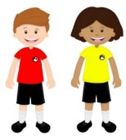
Sports Day will happen on the school field at Abbey in the morning or afternoon.
I will wear my PE kit in my team colours

My teacher will tell me when it is time to go out onto the field. I will line up sensibly with my friends in my team. I will walk onto the field sensibly. This will make my teacher happy.

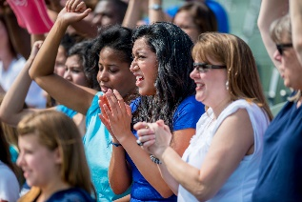
On Sports Day, parents and family will be able to come and watch children taking part in events on the field. There will be some noise from the parents, such as clapping and cheering. This is ok.
On Sports Day I will take part in different events. This will be fun.

Taking part in sports can be fun, but I won’t always win. Sometimes I might come second, third or even last. This is ok
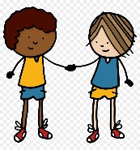
I will say to my friends ‘Well done!’ I might give them a handshake or high five. I will be a ‘good sport’ It’s ok not to win all the time.

Sports Day will be lots of fun, taking part in different events with my friends. I will be able to tell my family all about Sports Day at the end of the day.

