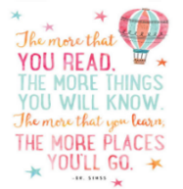
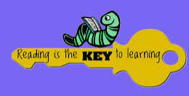
- CREATE A NEW FRONT COVER FOR YOUR FAVOURITE BOOK.  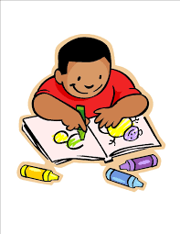  Completed: | - READ TWO BOOKS, COMPARE THE CHARACTERS AND WRITE DOWN SOME DIFFERNCES.  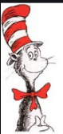  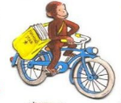  Completed: | - READ A NEWS ARTICLE FROM A NEWSPAPER, MAGAZINE, ONLINE OR A TABLET AND WRITE ABOUT THE ARTICLE  Completed: | - READ AND REMEMBER THIS ARTICLE (CAN YOU TELL OTHER PEOPLE ABOUT IT?)  ARTICLE 29. YOU HAVE THE RIGHT TO EDUCATION WHICH TRIES TO DEVELOP YOUR PERSONALITY AND ABILITIES AS MUCH AS POSSIBLE AND ENCOURAGES YOU TO REPSECT OTHER PEOPLE’S RIGHTS AND VALUES AND TO REPSECT THE ENVIROMENT.  Completed:
- READ SOMETHING LINKED TO YOUR FAMILY, YOUR CULTURE OR YOUR HERITAGE AND WRITE DOWN WHAT YOU FOUND OUT.  Completed: | - READ SOMETHING THAT MAKES YOU LAUGH AND WRITE DOWN WHY IT WAS FUNNY.  Completed: | - READ A BOOK THAT HAS BEEN MADE INTO A FILM AND WRITE DOWN SOME OF THE DIFFERNCES BETWEEN THE BOOK AND THE FILM  Completed: | - THINK OF A STORY YOU COULD WRITE AT HOME AND WRITE DOWN WHAT THE STORY IS ABOUT AND ONE OF THE CHARCATERS.  Completed:
- READ A BOOK ABOUT DIVERSITY AND ANSWER QUESTIONS ABOUT IT.  Completed: | - READ A BOOK ABOUT IDENTITY AND ANSWER QUESTIONS ABOUT IT.  Completed: | - READ A BOOK ABOUT COMMUNITY AND ANSWER QUESTIONS ABOUT IT.  Completed: | - READ 3 BOOKS BY THE SAME AUTHOR, TELL AN ADULT WHICH WAS YOUR FAVOURITE AND WHY.  Completed:
- READ AN ATLAS OR BOOK ABOUT THE WORLD AND ANSWER QUESTIONS ABOUT IT.  Completed: | - READ SOMETHING ABOUT MATHS OR NUMBERS AND TELL AN ADULT WHAT YOU HAVE LEARNED.  Completed: | - READ A BOOK WHICH RHYMES, AND EXPLAIN TO AN ADULT HOW OR WHY IT RHYMES.  Completed: | - READ A STORY FROM ANOTHER CULTURE AND ANSWER QUESTIONS ABOUT IT.  Completed:
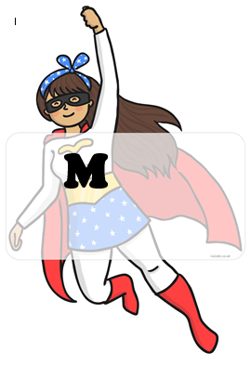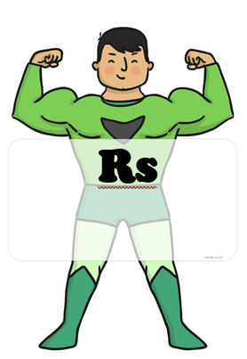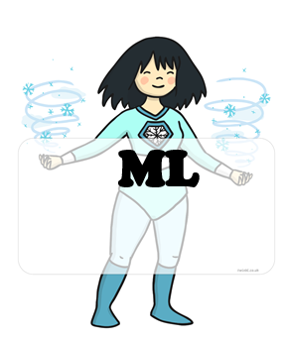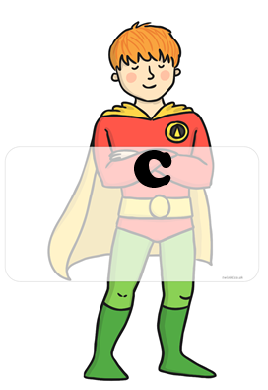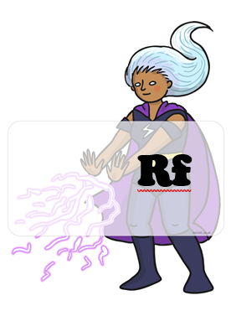 BLUE : home challenges YELLOW : school challenges

HOME CHALLENGES EVIDENCE
CHALLENGE 6:
CHALLENGE 5:
CHALLENGE 4:
CHALLENGE 3:
CHALLENGE 2:
CHALLENGE 1:
CHALLENGE 8:
CHALLENGE 7:

