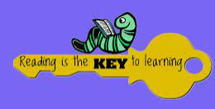
- RETELL A STORY USING T4W ACTIONS THAT YOU HAVE LEARNT IN CLASS. | - IENTIFY 3 HARDER TO READ AND SPELL WORDS IN A BOOK. | 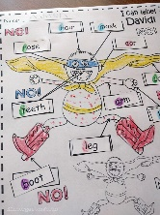  - DRAW AND LABEL THE MAIN CHARACTERS IN A STORY. | - PREDICT WHAT A NEW STORY MIGHT BE ABOUT USING THE FRONT COVER OF A BOOK.
- NAME 2 WAYS HOW YOU CAN TELL IF A BOOK IS FACTUAL. | - CREATE AN S MAP OF THE MAIN EVENTS IN A STORY. | - COMPARE THE SIMILARITIES AND DIFFERNECS BETWEEN TWO OF YOUR FAVOURITE BOOKS. | 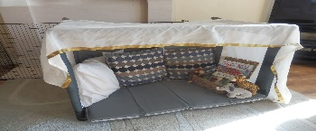  - MAKE A DEN TO SHARE A BOOK IN.
- RETELL A STORY USING T4W ACTIONS. | - DESCRIBE THE MAIN EVENTS IN A STORY. | - IDENTIFY THE MAIN CHARACTERS IN A STORY. | - FINISH A RHYMING STRING.
- SHARE A BOOK OUTSIDE. | - LISTEN TO AN AUDIOBOOK. | - SHARE AN EBOOK ONLINE FROM OXFORD OWL. | - CREATE A PROP TO SUPPORT YOUR STORY TELLING.
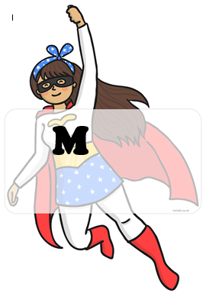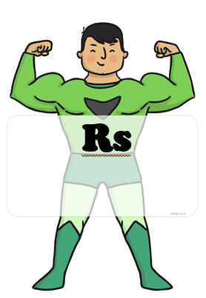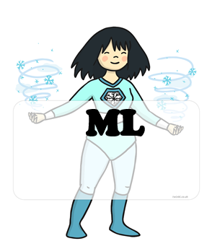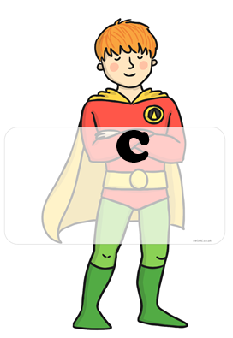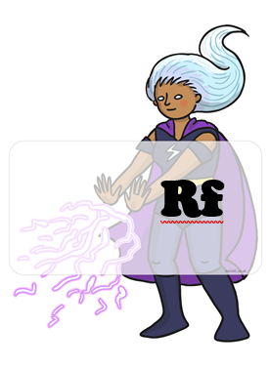 BLUE : home challenges YELLOW : school challenges

