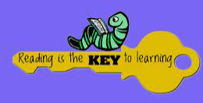
- RETELL A STORY USING ACTIONS TO ACT OUT THE STORY. WRITE DOWN WHAT THE STORY WAS. | 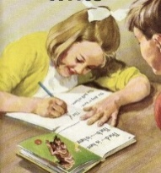  - IENTIFY 3 HARDER TO READ AND SPELL WORDS IN A BOOK AND WRITE THEM DOWN. | 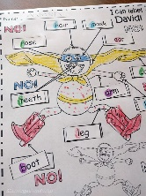  - DRAW AND LABEL THE MAIN CHARACTERS IN A STORY. | - CREATE A PROP TO SUPPORT YOUR STORY TELLING AND DRAW A PICTURE OF IT.
- READ A BOOK OUTSIDE AND TAKE A PICTURE OF WHERE YOU ARE. | - DRAW A PICTURE OF THE MAIN EVENT IN A STORY. | - LISTEN TO AN AUDIOBOOK, WRITE DOWN WHAT THE BOOK WAS. | 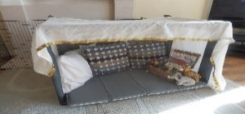  - MAKE A DEN TO SHARE A BOOK IN AND TAKE A PICTURE.
- RETELL A STORY TO A TEACHER OR ADULT USING THE PICTURES IN A BOOK. | - DESCRIBE THE MAIN EVENTS IN A STORY TO A TEACHER OR ADULT. | - IDENTIFY THE MAIN CHARACTERS IN A STORY AND TELL A TEACHER OR ADULT ABOUT THEM. | - READ A RHYMING STORY AND SHOW A TEACHER OR ADULT HOW IT RHYMES.
- NAME 2 WAYS HOW YOU CAN TELL IF A BOOK IS FACTUAL AND EXPLAIN THEM TO A TEACHER OR ADULT. | - COMPARE THE SIMILARITIES AND DIFFERNECS BETWEEN TWO OF YOUR FAVOURITE BOOKS TO A TEACHER OR ADULT. | - TELL THE STORY OF YOUR CURRENT STAGE OR READING BOOK TO A TEACHER OR ADULT. | - PREDICT WHAT A NEW STORY MIGHT BE ABOUT USING THE FRONT COVER OF A BOOK AND EXPLAIN IT TO A TREACHER OR ADULT.
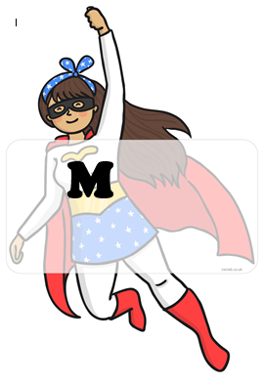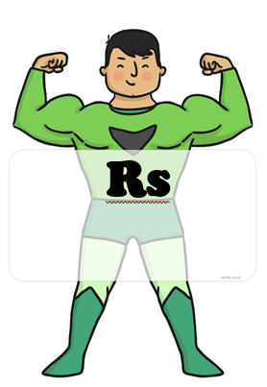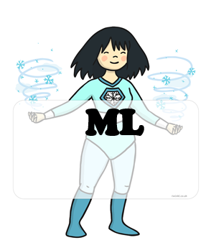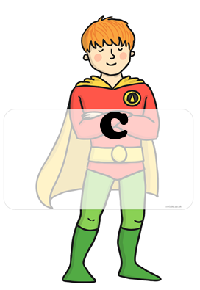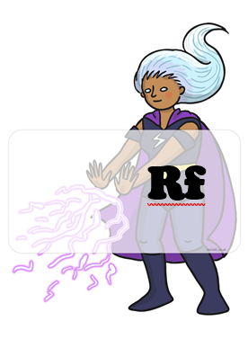 BLUE : home challenges YELLOW : school challenges

