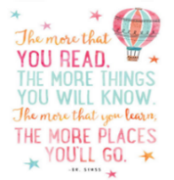
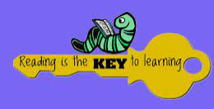
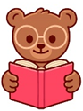  - USE A BOOK TO TELL A STORY TO YOUR TEDDY.  Completed: | - READ / LISTEN TO A BOOK IN BED.  Completed: | - READ / LISTEN TO A BOOK AND THEN WATCH THE MOVIE AND WRTE DOWN ONE DIFFERNCE.  Completed: | - SHARE A BOOK OUTSIDE.  Completed:
- READ / LISTEN TO A BOOK ABOUT ANIMALS AND WRITE DOWN SOMETHING YOU HAVE LEARNT ABOUT THE ANIMAL.  Completed: | READ / LISTEN TO YOUR FAVOURITE BOOK AND WRITE DOWN WHY IT IS YOUR FAVOURITE.  Completed: | 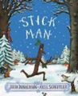  - FOLLOW ALONG TO THE STORY OF ‘STICK MAN’.  Completed: | - LOOK AT THE PICTURES IN A BOOK AND PREDICT HOW THE STORY IS GOING TO END.  Completed:
- READ A BOOK ABOUT DIVERSITY AND ANSWER QUESTIONS ABOUT IT.  Completed: | - READ A BOOK ABOUT IDENTITY AND ANSWER QUESTIONS ABOUT IT.  Completed: | - READ A BOOK ABOUT COMMUNITY AND ANSWER QUESTIONS ABOUT IT.  Completed: | - MAKE SOMETHING FROM A BOOK AND SHOW IT TO AN ADULT.  Completed:
- SHARE A BOOK WITH A FRIEND AND TELL AN ADULT WHICH FRIEND YOU READ WITH.  Completed: | - LISTEN TO A FAIRY TALE, AND USE ACTIONS TO RE-TELL THE EVENTS TO AN ADULT.  Completed: | - READ A FACT BOOK AND TELL AN ADULT A FACT FROM THE BOOK.  Completed: | - LISTEN TO AN E-BOOK AND TELL AN ADULT ABOUT THE BOOK.  Completed:
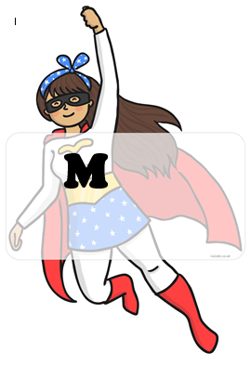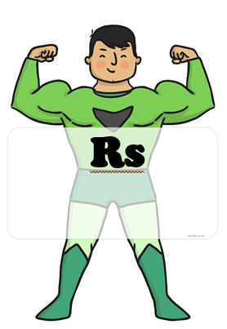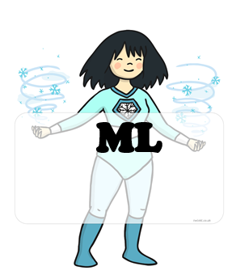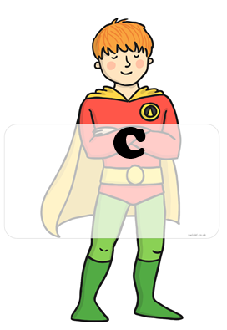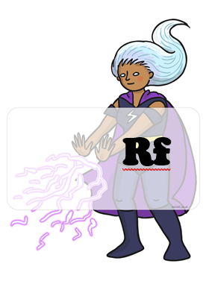 BLUE : home challenges YELLOW : school challenges

HOME CHALLENGES EVIDENCE
CHALLENGE 6:
CHALLENGE 5:
CHALLENGE 4:
CHALLENGE 3:
CHALLENGE 2:
CHALLENGE 1:
CHALLENGE 8:
CHALLENGE 7:

