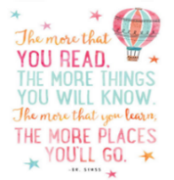
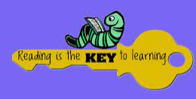
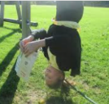  - READ A BOOK IN AN UNUSUAL PLACE, WRITE DOWN WHAT THE BOOK WAS AND WHERE YOU READ IT. MAYBE TAKE A PHOTOGRAPH.  Completed: | - READ A BOOK THAT ONE OF YOUR GRANDPARENTS/PARENTS/SIBLINGS LOVED AS A CHILD AND WRITE DOWN WHAT YOU THOUGHT ABOUT THE BOOK.  Completed: | 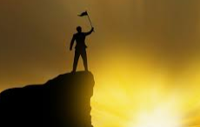  - READ ABOUT SOMEONE THAT INSPIRES YOU AND WRITE DOWN WHY THEY INSPIRE  YOU.  Completed: | - LISTEN TO AN AUDIO BOOK AND WRITE DOWN WHAT YOU THOUGHT ABOUT THE BOOK AND HOW IT FELT TO LISTEN TO IT RATHER THEN READ IT,  Completed:
- BORROW ANY BOOK, OF ANY KIND FROM YOUR LOCAL LIBRARY AND READ IT. WRITE DOWN THE NAME OF YOUR BOOK AND ABOUT YOUR EXPERIENCE IN THE LIBRARY.  Completed: | - READ A BOOK THAT TEACHES YOU A NEW SKILL (MAGIC TRICKS, SPORT, CRAFTS). WRITE DOWN THE NEW SKILL YOU HAVE LEARNED AND DEMONSTATE IT IN CLASS.  Completed: | - READ A COMIC OR MAGAZINE AND CREATE SOME PAGES OF YOUR OWN COMIC STRIP.  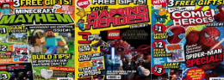  Completed: | - READ A RHYMING BOOK AND WRITE SOMETHING THAT RHYMES.  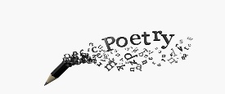  Completed:
- READ A BOOK ABOUT DIGNITY AND ANSWER QUESTIONS ABOUT IT.  Completed : | - READ A BOOK ABOUT EQUALITY AND ANSWER QUESTIONS ABOUT IT.  Completed: | - READ A BOOK ABOUT SAFETY AND ANSWER QUESTIONS ABOUT IT.  Completed: | - READ A BOOK ABOUT ENTERPRISE AND ANSWER QUESTIONS ABOUT IT.  Completed:
- READ ABOUT A PLACE OR COUNTRY YOU WOULD LIKE TO VISIT AND ANSWER QUESTIONS ABOUT IT.  Completed: | - READ ABOUT A TOPIC / SUBJECT THAT YOU KNOW NOTHING ABOUT AND ANSWER QUESTIONS ABOUT IT.  Completed: | - READ A BOOK THAT HAS BEEN MADE INTO A FILM AND TELL AN ADULT ABOUT THE DIFFERNCES BETWEEN THE BOOK AND THE FILM.  Completed: | - READ YOUR FAVOURITE POEM OR A FEW PAGES OF A BOOK TO YOUR CLASS AND TAKE SOME QUESTIONS ON IT.  Completed:
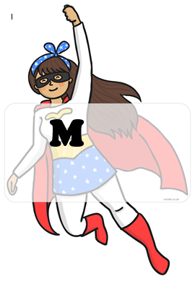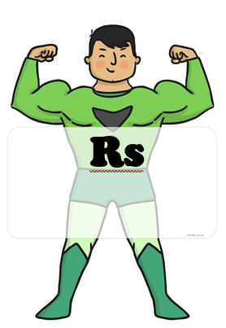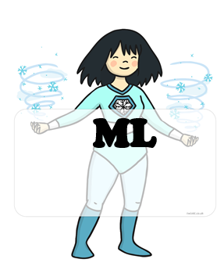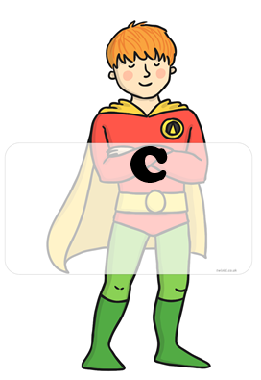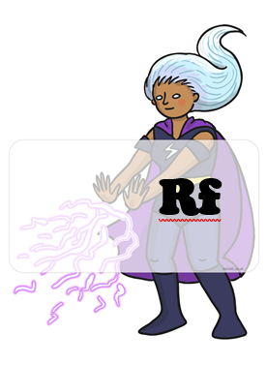 BLUE : home challenges YELLOW : school challenges

HOME CHALLENGES EVIDENCE.
CHALLENGE 6:
CHALLENGE 5:
CHALLENGE 4:
CHALLENGE 3:
CHALLENGE 2:
CHALLENGE 1:
CHALLENGE 8:
CHALLENGE 7:

